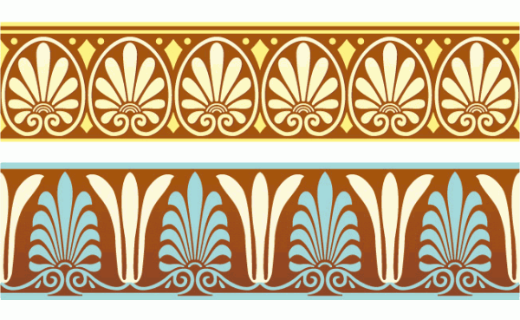

ANCIENT MEDITERRANEAN
MODULE/PART I

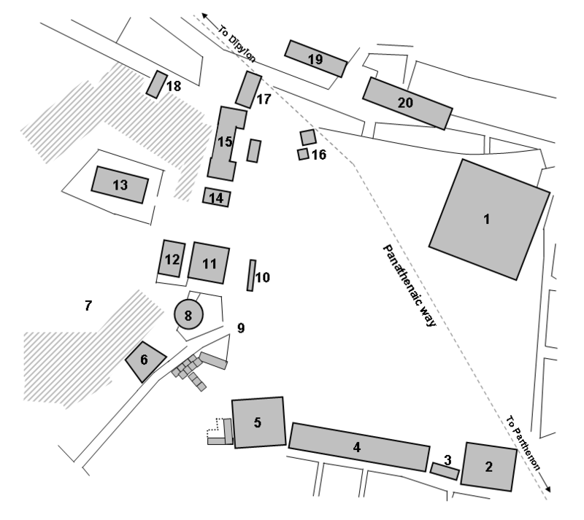
1 Peristyle Court
2 Mint
3 Enneacrounos
4 South stoa
5 Heliaea
6 Strategeion
7 Colonos Agoraios
8 Tholos
9 Agora stone
10 Monument of the Eponymous Heroes
11 Old Bouleuterion
12 New Bouleuterion
13 Temple of Hephaestus (Hephaestion)
14 Temple of Apollo Patroos
15 Stoa of Zeus
16 Altar of the Twelve Gods
17 Royal stoa 18 Temple of Aprodite
19 Stoa of Hermes
20 Stoa poikile

http://commons.wikimedia.org/wiki/File:AgoraAthens5thcentury.png#mediaviewer/File:AgoraAthens5thcentury.png

Athenian agora. Archaic through Hellenistic Greek. 600 B.C.E.–150 C.E. Plan.

The agora was the center of political and public life in Athens. It was a large open area surrounded by buildings of various functions. The Athenian Agora was an important central meeting place before the Classical period. However, during the Classical period under the reign of Pericles, the Athenian Agora was built into a central site for the city's religious, civic, and judicial practices. It was also the home to commerce and markets. The Agora's location in the center of the city, just below the Acropolis, notes its importance. The central location was easily accessible by all citizens. The Agora is where Athenian democracy thrived and where the citizens were able to take part in daily religious and civic duties.

Citation:
www.boundless.com

For more information:
http://www.agathe.gr/guide/

