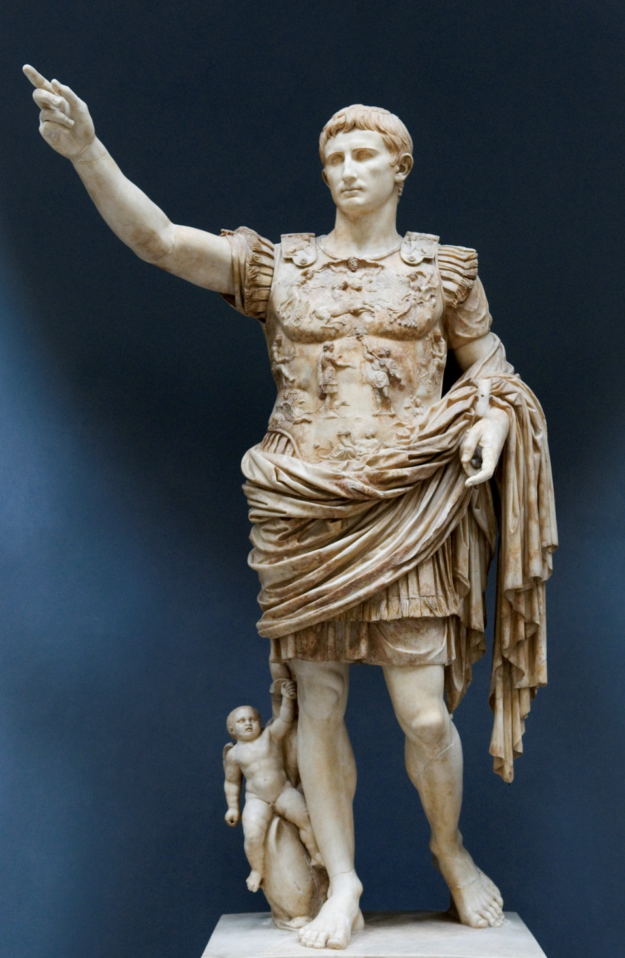

Function: it would have most likely been put in a public space so that people could see the statue and be in awe of how amazing Augustus seems based off of the sculpture.

Form: There are traces of red and blue colors on the cloak and breast plate.

Form: Around his waist is a paludamentum or officers cloak which helps give off a sense of power.

Form: Has many personal details like a small chin and broad cranium.

Context: his face id possibly depicted in Apollo’s manner, which would have associated himself with the gods.

Content: Augustus wanted to make him seem like a perfect leader, which is why he is shown in the controposto manner.

Function: Was based off of the Doryphorus, which gives off a heroic status just like the Augustus of Prima.

Form: The bas reliefs on the chest piece shows a complex political agenda, which helps us diverse between different deities.

Function: it is possible that this statue is a copy of a bronze original.

Form: Augustus is shown in an adlocutro pose, which means he is addressing troops and expresses to us that he holds significant power in the military.

Augustus of Prima, marble, 2.03m, https://upload.wikimedia.org/wikipedia/commons/f/fc/Augustus_of_Prima_Porta_(2984423197).jpg