Augustus of Primaporta

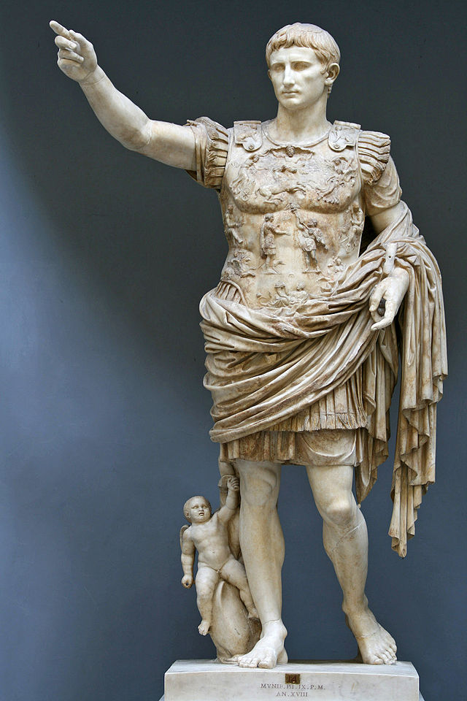

8
3

7
1
1.
4
The emperor wears military ceremonial dress and his right arm is outstretched, demonstrating that the emperor is addressing his troops. We immediately sense the emperor’s power as the leader of the army and a military conqueror.
6
2

5
9

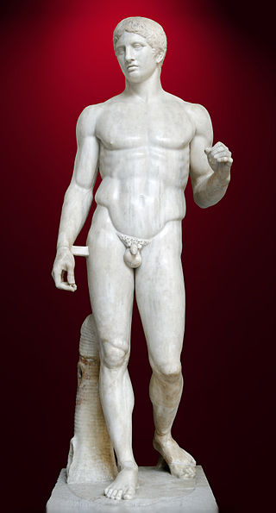

2.
Augustus borrows two sculptural styles that have contradictory symbolism. The artist took the orator’s gesture from Republican art that shows portraits of actual Romans, like the sculpture of the Roman Senator Aullus Metellus. The stance and idealized body comes from Classical Greek sculptures of gods and idealized athletes such as Polykleitos’ of Doryphoros. The reference to Classical Greece provides an idealized element, associates Augustus with the political golden age of Classical Athens. Augustus wants his reign to be seen as a new Golden Age.
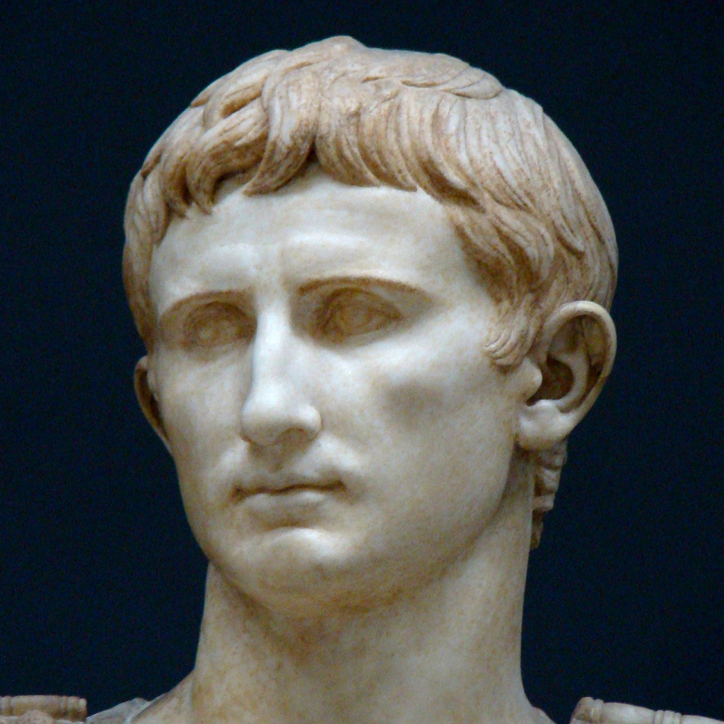
3.
The face depicts a youthful emperor, even though the statue was constructed when Augustus was about forty years of age. Augustus is depicted as being virile and strong.
The Primaporta style of facial construction consists of a broad forehead and narrow chin, ridged eyebrows, thin nose, and a rounded mouth. The eyebrow is also trademark of the Augustan style. The face is smoothed and idealized, and his hair is capped with the typical Augustus hairstyle.

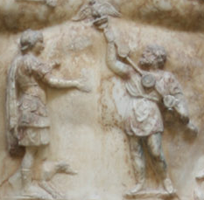
4.
The figures at the center of the cuirass (breastplate) are the most important feature. The figure on the right is identified as a Parthian barbarian because of his tunic and baggy trousers. It is believed that it refers to Phraates IV, the Parthian king. He is holding a Roman standard, which was lost by the Roman general Crassus to the Parthians in the battle of Carrhae in 53 B.C.E. The figure is returning the standard to the man wearing a cuirass, a helmet, and military boots. Either a dog or a she-wolf accompanies the Roman soldier, representing the Roman army.

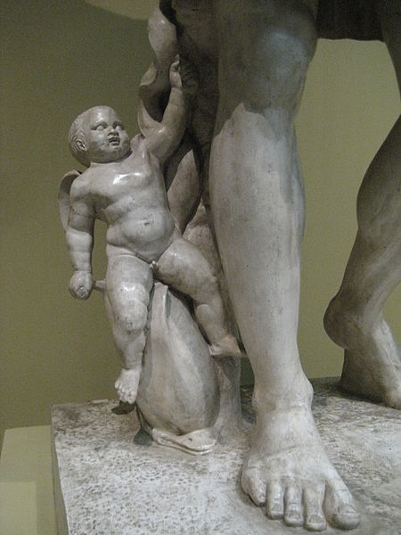

5.

On Augustus' lower right side is a statue of Cupid riding a dolphin. Cupid, or Eros, is the son of the goddess Venus. This symbolizes Augustus' claims of family lineage of the Julian family to Aeneas, the founder of Italy and the divine lineage to the goddess Venus.

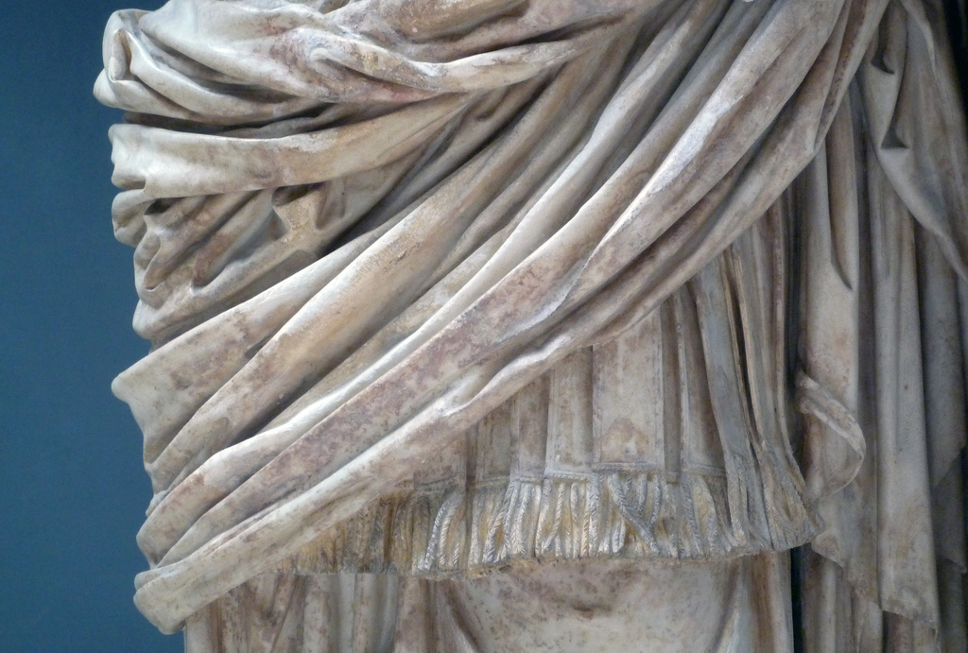
6.
The robe enhances the idea of Augustus' sacredness. The tunic becomes an emblem associated with the deified Julius Caesar. The tunic wrapped around his waist implies his connection to Caesar and the heavenly world.

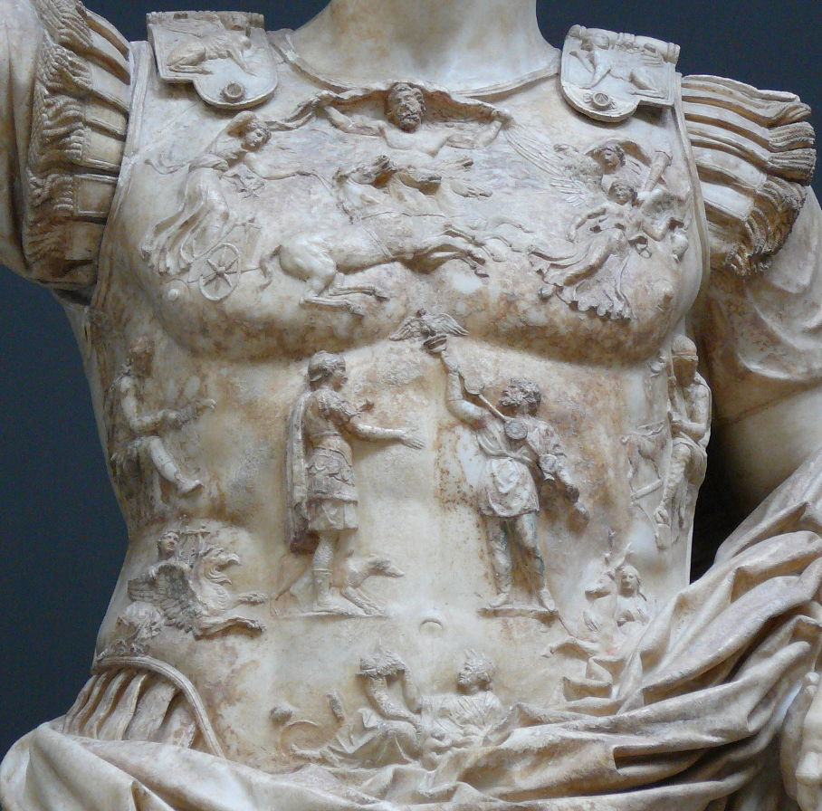
7
Surrounding this center image are reliefs of gods and personifications of defeated nations. Sol and Caelus, the sun and sky gods are located on the top. On the sides of the breastplate are female personifications of countries conquered by Augustus. These gods and personifications refer to the Pax Romana. The message is that the sun is going to shine on all regions of the Roman Empire, bringing peace and prosperity to all Roman citizens. Beneath the personifications are Apollo and Diana, two major gods to the Romans. These images. demonstrate that the emperor supports traditional Roman religion. At the very bottom is depicted Tellus, the earth goddess, who is cradling two infants and holding a cornucopia. Tellus is a symbol of fertility with her healthy babies and overflowing horn of plenty. This is another reference to the Pax Romana.

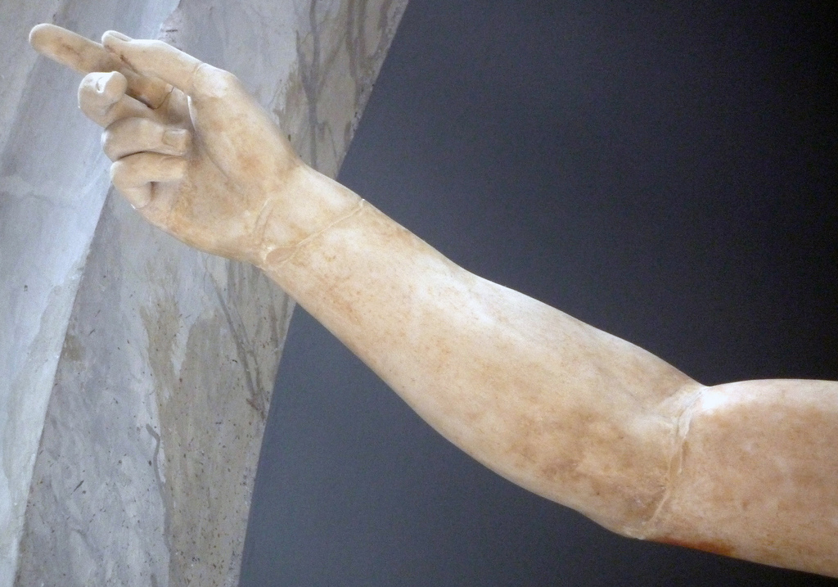
8.

Rising up the right hand is a Roman gesture in making a speech. It commands attention. The impression that a viewer gets from this posture is a domineering one, emphasizing the image of Augustus as a powerful ruler of Rome.

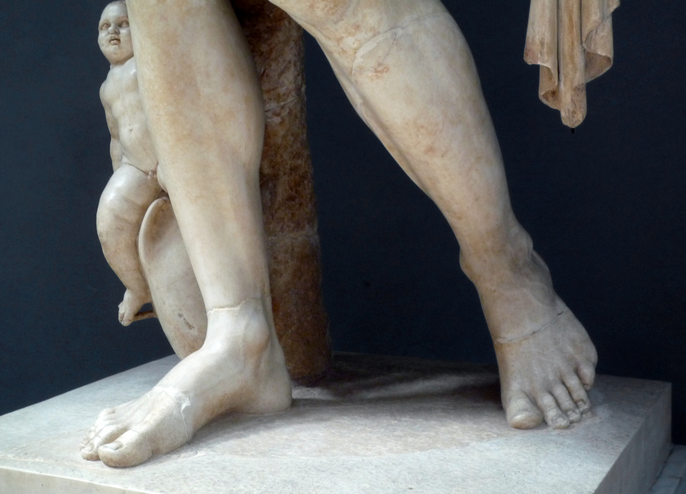
9.

Emperor Augustus has bare feet, echoing traditional Roman religious statuary, which always showed gods and goddesses barefoot. This also can symbolize that Augustus treads on holy ground (all of Rome), and that he is humble and barefoot before all.

