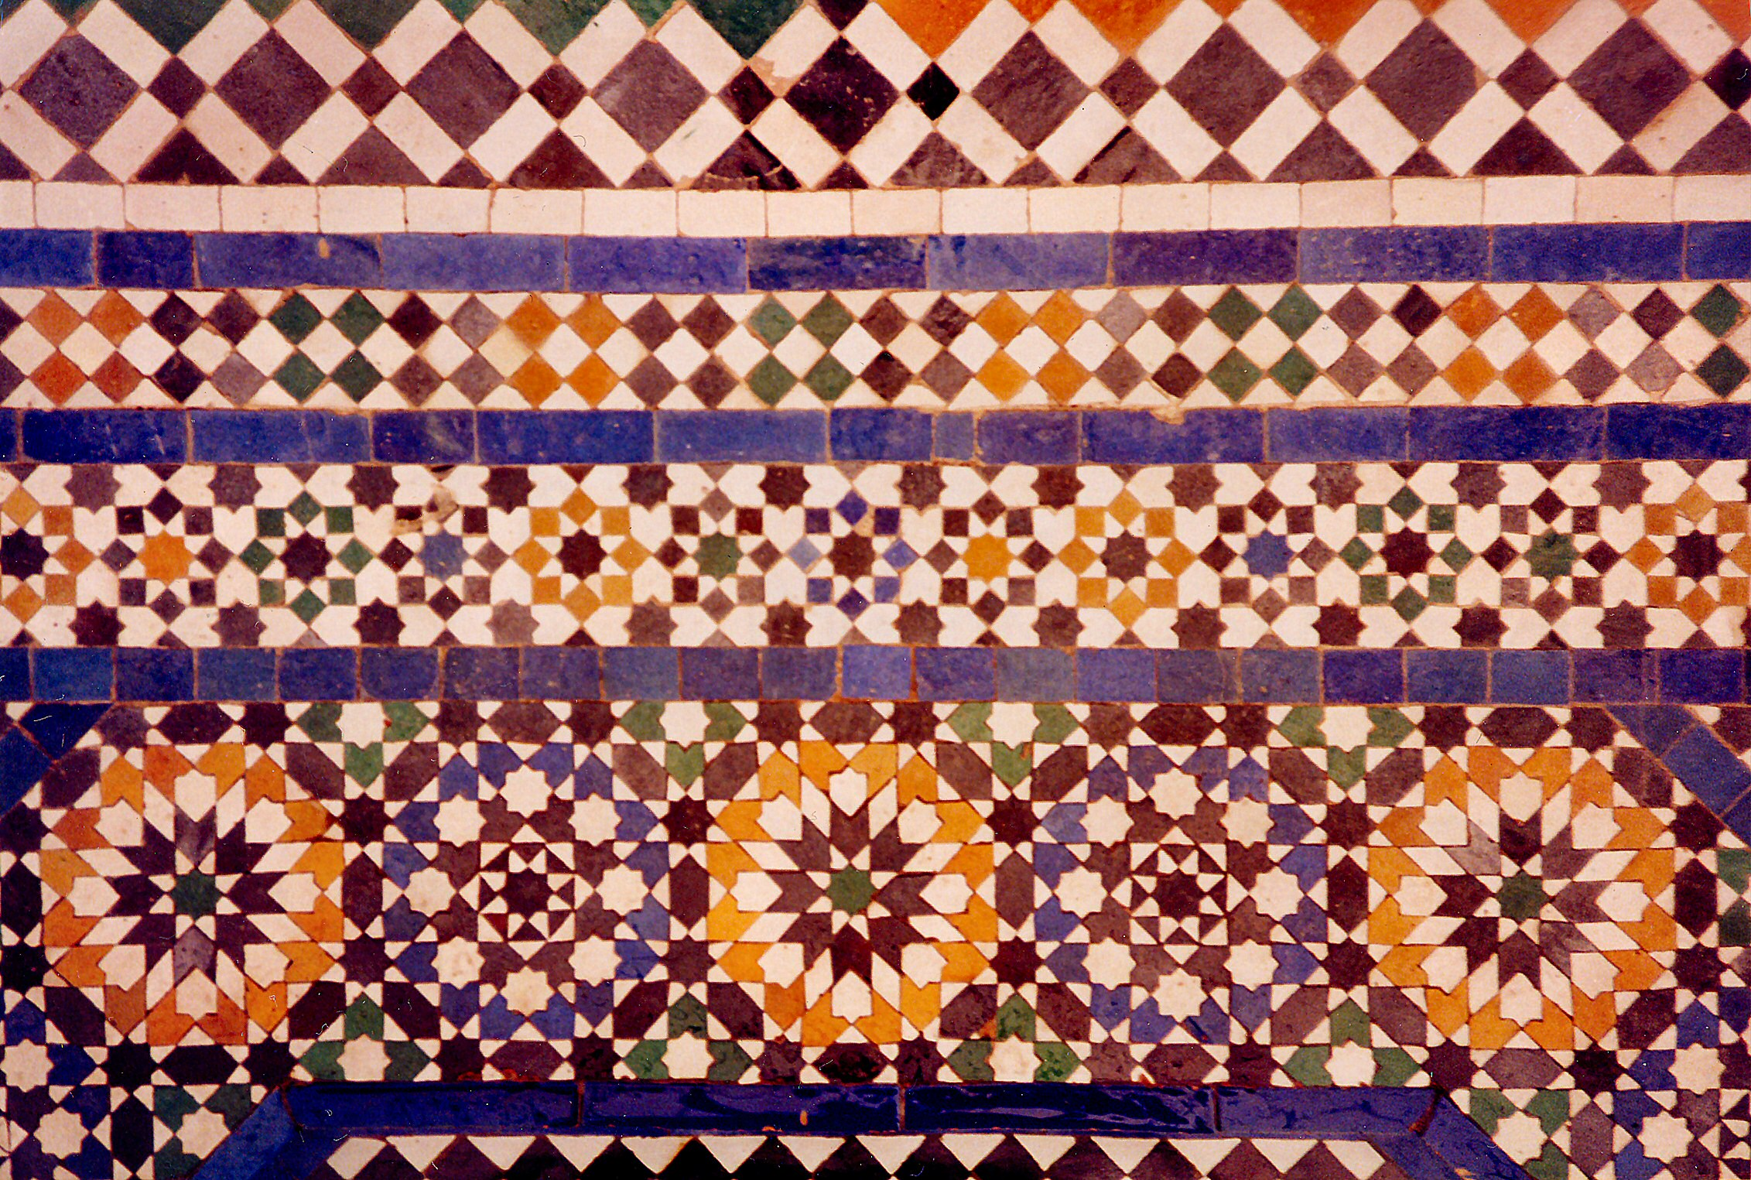

West and Central Asia Module

Bahram Gur Fights the Karg, folio from the Great Il-Khanid Shahnama. Islamic;
Persian, Il’Khanid. c. 1330–1340 C.E. Ink and opaque watercolor, gold, and silver on
paper.

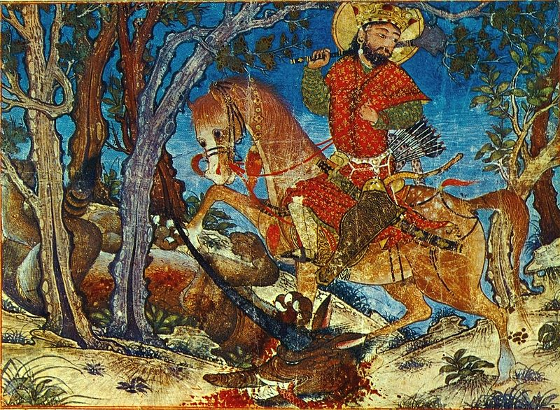

Image Citation: "Demotte Shahname 002" by AnonymousOriginal uploader was Евгений Ардаев at ru.wikipedia - Transferred from ru.wikipedia; transferred to Commons by User:Shakko using CommonsHelper.. Licensed under Public Domain via Wikimedia Commons -

A Persian miniature is a small painting on paper, whether a book illustration or a separate work of art intended to be kept in an album of such works called a muraqqa. The techniques are comparable to the Western and Byzantine traditions of miniatures in illuminated manuscripts (Wikipedia).
The Shahnama is the Persian national epic poem, recounting the history of Iran from the Creation until the Muslim conquest. With its 50,000 rhyming couplets the Shahnama, or "Book of Kings," is one of the largest epics of world literature. The poem narrates the history of the ancient kings of Iran from the mythical beginnings to the Arab conquest in 651 A.D. This manuscript exists today in the form of 57 illustrations and several text pages scattered among public and private collections. Extensive study of the manuscript has revealed that the original consisted of two volumes of about two hundred and eighty large folios and one hundred and ninety illustrations (Folios).
The Shahnama, the poet Firdausi's masterpiece in Persian verse written around 1000, tells the stories of ancient heroes and kings of pre-Islamic Iran; it is rich with exploits of love and betrayal, courage, and valor that lend themselves to illustration.
This scene shows Bahram Gur disguised as an envoy of the shah of Iran. Bahram Gur made his way to the court of Hind, ruled by an unjust king by the name of Shangul. Bahram Gur’s intent is to observe the kingdom and its troops. One evening after a big banquet, Bahram Gur mistakenly displayed his skills; the King of Hind became suspicious and tried to trick him into revealing his identity. When his attempt to deceive Bahram Gur failed, the King of Hind sent him to slay a fearsome karg, which was illustrated as a fearsome horned wolf. Bahram Gur cut the wolf with arrows and cut off his head with his sword.
The scene does not show him in the act of hunting. Instead, it shows Bahram Gur confident on his horse after the deed is done. He holds his mace in his hand, a quiver full of arrows, and his sword at his side. The corpse is depicted in the foreground.
The period of the Persian miniature began when Persia was ruled by a succession of foreign dynasties. These peoples came from the east and north. The Mongol invasion of 1219 onwards established the Ilkhanate as a branch of the Mongol Empire, and the new court had a major influence on book painting. The culture imported many Chinese works and probably artists, with their long-established tradition of narrative painting. The new rulers gave motivation to book production, and they developed an interest in historical writings as a means to further their emphasize their authority to rule over a foreign land. Not surprisingly, they chose the Shahnama (Book of Kings) in which to identify themselves with kings and heroes of the Iranian past. The Mongols brought to the area an excitement about. Local artists absorbed the new artistic influences from China, which were influenced by scrolls and drawings, and integrated them into the type of painting in which they were most familiar- book illustration (Art of Book).

Citations:

"Heilbrunn Timeline of Art History." Folios from the Great Mongol Shahnama (Book of Kings). Web. 14 Mar. 2015. <http://www.metmuseum.org/toah/hd/khan6/hd_khan6.htm>.

"Heilbrunn Timeline of Art History." The Art of the Book in the Ilkhanid Period. Web. 14 Mar. 2015. <http://www.metmuseum.org/toah/hd/khan2/hd_khan2.htm>.

"Persian Miniature." Wikipedia. Wikimedia Foundation. Web. 14 Mar. 2015. <http://en.wikipedia.org/wiki/Persian_miniature>.

