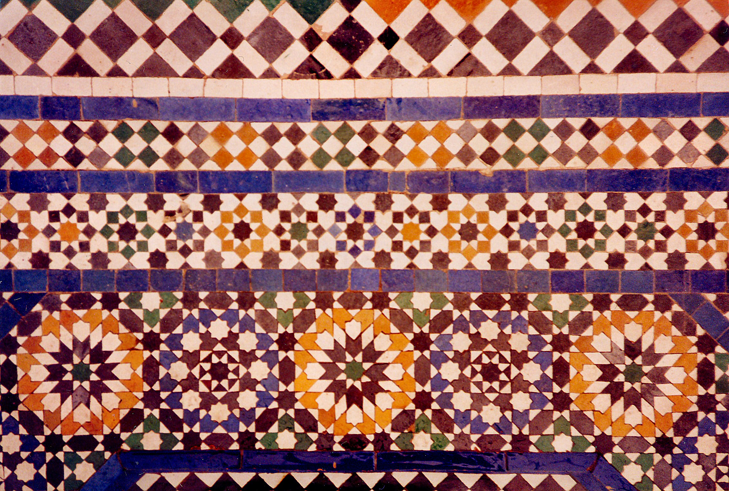

West and Central Asia Module

Buddha. Bamiyan, Afghanistan. Gandharan. c. 400–800 C.E. (destroyed in 2001).
Cut rock with plaster and polychrome paint.

"
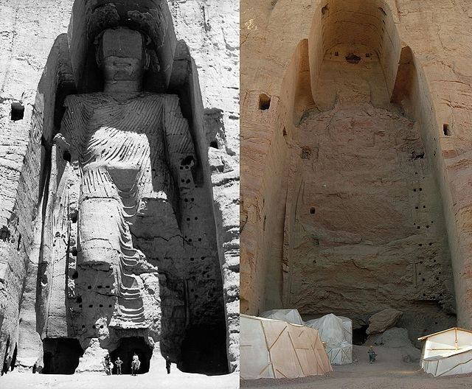

Image Citation: Taller Buddha of Bamiyan before and after destruction" by Buddha_Bamiyan_1963.jpg: UNESCO/A Lezine; Original uploader was Tsui at de.wikipedia.Later version(s) were uploaded by Liberal Freemason at de.wikipedia.Buddhas_of_Bamiyan4.jpg: Carl Montgomeryderivative work: Zaccarias
(talk)

Buddhism spread outward from India in every direction-west to Afghanistan. With it spread the Indian-Buddhist traditions in the arts.
Mahayana Buddhism emerged in the first century CE as a more liberal, accessible interpretation of Buddhism. As the "Greater Vehicle" (literally, the "Greater Ox-Cart"), Mahayana is a path available to people from all walks of life - not just monks (Mayana). The sculptors at Bamiyan, Afghanistan, expressed this new Mahayana Buddhism with the creation of a series of colossal sculptures. The largest are between 120 and 175 feet tall. The main bodies were carved directly from the sandstone cliffs, but details were modeled in mud mixed with straw. The surface was then coated with stucco and painted to increase the expressive qualities of the faces, hands and robe. The lower parts of the statues' arms were constructed from the same mud-straw mix while supported by wood armatures. Large wooden masks or casts constructed the upper parts of their faces. The rows of holes, once seen in the rock, are believed to have supported wooden pegs that steadied the outer stucco (Wikipedia).

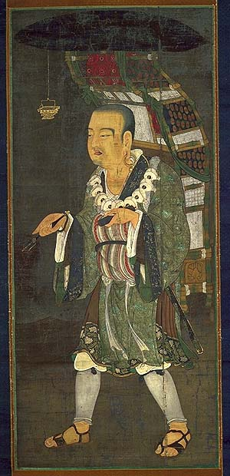
A Buddhist monk named Xuanzang is famous for his seventeen-year journey to India. He recorded his overland journey in detail in the classic Chinese text Great Tang Records on the Western Regions. He wrote about the Buddhas of Bamiyan. Xuanzang's work is the most detailed account of the countries of Central and South Asia by a Chinese Buddhist pilgrim. While his purpose was to obtain Buddhist books and to Buddhist instruction while in India, he recorded the cultures of the seventh century for later generations.

He wrote the following:
‘On a declivity of a hill to the northeast of the capital was a standing image of the Buddha made out of stone 140 or 150 feet high, of a brilliant golden color and resplendent with ornamentation of precious substances.”

Photo Citation: "Xuanzang w".
Licensed under Public Domain
via Wikimedia Commons

The sculptures were dynamited and destroyed in March 2001 by the Taliban, on orders from leader Mullah Mohammed Omar after the Taliban government declared that they were idols. Anti-aircraft guns had little effect, so the engineers placed anti-tank mines between their feet, then bored holes into their heads and packed them with dynamite.

Facts about The Buddhas

- The Buddha was built between the third and fifth centuries.
- The largest was fifty-seven meters high (the height of a 20 story building).
- There are total of three colossal statues carved 4,000 feet apart. The third is a reclining Buddha that has not been discovered yet.
- At one time, two thousand monks meditated in caves among the sandstone cliffs.
- The world’s earliest oil paintings have been discovered in caves behind the partially destroyed colossal statues. Scientists have confirmed that the oil paintings, probably of either walnut or poppy seed oil, are present in twelve of the fifty caves dating from the 5th to 9th century.

- The whole mountain surrounding the Buddha is full of tunnels. The tunnels lead to little chambers in which the monks lived and prayed.
- The top of the Buddha’s face had been carved off and burned, by religious zealots of Aurangzeb’s soldiers in the 18th century.
- In Bamiyan, as elsewhere in Central Asia, destruction came with the arrival Ghengis Khan in 1221 C.E. He sent a small army to seize the valley, commanded by his grandson. When a bowshot from the fortress of the Red City killed the grandson, the Khan swore revenge. Ghengis Khan was true to his word, and the city of Bamiyan was never rebuilt. (Facts About Bamiyan)

Citations:

"Buddhas of Bamiyan." Wikipedia. Wikimedia Foundation. Web. 14 Mar. 2015. <http://en.wikipedia.org/wiki/Buddhas_of_Bamiyan>.

"Everything Afghanistan." • Facts about Bamiyan & the Buddhas The Buddha Was... Web. 14 Mar. 2015. <http://watanafghanistan.tumblr.com/post/13848076735/facts-about-bamiyan-the-buddhas-the-buddha-was>.

"Mahayana Buddhism." - Buddhist Sects. Web. 14 Mar. 2015. <http://www.religionfacts.com/buddhism/sects/mahayana.htm#sthash.Zx7aqPVw.dpuf created a series of colossal sculptures>.

