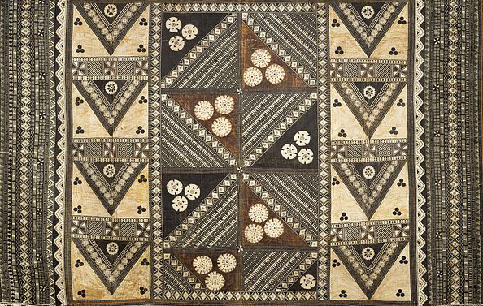

Pacific Arts

Buk (mask). Torres Strait. Mid- to late 19th century C.E. Turtle shell, wood, fiber, feathers, and shell.
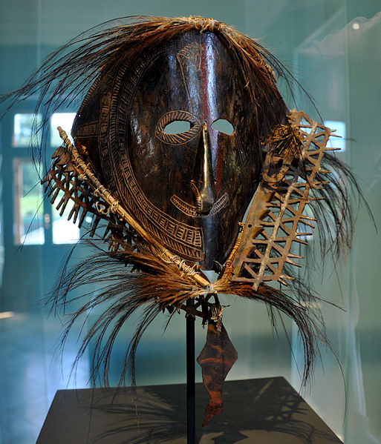

This is not the same image in your set.

Photo Citation:
By Photograph: Andreas Praefcke (Own work (own photograph)) [Public domain], via Wikimedia Commons

The very complicated masks and figures were created from plates of turtle-shell are unique to the culture of the Torres Strait. Torres Strait lies between Australia and New Guinea. Diego de Prado, the Spanish explorer, saw turtle-shell effigies in the Torres Strait islands in 1606. These masks are used mainly during male initiations and funerary rites. The masks are believed to represent culture heroes from myths and their related totem animals. Some masks depict the human forms, while others depict birds, fish, or reptiles. The mask in your image set combines the features of both humans and animals (Met Museum).
The turtle-shell masks are believed to have been used during funerary ceremonies as well as increase rites. Increase rites are rituals intended to secure plentiful harvests and an abundance of fish and game animals. The ceremonies often involved performances in which lead men, wearing the masks as well as costumes of grass, recreated the lives of mythical heroes of the culture. The subjects of the performances were pulled from oral tradition. The masks were worn over the head like a helmet. The object in the image set depicts a human face, possibly portraying one such hero. It is topped by a oceanic bird, perhaps representing a personal totem. (Heilbrunn).

Citation:
"Mask (Buk, Krar, or Kara) | Torres Strait Islander." Mask (Buk, Krar, or Kara). Web. 12 Apr. 2015. <http://www.metmuseum.org/collection/the-collection-online/search/311950>
"Heilbrunn Timeline of Art History." Mask (Buk, Krar, or Kara) [Torres Strait Islander People, Mabuiag Island, Torres Strait, Australia] (1978.412.1510). Web. 12 Apr. 2015. <http://www.metmuseum.org/toah/works-of-art/1978.412.1510>.

Citation:

