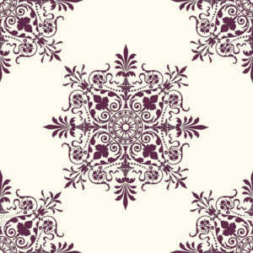
Later Europe and America Module II
The Coiffure. Mary Cassatt. 1890–1891 C.E. Drypoint and aquatint.
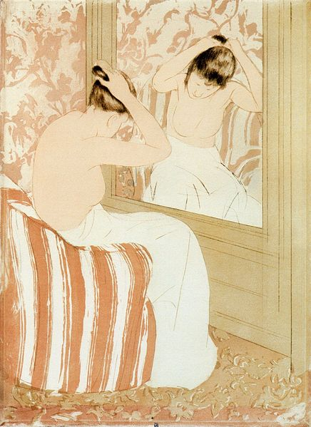

Photo Citation: Mary Cassatt [Public domain], via Wikimedia Commons
After Japanese ports reopened to trade with the West in 1853, a wave of foreign Japanese imports flooded Europe. Among this surge of goods were woodcut prints by masters of the ukiyo-e school. “These artworks influenced Impressionist and Post-Impressionist art by demonstrating that simple, transitory, everyday subjects from "the floating world" could be presented in creative ways” (Met). In The Coiffure, Mary Cassatt depicts a woman in a private moment, as she pins up her hair for the day. This print is part of a series of ten color prints that Cassatt exhibited in 1891. Cassatt had seen an exhibition of Japanese woodblock prints at the Ecole des Beaux-Arts and became fascinated by their everyday themes and simple aesthetics. In a letter written that week to her friend, the painter Berthe Morisot, she wrote, “You who want to make color prints wouldn’t dream of anything more beautiful. I dream of doing it myself and can’t think of anything else but color on copper…P.S. You must see the Japanese—come as soon as you can.” (Khan)

“The Coiffure is one of two nude studies in Cassatt's color series. Although she did not often represent the nude, Cassatt's simple handling of line and form confirms her skill in drawing the human figure. The straight lines of the mirror and wall and the chair's vertical stripes contrast with the graceful curves of the woman's body. The rose and peach color scheme enhances her beauty by highlighting her delicate skin tone. Cassatt also emphasizes the nape of the woman's neck, perhaps in reference to a traditional Japanese sign of beauty.” (NGA)

Citations:

"The Coiffure." The Coiffure. Web. 25 Jan. 2015. <https://www.nga.gov/collection/gallery/cassatt/cassatt-46732.html>.

"Heilbrunn Timeline of Art History." Japonisme. Web. 25 Jan. 2015. <http://www.metmuseum.org/toah/hd/jpon/hd_jpon.htm>.

"Khan Academy." Khan Academy. Web. 25 Jan. 2015. <https://www.khanacademy.org/humanities/becoming-modern/civil-war-gilded-age/a/cassatt-the-coiffure>.

