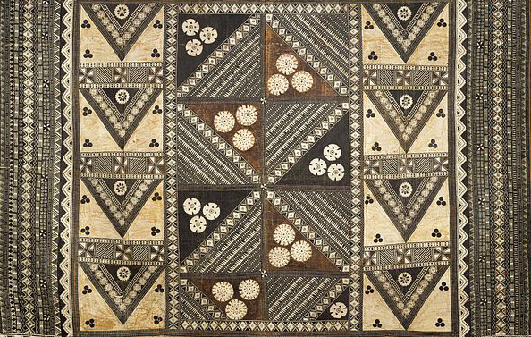

Pacific Arts

Female deity. Nukuoro, Micronesia. c. 18th to 19th century C.E. Wood

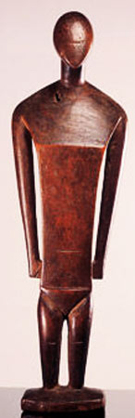

Kave De Hine Aligi was the primary goddess of Nukuoro, a a island in the eastern Caroline Islands. Kave was a powerful female spirit who “reigned” over Nukuoro during the frequent absence of the male spirit Iaigausema.
Images of deities were known as dinonga eidu and were kept in cult houses. Carved wooden images, as ritual objects are extremely rare in Micronesia. The sculptures were wrapped on cloth, and were kept in cult houses. On festival days, the inhabitants would gather around the decorated statue and offer fruits as sacrifice.
The sculptor has reduced the human body to basic geometric shapes. The eyes, ears, and mouth are omitted, and the arms and legs are presented only in their simplest forms. The shoulders are decorated with intricate patterns that correlate to the tattoos of Nukuoro chieftains and their families.

Image Citation:
By Hiart (Own work) [CC0], via Wikimedia Commons

Citation:
Web. 12 Apr. 2015. <https://www.wienand-koeln.de/pdf/978-3-86832-036-7.pdf>

Citation:

