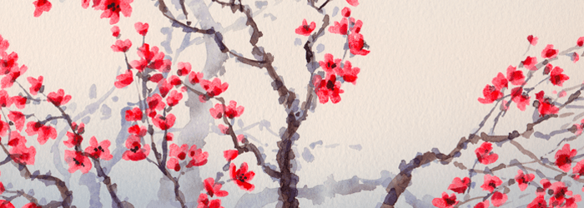
South, East, and Southeast Asia II

Forbidden City. Beijing, China. Ming Dynasty. 15th century C.E. and later. Stone
masonry, marble, brick, wood, and ceramic tile

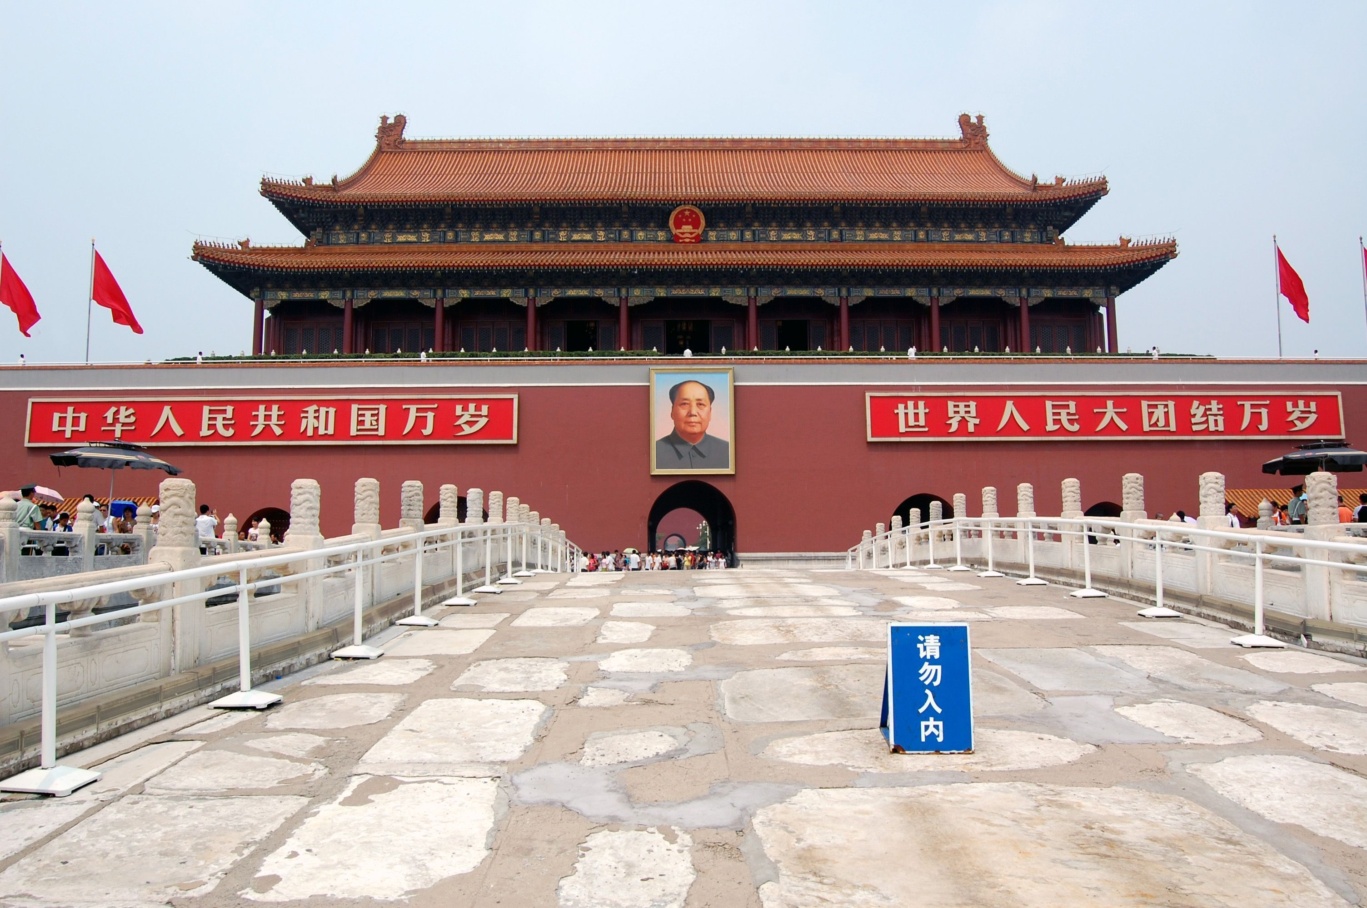
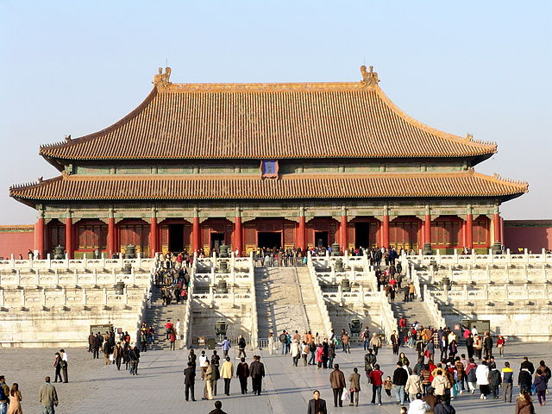
Licensed under CC BY-SA 3.0 via Wikimedia Commons - http://commons.wikimedia.org/wiki/File:Forbidden_city_map_wp_0.png#/media/File:Forbidden_city_map_wp_0.png
http://commons.wikimedia.org/wiki/File:Forbidden_City_
Beijing_Shenwumen_Gate.JPG#/media/File:Forbidden_City_
Beijing_Shenwumen_Gate.JPG

The Forbidden City, located in the center of Beijing, exemplifies the grandeur and authority of China’s imperial past. The Imperial City demonstrates the beauty of Chinese architecture, which is a very important part of the Chinese tradition. It also indicates the worldview of the Chinese people and their concept of the cosmological order.
The Forbidden City was the imperial palace of the Ming and Qing dynasties. It is now called the Palace Museum. It is located one kilometer north of the Tian'anmen Square, with its north gate, the Gate of Divine Might facing the Jingshan Park. The structure is the world’s largest palace complex. It covers a floor space of 720,000 square meters, and is comprised of 9,999 buildings. The rectangular city is surrounded in a 52-meter-long, 6-meter-deep moat as well as a 10-meter-high, 3,400-meter-long city wall. The wall has a gate on each side.
The Imperial City was divided into two parts. The northern half, the Outer Court, was where the emperors executed their supreme power and authority over the nation. The southern half, the Inner Court, was where the emperor lived with their royal family. Until 1924, when the last emperor in China was forced out of the Inner Court, fourteen emperors of the Ming dynasty and ten emperors of the Qing dynasty had ruled China here. The palace complex served five hundred years as the imperial palace. Today, it houses rare treasures and artifacts.
In terms of plan, a central axis runs through the whole palace. The axis is the central axis of Beijing City. The Forbidden City is divided into southern and northern parts by the axis. The main structures are arranged along the central axis, and the buildings on both sides of it are symmetrical.
Construction of the palace complex started in 1407, and it was completed fourteen years later. It is recorded that a million workers, including one hundred thousand artists, were needed in its construction. Stones were quarried from a suburb of Beijing and large amount of timbers and other materials were brought in from distant provinces.
Yellow is the symbol of the royal family, and it is the dominant color in the Forbidden City. Roofs are built with yellow glazed tiles; decorations in the palace are painted yellow; even the bricks on the ground are yellow. Wenyuange, the royal library, has a black roof and is the only exception. Black was believed to represented water then and could extinguish fire.
The outer courts contained three great audience halls; the Hall of Supreme Harmony, the Hall of Middle Harmony, and the Hall of Protecting Harmony. All these buildings were wooden framed structures, and they would house such events as the crowning of a new emperor, imperial weddings, and birthday celebrations. The Hall of Supreme Harmony was the largest and is also the largest timber framed building in China. It hall is raised on a three tiered marble podium, and the roof is supported by timber columns.
The buildings in the complex were mostly red in color and a dragon motif was used through out as symbol of goodness and strength. A dragon with five claws holding a flaming pearl in waves or clouds was the traditional symbol of the emperor. The eaves of the imperial palace were decorated with carvings of dragons and other Chinese mythological creatures.

Citations:
"Forbidden City." Forbidden City. Web. 30 Apr. 2015. <http://www1.chinaculture.org/gb/en_artqa/2003-10/20/content_38839.htm>.

nec.edu.np/faculty/rajjanmc/Lecture%207.doc

