George Washington. Jean-Antoine Houdon. 1788–1792 C.E. Marble.
Later Europe and America Module I

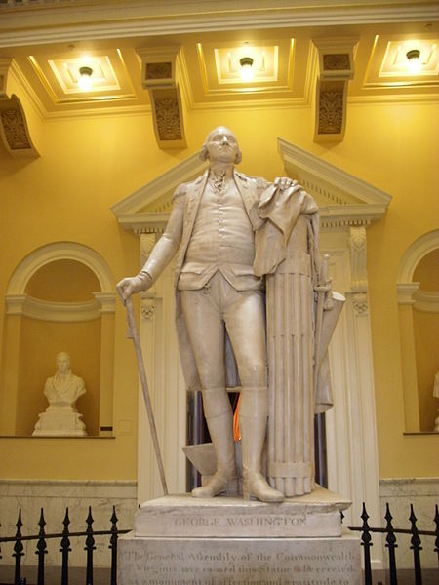

Citation: Christopher Hollis for Wdwic Pictures [GFDL. CC-BY-SA-3.0 (http://creativecommons.org/licenses/by-sa/3.0/)

In the late 18th century there was a renewed interest in classical antiquity, known as Neoclassicism. During an era of political turmoil in America, artists looked to the influences of Greek and Roman cultures due to their rationality and political organization. When deciding to commemorate one of America’s greatest leaders in war as a commemoration, the “leading” French Neoclassical sculptor, Jean-Antoine Houdon was chosen to create the artwork.
George Washington is a statue by French sculptor Jean-Antoine Houdon. It dates from from the late 18th century, and is based on a life mask and other measurements of George Washington taken by the Houdon. The work is considered one of the most accurate depictions of the former President of the United States. The sculpture is located in the rotunda of the Virginia State Capitol in Richmond, Virginia.
Houdon presented Washington as a modern Cincinnatus, the Roman farmer and general who left his land to fight for his state, but after victory, returned to his farm. Washington left politics and the military to become a man of peace and simplicity. In this sculpture, Houdon attempts to balance the dualities of military and public, war and peace, classical antiquity and modern.
Washington wears his Revolutionary Way uniform but holds a civilian walking cane with his right hand. To the left of and behind the general is a farmer’s plowshare, yet he rests his left hand on a bundle of rods called fasces. The fasces are a Roman symbol of civil authority. Houdon converted the symbol to an American convention by forming the bundle with thirteen rods, symbolizing the unified thirteen colonies. He added arrows in between that possibly refer to Native Americans or the concept of America being a wild frontier.

Citations:

"George Washington (1785-1792 Statue)." Wikipedia. Wikimedia Foundation. Web. 23 Jan. 2015. <http://en.wikipedia.org/wiki/George_Washington_(1785-1792_statue)>

