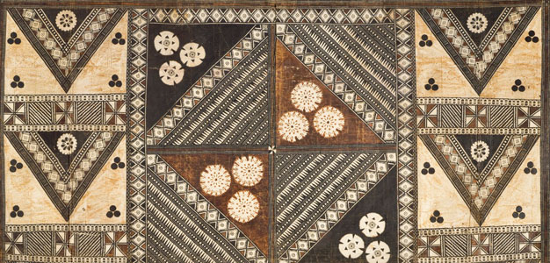
African Art Module

Sika dwa kofi (Golden Stool). Ashanti peoples (south central Ghana). c. 1700 C.E. Gold over wood and cast-gold attachments.

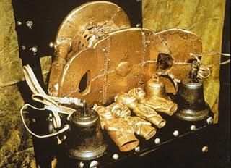

Image Citation: https://www.flickr.com/photos/imknowmadic2/3294676359/

Tradition has it that this stool, covered with pure gold leaf, floated out of the sky and landed on the lap of the first Asantehene (Asante king), Osei-tutu. He unified the people in the 17th century. His chief priest declared that the soul of the nation resided in this stool. Made of gold and 18 in high, 24 in long, 12 in wide, no one has been allowed to sit on the sacred stool, nor has it touched the ground. It is always placed on a blanket.
A new king is lowered and raised over the Golden Stool without touching it. The Asante believe no one can be a legitimate ruler without the stool.
The Golden Stool is the royal and divine throne of the Akan people (Ashanti people). The seats were traditionally symbolic of a chieftain's leadership. The Golden Stool is believed to house the spirit of the Asante nation—living, dead and yet to be born (Wikimedia).
It is kept under the strictest security; it is taken outside only on exceptional occasions and never comes into contact with earth or the ground. The Asante have always defended the Golden Stool when it was at risk. Bells are attached to it so it can warn the king of danger or those that might. Replicas have been produced for the chiefs and at their funerals are ceremonially blackened with animal blood. The stool is one of the main focal points of the Asante today because it still shows succession and power.

Citations:
"https://www.khanacademy.org/humanities/art-africa-oceania-americas/africa-art/kuba/a/ndop-portrait-of-king-mishe-mishyaang-mambul

