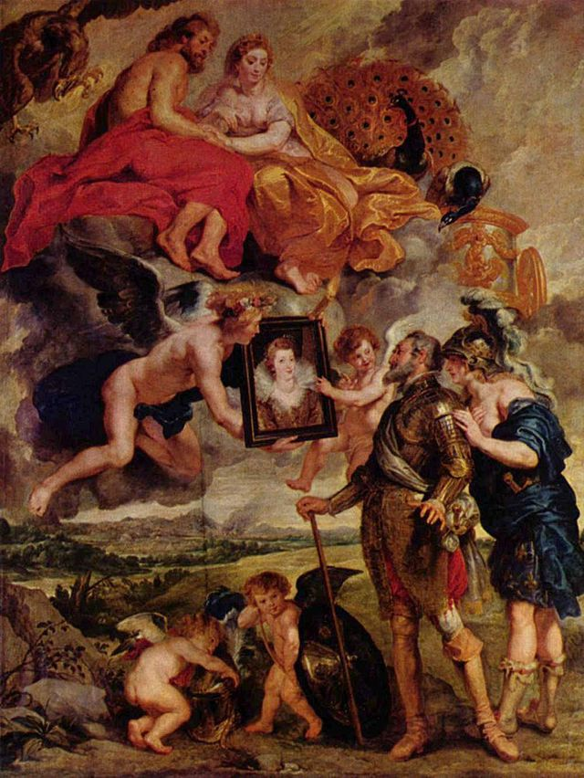
Henri IV Receives the Portrait of Marie de’ Medici, from the Marie de’ Medici Cycle. Peter Paul Rubens. 1621–1625 C.E. Oil on canvas.

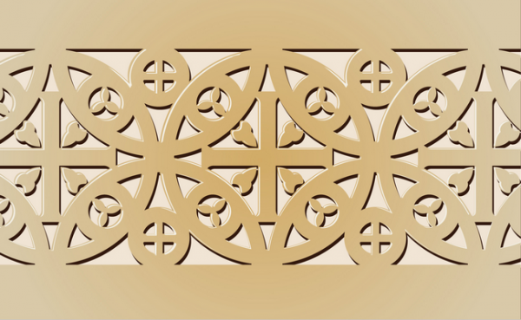
Early Europe and Colonial Americas Module III

"Peter Paul Rubens 048" by Peter Paul Rubens - The Yorck Project: 10.000 Meisterwerke der Malerei. DVD-ROM, 2002. ISBN 3936122202. Distributed by DIRECTMEDIA Publishing GmbH.. Licensed under Public Domain via Wikimedia Commons

Peter Paul Rubens’ most important commission, in terms of establishing his reputation, was given to him by Marie de Medici. Marie came from the ruling Medici clan of Florence, and it was for political reasons that a marriage was arranged between her and the French King Henri IV. The marriage was not a happy one-full of discord. To get a sense of just how unsuccessful the marriage, strong suspicion attached itself to his wife after the king’s assassinated on a Paris street. Marie had herself crowned regent, ruling in place of the young prince, who would later to become King Louis XIII. She and her son, who resented her seizure of power as well as her extravagant lifestyle, eventually exiled her from France.
It is therefore both understandable that Marie de Medici would devise a way to fix her legacy. With the aid of Ruben’s genius, they devised an elaborate allegorical sequence, involving twenty-four ambitious paintings full of gods and goddesses, to tell he life story. The series of paintings is a fantastic example of how art could legitimize royalty by associating it with the pagan gods and other elements of classical culture.
“With Cupid, Hymenaios, the god of marriage, displays the Princess Marie on canvas to her future king and husband.
Jupiter and Juno are sitting atop clouds looking down on Henry as they provide the viewer a key example of marital harmony and thus show approval for the marriage.”
“A personification of France is shown behind Henry in her helmet, her left hand showing support, sharing in his admiration of the future sovereignty. Frances's intimate gesture may suggest closeness between Henry and his country. This gesture would usually be shared among male companions, telling each other's secret. The way France is also dressed shows how female she is on top revealing her breasts and the way the fabric is draped adding notions of classicism. However her bottom half, most notably her exposed calves and Roman boots hints at a masculinity. A sign of male strength in the history of imagery was their stance and exposed strong legs. This connection between the two show that not only are the gods in favor of the match, the King also has the well wishes of his people.”

Citations:
"Marie De' Medici Cycle." Wikipedia. Wikimedia Foundation. Web. 5 Jan. 2015. <http://en.wikipedia.org/wiki/Marie_de'_Medici_cycle>.

