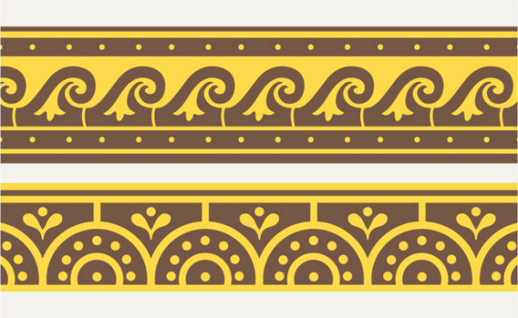

ANCIENT MEDITERRANEAN
MODULE /PART II

House of the Vettii. Pompeii, Italy. Imperial Roman. c. second century B.C.E.; rebuilt c. 62 – 79 C.E. Cut stone and fresco.

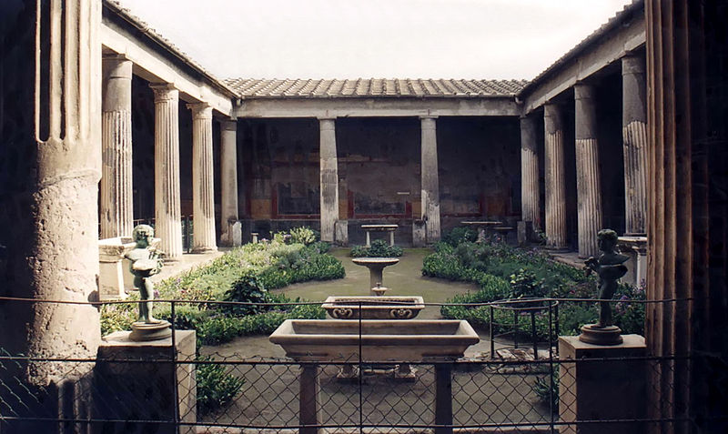
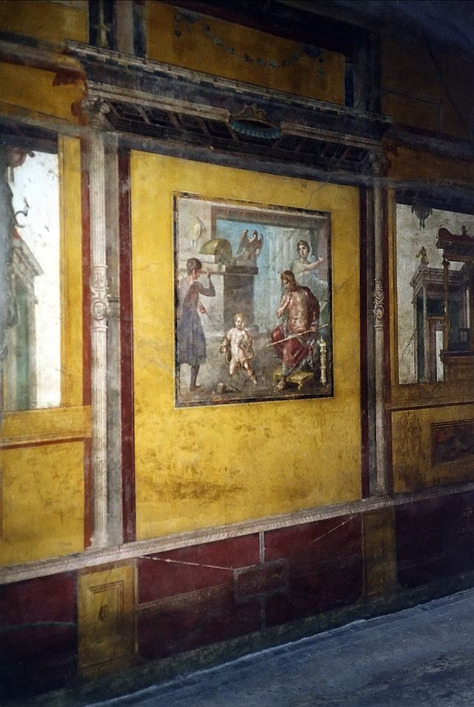

Image: "Pompeji Casa Dei Vettii Hercules Child". Licensed under Creative Commons Attribution-Share Alike 2.5 via Wikimedia Commons - http://commons.wikimedia.org/wiki/File:Pompeji_Casa_Dei_Vettii_Hercules_Child.jpg#mediaviewer/File:Pompeji_Casa_Dei_Vettii_Hercules_Child.jpg

By Taken by the uploader, Patricio Lorente [CC-BY-SA-2.5 (http://creativecommons.org/licenses/by-sa/2.5) or CC-BY-SA-2.5 (http://creativecommons.org/licenses/by-sa/2.5)], via Wikimedia Commons

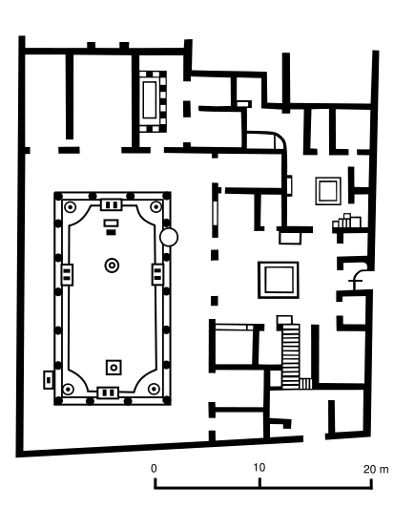
In Pompeii, Italy, one of the most famous of the luxurious residences (domus) is the House of the Vettii. It was by the eruption of Mount Vesuvius in 79 C.E. The house is named for its owners, two brothers who are freed slaves that become wealthy. Some beautiful frescoes have been preserved form the Pompeian Fourth Style. After a large earthquake in A.D. 62, many of the older elite families moved out of Pompeii to other towns. This wealth vacuum led to the rise of the "nouveau-riche", often wealthy freedmen pursuing power and stature.

A Roman house is a stage on which the rituals of daily life and social hierarchy would be performed. During the time of the Roman republic (fifth through first centuries B.C.E.), aristocratic families (patricians) used domestic display as a way to reinforce social rank in the culture as well as a way to advance their own prosperities. Since Republican society operated on the basis of this patron-client relationship, the home played a key part in the reinforcement of social hierarchy. The patron would receive his clients in the atrium of the home each business day. Each client would be able to see the patron’s household wealth through the opulence of the home. Governed by an ancestral custom (mos maiorum), clients would seek favors from the patron. The patron provided protection and support in return. (http://smarthistory.khanacademy.org/)

By M.violante 10:28, 10 March 2007 (UTC) (Own work) [GFDL (http://www.gnu.org/copyleft/fdl.html) or CC-BY-SA-3.0 (http://creativecommons.org/licenses/by-sa/3.0/)], via Wikimedia Commons

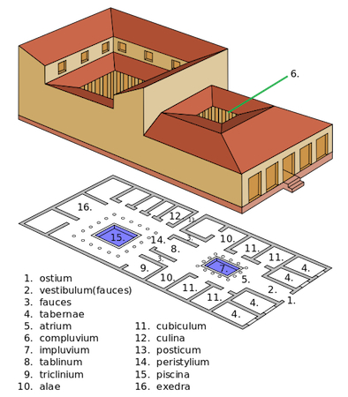
“The standard house (domus) plan has several key architectural elements. Generally entered from the street via a narrow doorway (fauces), the large centralized reception hall (atrium) is flanked by wings (alae) and often bounded by bedrooms (cubicula). The office of the head of household (paterfamilias), known as the tablinum, links the public part of the house (pars urbana) to the private part of the house (pars rustica). This latter area often focuses on an open, colonnaded courtyard (peristylium) and serves as the center of family life, with the kitchen (culina), dining room(s) (triclinium or oecus), and often a small garden (hortus). Many houses also had a second level that may have contained additional sleeping spaces and perhaps storage.” (Text and image from http://smarthistory.khanacademy.org/)

Many rooms in the House of the Vettii are lavishly painted. Each triclinium is themed and painted in the Fourth Style. The Fourth Style features a return to architectural realism – the wall appears interrupted to reveal architectural panoramas. The Fourth Style is a culmination of the four fresco styles as it often features a mixture of styles. Each panel in the rooms follows the room's theme, providing visual entertainment and a narrative during dining. The Ixion Room is a great example of the Fourth Style wall painting. Within each red panel is a scene depicting myths where the main character commits a major slight. One panel is dedicated to Ixion, who refused to pay a dowry and murdered his father-in-law. Another Fourth Style triclinium depicts scenes from the lives of Hercules and the dining room is decorated in panels of red and black with a collection of putti (mythological winged gods associated with love) engaged in various occupations.

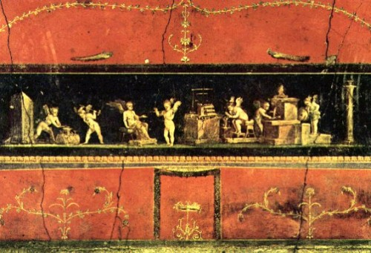
Image: http://www.ancient.eu/image/1381/

Most homes in Pompeii and Herculaneum included an open garden area that had paintings, statues and fountains. But it was the peristyle that was a design that showcased the wealth and status of the owner. It became very popular in Pompeii by the 1st Century AD. The image at the top of the handout shows the peristyle garden of the House of the Vettii. It shows an image of a wide courtyard in the middle of a home with an open ceiling surrounded by columns and decorated walls. The interior garden has plants and decorated with fountains.

Citations:
House of the Vettii. (2014, October 18). Retrieved October 25, 2014.

House of the Vetii. Khan Academy. Web. <(2014, October 25). Retrieved from http://smarthistory.khanacademy.org/house-of-the-vettii-pompeii.html)>.

