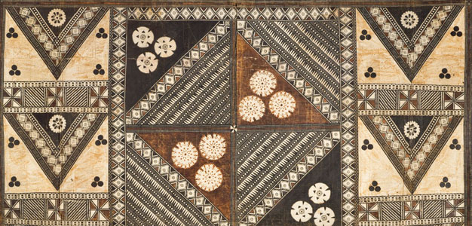
African Art Module

Lukasa (memory board). Mbudye Society, Luba peoples (Democratic Republic of the
Congo). c. 19th to 20th century C.E. Wood, beads, and metal.
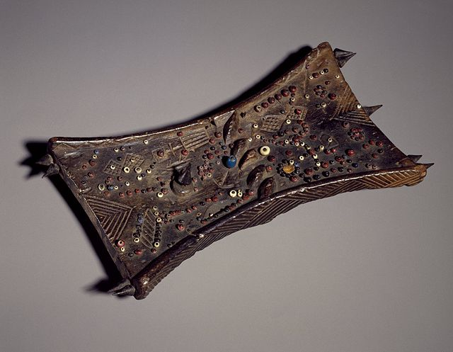

Image Citation: "Brooklyn Museum 76.20.4 Lukasa Memory Board"
by Brooklyn Museum. Licensed under CC BY 3.0 via Wikimedia Commons - http://commons.wikimedia.org/wiki/

Lukasas are wooden memory boards covered with complex designs used by Luba people. Luba are a Bantu-speaking people of Central Africa in the corner of what is today known as the Democratic Republic of the Congo (DRC). Today, Luba maintain their cultural identity while they engage in modern economic, political, and social development. They use beads and incised designs on lukasa memory boards to preserve their history.
Usually a geometric pattern is carved onto the lukasa's sides and exterior surface while the interior surface is covered with a combination of beads, shells, or other materials. For people who can “read” a lukasa, the beaded patterns and carved designs tell a narrative of the chiefdom’s history, including its government, geography, major events, important people, and religious beliefs (Primary Sources).
Members of Mbudye, a society of revered men and women who undergo a long education to interpret the lukasa’s surfaces, are the sole readers of the artifact. With training, they can interpret not only the obvious meanings but also the information encoded in the lukasa's patterns. Mbudye members use lukasas to explain kingship, and tell about the lives and contributions of particular authorities. Mbudye try to apply their knowledge of the past to help understand and solve current issues (Primary Sources).

Citations:

"Preserving Culture and History in Africa Tags: Africa, Curriculum, Democratic Republic of the Congo, Ethiopia, Folktales, Mali, Primary Source World, Primary Sources, Talking Drums, West Africa ." Home. Web. 2 Mar. 2015. <http://resources.primarysource.org/content.php?pid=144239&sid=1226875>.

