Near East and Egyptian Art
This review has been designed to help you narrow down the most important works of art covered in the Near East and Egyptian Art. It is NOT meant be a replacement for reading the text or attending synchronous sessions, but to serve as a supplement. You are responsible for keeping up with the reading in your text as well as provided supplemental readings/websites.

Overview:
The recording of history begins with the invention of writing in the ancient Near East. In Mesopotamia, large, urban areas centered on manmade mountains topped by temples. From these temples, priests sought to appease the gods. City-states were often threatened by other city-states, and by foreign invaders. Mesopotamian history is noted for its instability, and shifts in the balance of power. Despite the constant changes, two major characteristics are found in all Mesopotamian art: narrative and power. Art tells stories, often of the might and exploits of kings and men favored by the gods.
Ancient Egypt produced art that is monumental and unchanging. Egyptian art was created for divine kings and for the ka of the dead. Egypt counted on the pharaoh to keep order, prosperity, and stability. The culture prized the regular and predictable: the journey of the sun; the annual flooding of the Nile; and the voyage to the afterlife. It is this regularity that establishes standard forms of depicting the human figure and influences the subject matter in art for a couple of thousands of years.

Near Eastern and Egyptian Art and Architecture

Near Eastern Art Characteristics
- Marked by different Mesopotamian peoples and their shifting focus of power. Do not have cultural uniformity and continuity that are reflected in the traditions of ancient Egypt.
Characteristics/Conventions:
- The enduring architectural monument was the temple. Reflects the view of life in which human beings were meant to serve the gods, who were personified the powerful forces of nature.
- Strong fortifications were necessary. The city-states of Mesopotamia were so often at war with each other.
- Depicting the power and authority of the king. Kings sensed that are could help glorify their reigns, and tell narratives that would last into the ages. Resulted in steles to commemorate military victories and laws – palaces to glorify.
- Hybrids of animals and men are common themes. Protective guardians and symbols of power.
- Deification of the king.
- The use of hierarchy of scale, composite figures, and registers.
- Use of whitewashed plaster, glazed tile, and paint on mud-brick buildings due to lack of good stone in region.

Egyptian Art Characteristics
- Marked by CONSERVATISM: rules, conventions established in early period persist for 3000 years. There is little fluctuation, with the exception of the Amarna Period under Akhenaton.
Characteristics/Conventions:
- Architecture on a monumental scale- funerary monuments and temple complexes.
- Stress placed on deifying the pharaoh. Monumental works created to show their power and authority.
- The use of registers, with the bottom line as the ground line was used as the means to tell narratives.
- Art is generally a combination of text and images.
- On flat surfaces, things may be seen from the front, the side, or above.
- Sculptural works, carved from blocks of hard stone, are usually blockish, with a dominance of vertical and horizontal lines to communicate permanence and stability.
- High rank is portrayed with strict conventions. Everyone else is portrayed naturalistically.
Conventions used for depicting the pharaoh or the pharaoh's family:
- Stylized and Idealized, intended to look divine.
- In prime of life.
- Broad shoulders, narrow hips.
- Some muscle definition, but not "too much"
- Calm facial expression.
- Hieratic perspective/scale.
- Flat surface: composite view (face, hips, legs and feet in profile, torso frontal).
- Sculpture: facing strictly frontal.
- Poses: either sitting with both feet on the ground, standing with one foot a few inches forward, or striding forward.

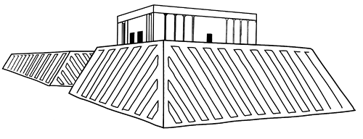 | White Temple and its ziggurat. Uruk (modern Warka, Iraq). Sumeria. C 3500 – 3000 B.C.E. mud brick.  Content:  A ziggurat is the massive platform that raises the temple above ground.  The temple and ziggurat are considered different buildings.  City-states were governed and ruled independently, and temples were in the center of cities.  Temples are dedicated to specific gods. This temple was probably dedicated to Anu, a sky god  The temple height created a belief that gods live above our world in the sky at night.  Access to the structure was allowed only to the highest strata’s of society  The corners of the ziggurat face the cardinal directions.  Bent axis approach is a nonlinear approach that incorporates 2-3 angular changes in direction.  Style:  It was made of mud brick.  The sides were sealed them with tar to protect from the floods  (http://www.cram.com/user/jsalka)
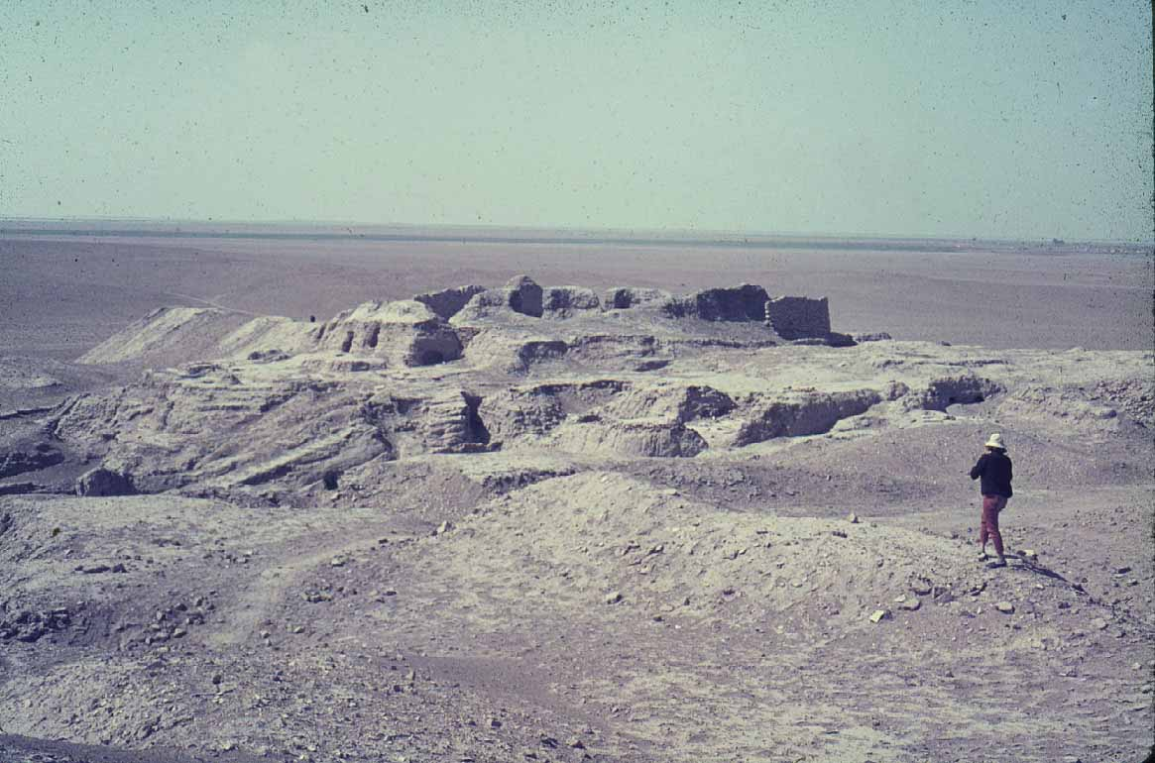 | Contextual Analysis:  Temples such as this were reserved for a select few and were considered waiting rooms to the gods where one would present the gods with offerings. Each temple was dedicated to a specific god and each city-state had a temple dedicated to a different god. The purpose of a temple was all about being looked upon favorably by the gods, or the specific god the temple was dedicated to. The temple was the pinnacle of a city, always placed in the center of town. The purpose of the ziggurat structure was to reach the temple upwards to the heavens; it shows that ancient Sumerians believed in the concept of the gods existing above the human world. The temple was the human's attempt to connect the god’s world and the human world.  (http://www.cram.com/user/jsalka)
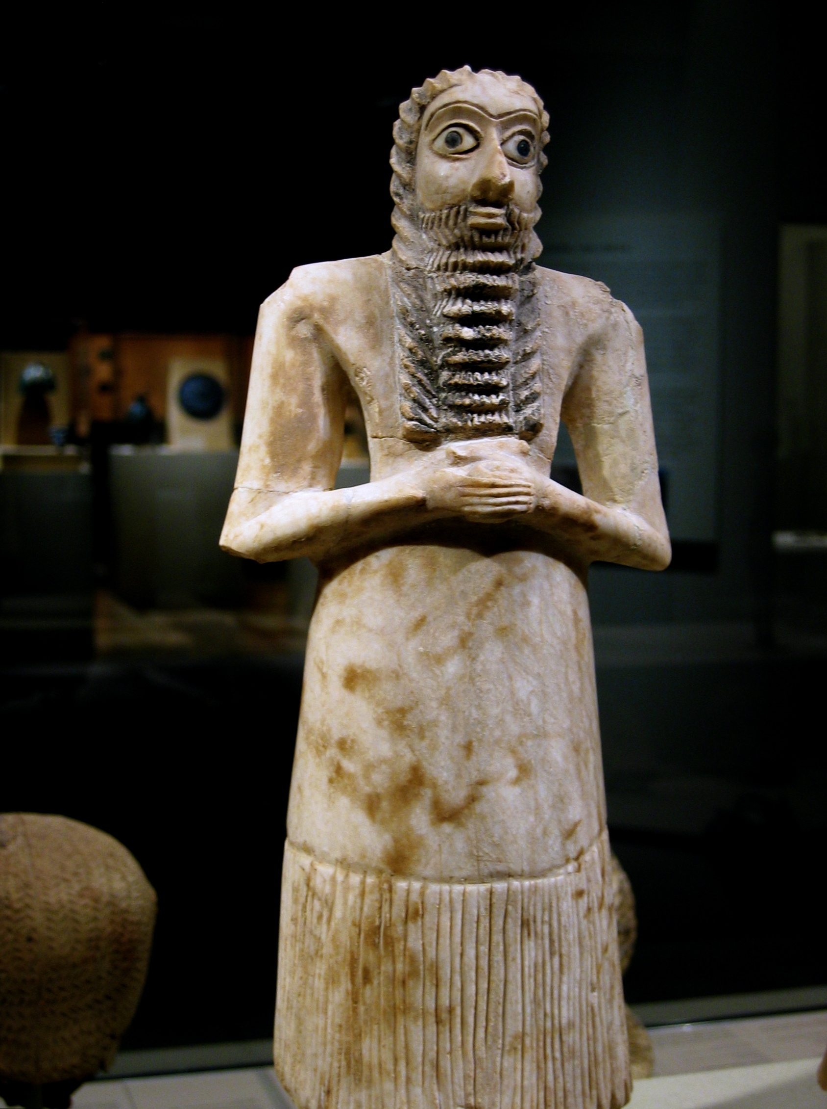 | Statues of Votive figures, from the Square Temple at Eshnunna (modern Tell Asmar, Iraq). Sumerian. c. 2700 B.C.E. Gypsum inlaid with shell and black limestone.  Content:  The figures are Sumerian votive figures.  The sculptures are intended to be seen from the front.  The figurines are of individual citizens  Style:  Sculptures are stylized, short, and compact.  The arms of the sculpture are folded in a prayerful posture.  The eyes are enlarged.  The back is inscribed with “It offers prayers.”  The sculptures are subtractive. The artist starts with cylindrical form or brick like form then carve away  Contextual Analysis:  The votive figures are known to be resembled after a human praying of worshiping. Each votive figurine was made to represent one of the individuals of Sumer. Those who had the privilege of having a votive figurine model were the wealthy citizens. The purpose of these figurines was to be placed in the temples of Sumer so the citizens would be seen well through the eyes of their gods. Within the different statuettes, a hierarchal scale is present, the larger the figurine the more wealth or importance the person it was modeled after had. Also from votive figures, the idea of patronism arises. Patronism is the act of a wealthy being hiring an artist to make themselves look god-like or better in the eyes of the gods. Basically patronism is the paying for art modeled after oneself.  (http://www.cram.com/user/jsalka)
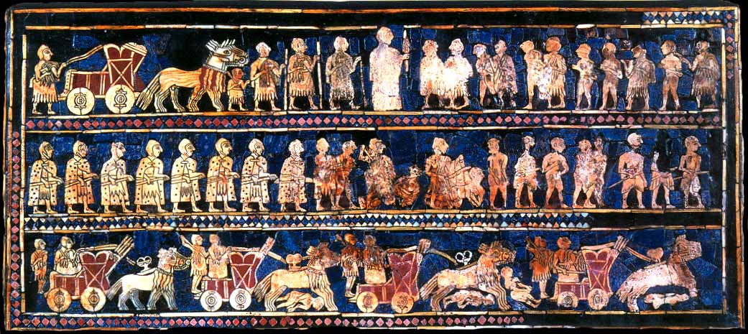 | Standard of Ur from the Royal Tombs at Ur (modern Tell el-Muqayyar, Iraq). Sumerian. 2400 B.C.E. Wood inlaid with shell. lapis lazuli, and red limestone.  Content:  The work was discovered in a tomb  (found in a royal cemetery).  The back is the scene of war  The composition is arranged into three horizontal registers.  Style:  It is made of wood with inlays of lapis.  People are depicted in composite view  Hierarchal scale shows importance of persons through size.  Contextual Analysis:  The Standard of Ur is made with lapis lazuli, a precious stone reserved for only the wealthiest citizens. The stone had sacred value in the burial of the deceased. It also becomes more prevalent in culture how significant the burial and celebration of the deceased is in Egyptian culture as opposed to other older cultures. The front and backsides of the piece are referred to as panels, one depicting war and one depicting a sort of party scene. The panels are broken down into three correlating registers, which hint at the beginning of writing a story in chronological order. This piece is one of the earliest depictions of the Sumerian army. Within the army, many advances are displayed such as the wheel, animals pulling carts, and metal swords. The naked figures are thought of as a metaphor for defeat, not their literal state of being during the battle.  (http://www.cram.com/user/jsalka)
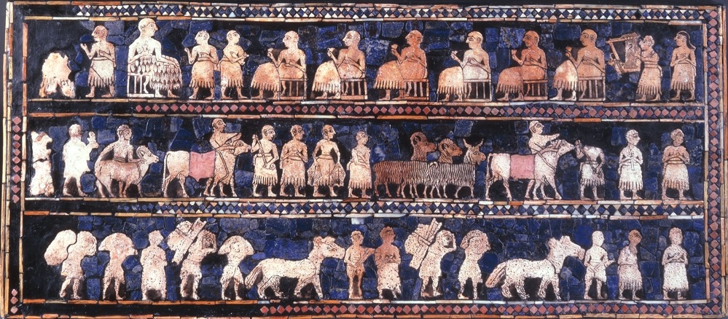 | Standard of Ur from the Royal Tombs at Ur (modern Tell el-Muqayyar, Iraq). Sumerian. 2400 B.C.E. Wood inlaid with shell. lapis lazuli, and red limestone.  Content:  The work was discovered in a tomb  (found in a royal cemetery).  The front is scene of peace.  The composition is arranged into three horizontal registers.  Style:  It is made of wood with inlays of lapis.  People are depicted in composite view  Hierarchal scale shows importance of persons through size.  Contextual Analysis:  The Standard of Ur is made with lapis lazuli, a precious stone reserved for only the wealthiest citizens. The stone had sacred value in the burial of the deceased. It also becomes more prevalent in culture how significant the burial and celebration of the deceased is in Egyptian culture as opposed to other older cultures. The front and backsides of the piece are referred to as panels, one depicting war and one depicting a sort of party scene. The panels are broken down into three correlating registers, which hint at the beginning of writing a story in chronological order. In the party scene, everyone facing the king, who happens to be larger than the rest, again showing emphasis on one essential person.  (http://www.cram.com/user/jsalka)
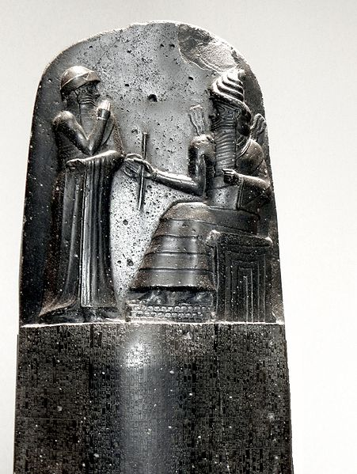 | The Code of Hammurabi. Babylon (modern Iran). Susian. c. 1792 – 1750 B.C.E. Basalt.  Content:  The work is a stone stele (a commemorative monument).  It is made of basalt.  It depicts the written form of Hammurabi's laws. It has nearly 3,000 letters and contains almost 300 laws.  The king is depicted in the presence of Shamash. The king is raising his hand to show respect for the gods.  Shamash is depicted with his horned helmet.  Style:  The work is carved in a subtraction relief technique.  Contextual Analysis:  This piece's purpose is to be a record of and communicate all of Hammurabi's laws to his people. The only reason we have this piece today is because it was stolen from Babylon when it was conquered. Babylon flourished under Hammurabi's laws and dominated Mesopotamia. Hammurabi was a powerful Mesopotamian King and the laws cover all aspects of life from stealing and theft to consequences of adultery to destruction of others property. The complexity of these laws shows a very developed society. It is also clear Hammurabi's rein was very established. The Mesopotamian society believed in close communication and connection with the gods and believed Hammurabi's laws were the combined work of Hammurabi and the gods, religion and politics mixed greatly.  (http://www.cram.com/user/jsalka)
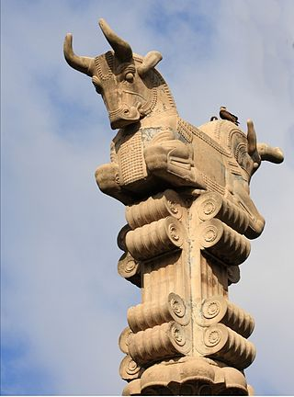 | Audience Hall (apadana) of Darius and Xerxes. Persepolis, Iran. Persian. c. 520 – 465 B.C.E.  Content:  Columns of Persepolis have a bell-shaped base that is an inverted lotus blossom.  The capitals were bulls or lions.  Each column was painted brightly.
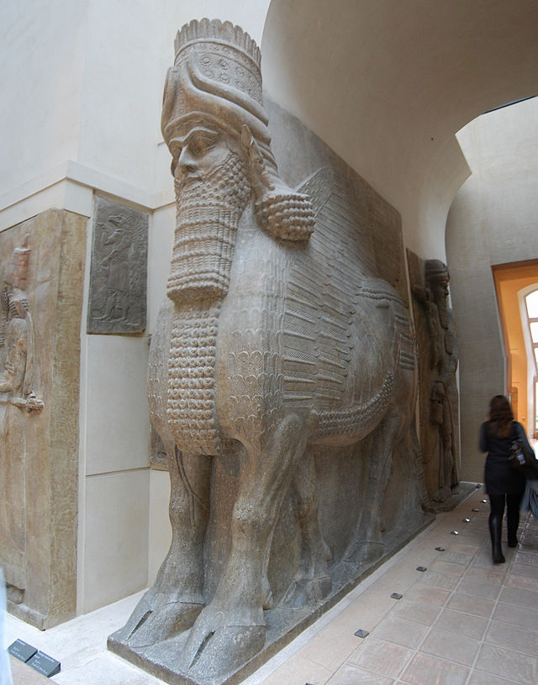 | Lamassu from the citadel of Sargon II, Dur Sharukin (modern Khorsabad, Iraq). Ne-Assyrian. c. 720 – 705 B.C.E. Limestone.  Content:  The lamassu is the name of the mythological creature depicted--combines the head of a person with the body of a bull and also winged  The statue was placed at the entrance gate of the citadel as a guardian.  The work represents power and authority of the ruler. It was made to ward off the kings enemies  The sculpture has five legs--to show movement.  The sculptures are over 13 feet tall.  Contextual Analysis:  The Assyrians were a war faring society. These pieces were placed at the gates of the citadel as a form of intimidation. The lamassu figures were intended to scare invaders away. The mythical creatures present the power of the King to his people and those of other cities. These creatures are completely made up, but resemble authority and power, thus preventing other places from invading for fear of being dominated.  (http://www.cram.com/user/jsalka)
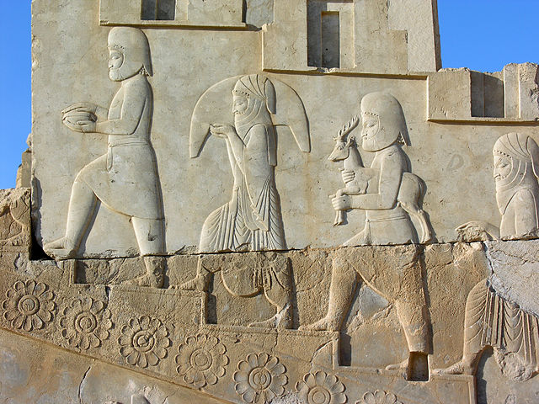 | Audience Hall (apadana) of Darius and Xerxes. Persepolis, Iran. Persian. c. 520 – 465 B.C.E.  Content:  The stairway depicts representatives from 23 different subject nations bringing tribute to the king.  The reliefs may have been painted at one point  Style:  The work has some archaic Greek and Persian influence (shown in details like the garments folds and shows contact with foreign nations and the exchange of ideas)  The nobility are individualized through costume.  All of the people depicted have similar faces but the clothing is unique to where they come from (gives the message that you are all different and can keep your traditions but everyone is the same and ruled under one singular force; legitimizes the kings rule)  (http://www.cram.com/user/jsalka)
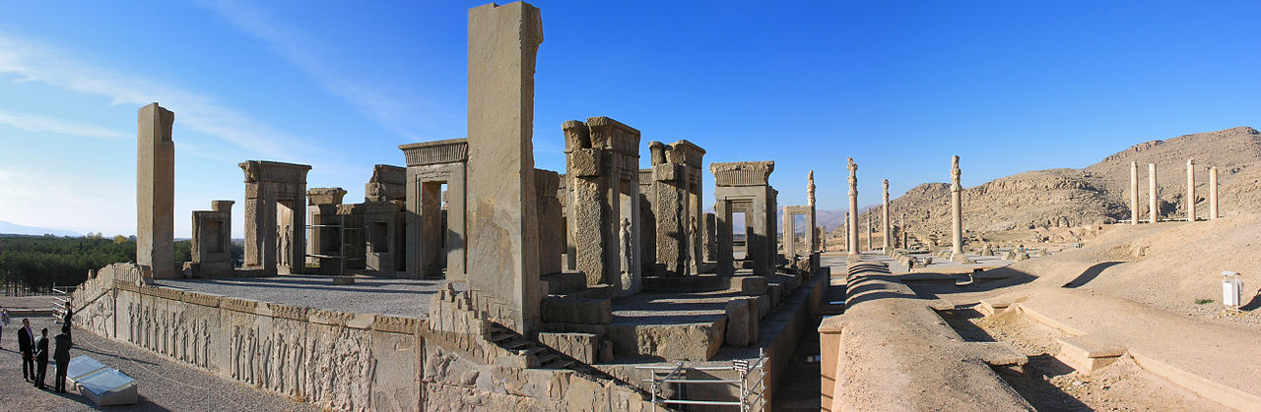 | Audience Hall (apadana) of Darius and Xerxes. Persepolis, Iran. Persian. c. 520 – 465 B.C.E.  Content:  The citadel was set on a high plateau and was heavily fortified.  The complex had an Apadana (a royal audience hall, this one could hold thousands of people).  The entrance was called the “gate of all lands” and had lamassu guarding it.  A ceremonial stairway ushered the masses, friezes on the stairwell showed the kings power and ability to unify many peoples.  Style:  The apadana style hall was an audience hall.  It had 36 columns covered by a wood roof.  Each column was 60 feet tall.  Contextual Analysis:  The audience hall was the main gathering place for governing people and royalty. It survived the siege of Alexander the Great; there was strong bad blood between the Persians and the Ancient Greeks. It is rare to see marble in Iran because it was a rare stone for Persians. Darius and Xerxes are the sons/successors of Cyrus the Great who took the throne of the Persian empire. This building represents the perfect combination of Greek style and Egyptian floor plan, thus it is significant because of its mix of ideas. The columns are very Greek, and at the top are animals back to back, which held the beams of the roof. The use of symbols such as animals is characteristic of the Egyptian culture
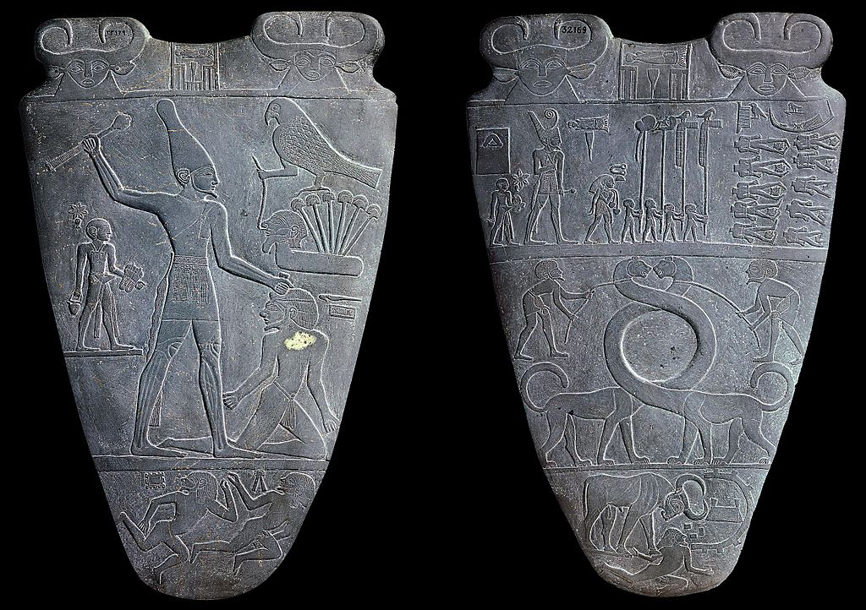 | Palette of King Narmer. Predynastic Egypt. c. 3000 - 2920 B.C.E. Greywacke.  Content:  The palette was used for eye make-up.  On the back, King Narmer with a mallet beats down the defeated foe.  A servant holds his sandals, as this is a “sacred” act. Defeated enemy lie beneath his feet.  On the front, the bodies of the defeated troops are seen from above with their heads placed between their legs.  Harnessed lions with elongated necks create a circle used to hold the make-up.  Style:  The palette was created with a subtractive technique.  The work is an incised work of art-low relief.  The work uses composite view to struggling to realistically show human figures. The shoulders forward, hips slightly side ways, head sideways, and feet sideways.  Contextual Analysis:  This document really begins to show the use of art in documenting historic events and the clear line up of a story (narrative art). This piece is dated back to the oldest period of Egyptian history known as predynastic Egypt. The palette documents the unification of Egypt under the hands of King Narmer. Prior to King Narmer, upper and lower Egypt were separate places. Each image has a meaningful purpose behind it adding to the story of unification. The animals in the piece resemble gods and their characteristics. It is known this palette is in commemoration of King Narmer because his name appears at the top of the stone in ancient calligraphy and he is placed in the middle of the stone and depicted larger than the rest of the figures. In Egyptian art it is common to see people of importance get central focus and be larger in scale than other figures. In the palette there are symbols resembling both upper and lower Egypt further showing the importance and unification of the two. Egypt was unified in a violent battle as seen on the palette; the enemy is in a kneeling position underneath the dominance of King Narmer. The presence of the gods in the piece show that the people are doing the work of the gods as they guide in animal form. The palette was clearly intended to be read. There are both ceremonial and functional palettes found from this time period, however, the palette of King Narmer in particular is ceremonial. The functional palettes were used to grind up eye make-up not only used for looks but for sun protection as well.  (http://www.cram.com/user/jsalka)
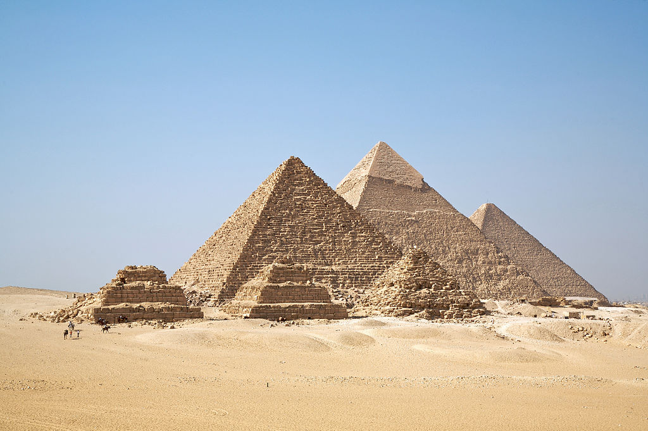 | Great Pyramids (Menkaura, Khafre, Khufu) and the Great Sphinx. Giza, Egypt.  Content:  The corners of the pyramids are aligned with the cardinal directions.  The pyramids are funerary temples for the pharaohs.  Pyramids face the rising sun.  Style:  The pyramids are made of limestone bricks. No mortar was used.  The sloped side, created by stone casings, shape reflects the rays of the sun.  Contextual Analysis:  The pyramids were made as a form of coffin or funerary temple in order to hold the mummified pharaoh bodies and all their riches for a comfortable afterlife. The importance of death in Egyptian culture becomes very prevalent. The structure of the pyramids, stacking huge, heavy stone blocks upon one another, shows the Egyptian people's impressive understanding of engineering. The pyramids were built mostly with human labor, thus their techniques of getting the stone blocks stacked on one another were rather advanced for the time.  (http://www.cram.com/user/jsalka)
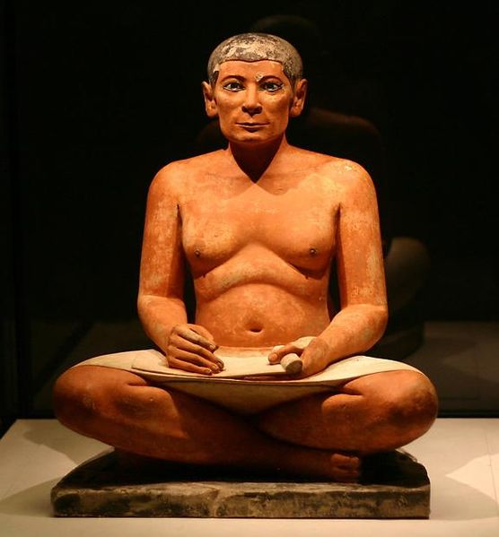 | Seated Scribe. Saqqara, Egypt. Old Kingdome, Fourth Dynasty. c. 2620 – 2500 B.C.E. Painted limestone  Content:  The sculpture’s focus is someone with lesser status.  Showing a normal body with sagging chest is unusual in Egyptian culture art.  The work is naturalistic.  Style:  The sculpture is made of painted limestone.  The skin tone is the color of the raw stone.  The work is an exception to some of the Egyptian art norms.  The work is naturalistic with individualized, defined features where as the art of the pharaoh is more idealistic.  The sculpture has a stiff frontal pose.  Contextual Analysis: The ultimate purpose of the sitting scribe is unknown by historians. It is thought it could perhaps be a funerary piece put in an important figures tomb to assure comfort in the after life. The main reason this piece is studied is because of its unique focus on a person of lower status and the early development of the human figure.  (http://www.cram.com/user/jsalka)
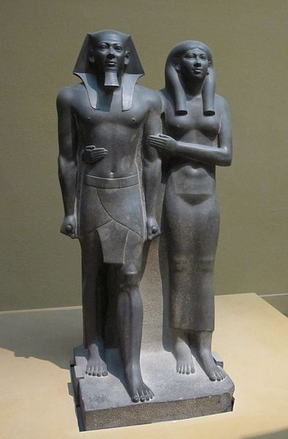 | King Menkaura and queen. Old Kingdom, Fourth Dynasty. c. 2490 – 2472. B.C.E. Greywacke  Content:  The king is depicted with one foot stepping forward (symbolic). The queen embraces her husband.  It is a funerary piece for the benefit of the ka.  The queen is wearing flax linen, but looks almost nude (wet drapery style).  The king has clenched fists.  The couple have a vacant “other worldly” stare.  Style:  The work is a diorite carving.  The sculpture has a stiff frontal positioning--showing authority and intimidation.  Stone tools were used to carve (iron and copper tools as well).  The sculpture has a heavy block like structure. The figures are not cut away from the rock.  The shins have a sharp crease.  Contextual Analysis:  The one-foot forward position resembles the 'ready for action' attitude of a successful pharaoh. The position shows power and significance, it is intimidating and authoritative. The statue is made of hard, dense stone saved for only wealthy citizens, statues made from this stone were intended to last. The detail and obvious time ad effort put into this statue and many other funerary statues show the Egyptians obsession with death and the afterlife and the importance of death. Most pharaohs started having their funerary statues carved at the beginning of their rein to assure their comfort in riches in the afterlife. In these statues individual style was not appreciated or allowed, an artists talent was based upon their ability to copy the traditional, godlike / idealistic image of a pharaoh with no innovation. During ancient Egypt artwork, the cannon of proportions made an appearance, this is the first known rule of proportions. This rule helped artists create idealized size proportions that never varied from piece to piece. Another important aspect of this statue is the wet drapery on the queen figure. It shows her royal status, but is slightly provocative at the same time. It may have has fertility connotations.  (http://www.cram.com/user/jsalka)
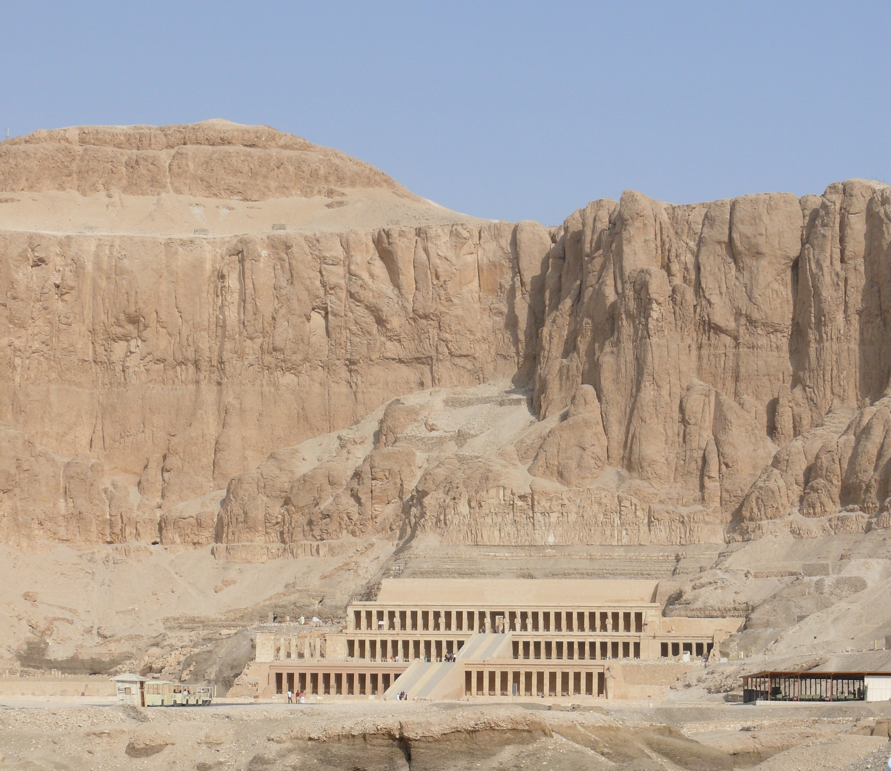 | Mortuary Temple of Hatshepsut. Near Luxor, Egypt. New Kingdom, 18 th Dynasty. c. 1353 – 1335 B.C.E. Limestone  Content:  The structure is a rock cut tomb.  The plan shows bilateral symmetry.  It is a tiered construction, with each higher tier becoming more sacred than the others.  Style:  The temple is a tiered terrace construction. The terraces were once planted with trees.  The temple mirrors the natural landscape around it.  The architecture has an interesting interplay of horizontals and verticals.  The tiers have rows of columns (colonnades).  The temple was decorated with about 200 statues of Hatshepsut.  Every column decorated and painted with a carving of Hatshepsut.  Contextual Analysis:  Hatshepsut is the first documented female ruler in history. She gave birth to no sons, but when her husband, the former pharaoh died, the kingdom was given to one of his lesser wives sons. The son was too young to rule, so she took the kingdom and ruled under her terms. As a woman, she had to fight to protect her rights as pharaoh. She ruled for two decades. The mortuary temple is one of the first temples in which an architect is named, Senmut. The pharaoh after Hatshepsut destroyed much of her commemorations; this particular temple has been reconstructed.  (http://www.cram.com/user/jsalka)
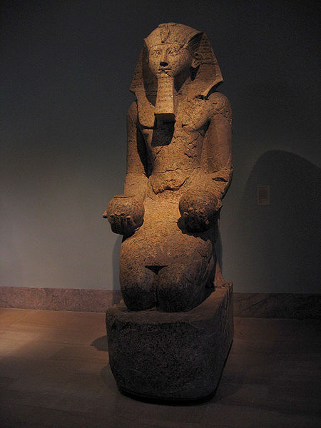 | Content:  The sculpture is of a kneeling pharaoh.  It is a ka statue.  Queen Hatshepsut is depicted with pharaoh attire (beard) and a masculine body.  She holds offerings to the gods in her hands.  Style:  It is made of granite.  The sculpture was made by subtractive techniques from a block of stone.  Contextual Analysis:  This statue is seen inside the mortuary temple of Hatshepsut, there are many kneeling and standing statues that fill the halls of the temple; all the statues are of Hatshepsut. The statues are known as Ka statues. Ka statues are believed to hold the "soul" or internal spirit that transcends from the body of a human into the afterlife. The Ka is the so called "soul" or "spirit" that transcends life on Earth to the afterlife. The statue is free standing and holds offerings to the gods, its purpose is not only to hold the Ka, but also give offerings to the gods. These Ka statues were made while Hatshepsut was still alive, as were most funerary statues. The destruction of these statues and many other Hatshepsut commemorations by the following pharaoh is known as iconoclasm. (images that have meaning about a political or religious idea are intentionally destroyed to wipe out the idea)  (http://www.cram.com/user/jsalka)
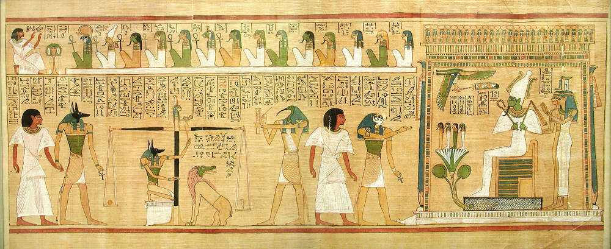 | Last Judgment of Hu-Nefer, from his tomb (page from the Book of the Dead). New Kingdom, 19th Dynasty. c. 1275 B.C.E. Painted papyrus scroll  Content:  The work is painted papyrus scroll.  It depicts a narrative of a man’s initial journey towards the afterlife.  Composite view images of the deceased and the gods are painted along with hieroglyphics.  The many gods, with animal heads are in the hall of judgment. Each god has an their individual task in the judgment of the person’s soul in the after-life.  Egyptian worship is polytheistic.  Style:  The work is painted on papyrus paper.  The work marks a return to traditional Egyptian style (after Amarna shift).  Figures are depicted in the composite view or frontality.  Contextual Analysis:  This piece is very unique because it is on papyrus paper. It is rare to find scrolls such as these because they easily break down. This particular page being of a scene that depicts the afterlife gave insight into the belief of the afterlife. The scroll was found in a scribe’s tomb, showing that not only pharaohs but other high status citizens had tombs as well. After Akhenaton, Egypt returns to a polytheistic culture, as depicted in this piece. The god Anubis is always seen in scenes of the afterlife among many other gods in this scroll, his job is to be the first god to transition the dead to the afterlife. This scene is called the hall of judgment; it is essentially the stage right after death in which the soul is tested to decipher where it goes exactly. One of the tests illustrated is the scale of ones heart versus the feather and the heart must weigh more than the feather to show the persons dedication to truth.  (http://www.cram.com/user/jsalka)
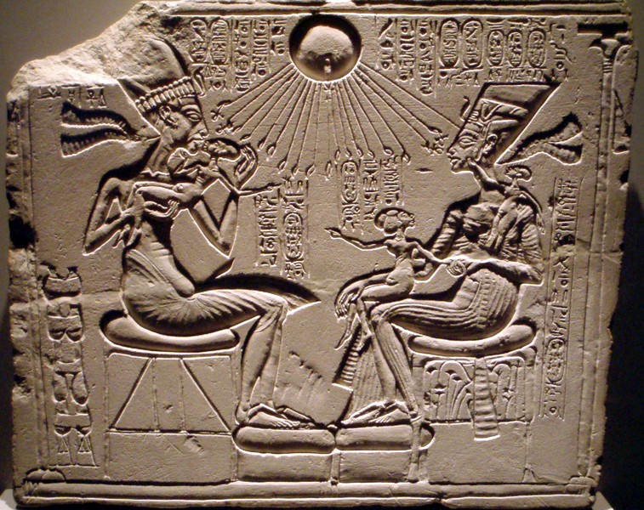 | Akhenaton, Nerfitii, and three daughters. New Kingdom (Amarna), 18th Dynasty. c. 1353 – 1335 B.C.E. Limestone  Content:  The Pharaoh Akhenaton is depicted with his wife in an intimate family scene.  The three small female figures are the daughters of the pharaoh.  The pharaoh is depicted basking in sun rays of life of the sun god Aten  The concept of monotheism is new. The worship of Aton is new and radical.  The pharaoh and is wife, Nefertiti are depicted kissing their children and loving them. This intimate, natural view of the family and humanity is very different than New Kingdom artworks.  Style:  The work was created using a subtractive technique (incised).  A ba relief is a sculptural relief in which the projection from the surrounding surface is slight and no part of the modeled form is undercut.  The elongated figures and the naturalistic-more humanistic scenes mark the Amarna style.  Contextual Analysis:  Because most of ancient Egypt's artifacts were crafted with stone, we today get to see many of the works of art. Stone lasts, thus the artifacts crafted on stone last. Again it is seen that Akhenaton only believed in one god, switching from a polytheistic culture to a monotheistic culture. Being a monotheistic culture allows for Akhenaton to be the only higher power. This is also one of the first pieces to show family intimacy and love. The symbols at the end of the sunrays are portraying the giving of life from the one and only god Aten. Having only one god also makes Akhenaton more connected to the higher powers.  (http://www.cram.com/user/jsalka)
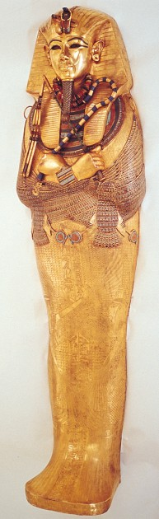 | Tutankhamen’s tomb, innermost coffin. New Kingdom, 18th Dynasty. c. 1323 B.C.E. Gold with inlay of enamel and semiprecious stones.  Content:  King Tut's tomb  The innermost coffin is one of the three layers of coffins (all gold).  The coffin housed the mummy.  This coffin was the most elaborate and decorated coffin.  It is made gold and other precious and semi precious stones.  It is inscribed with hieroglyphics  The tomb is a rock cut tomb.  Style:  It is made of beaten, modeled gold.  It has inlayed stones of color.  The sarcophagus is intricately inscribed and detailed.  The pharaoh is depicted with crossed arms, which is typical of royal burials.  King Tutankhamen holds the crook and flail and wears the nemes. These are the symbols of the Egyptian pharaoh.  Contextual Analysis:  King Tut was in retrospect a fairly mild pharaoh, he died young (age 18); however, when his tomb was found completely intact, King Tut became a huge symbol of Egypt. The discovery of the tomb allowed historians to gain more understanding of the burial process and the importance of the afterlife. Before King Tut's tomb, all the funerary temples found had been looted. Because King Tut was less significant, his tomb was placed behind a more recent pharaohs tomb, thus why it was protected from looters. The insight the tomb brought to historians about the afterlife in Egypt is huge.  (http://www.cram.com/user/jsalka)
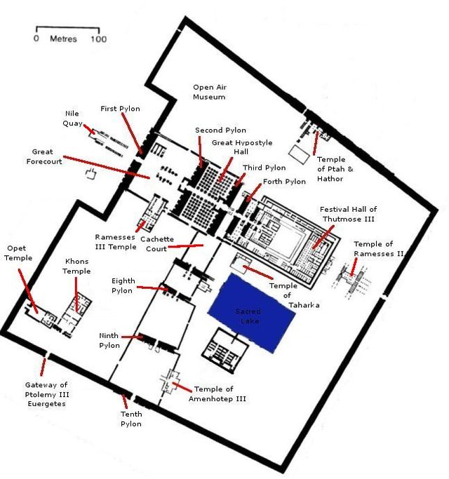 | Temple of Amun-Ra and Hypostyle Hall. Karnak, near Luxor, Egypt. New Kingdom, 18th and 19th Dynasties. Temple: c. 1550 B.C.E.; hall: c. 1250 B.C.E. Cut sandstone and mud brick.  Content:  The pylon is a massive stone wall at the front entrance of the temple. (facing the west)  The further into the temple, the more sacred. As each room advances into another, the amount of people could enter reduces.  The massive hypostyle hall is an architectural wonder.  Each pharaoh built on to the temple at Karnak.  (http://www.cram.com/user/jsalka)
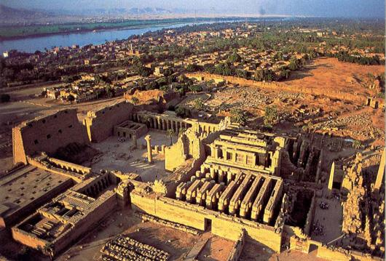 | Temple of Amun-Ra and Hypostyle Hall. Karnak, near Luxor, Egypt. New Kingdom, 18th and 19th Dynasties. Temple: c. 1550 B.C.E.; hall: c. 1250 B.C.E. Cut sandstone and mud brick.  Style:  The temple displays bilateral symmetry.  Each inner layer of the temple becomes more sacred.  Hypostyle hall has large lotus columns (134 sandstone columns).  The clerestory, the first introduction to windows, allows light into inner sections of the temple.  It is built post and lintel construction.  Each column is carved and painted.  (http://www.cram.com/user/jsalka)
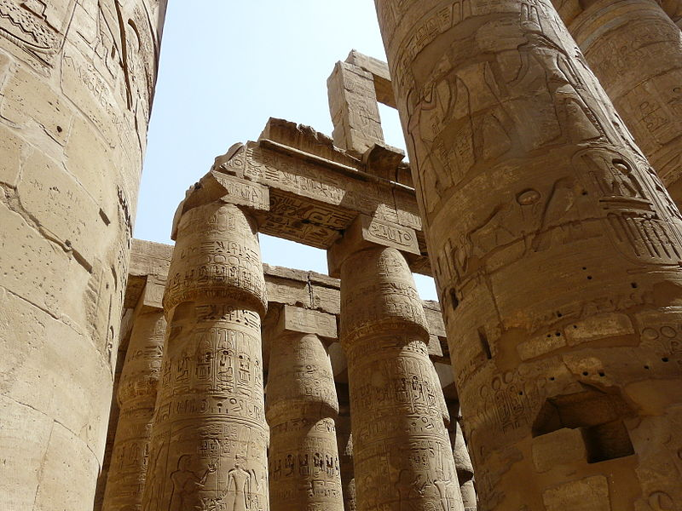 | Temple of Amun-Ra and Hypostyle Hall. Karnak, near Luxor, Egypt. New Kingdom, 18th and 19th Dynasties. Temple: c. 1550 B.C.E.; hall: c. 1250 B.C.E. Cut sandstone and mud brick.  Contextual Analysis:  The advancement of clerestories in this temple is huge in the world of architectural history. Clerestories were the first form of window to let natural light into large structures. This is significant because there were no lights during this time so it allowed people to be within an enclosed structure but not be in the complete dark. Therefore, not only is this temple a huge part of art history, but it is also significant in architectural history.  (http://www.cram.com/user/jsalka)

