The Stone Breakers. Gustave Courbet. 1849 C.E. (destroyed in 1945). Oil on canvas.  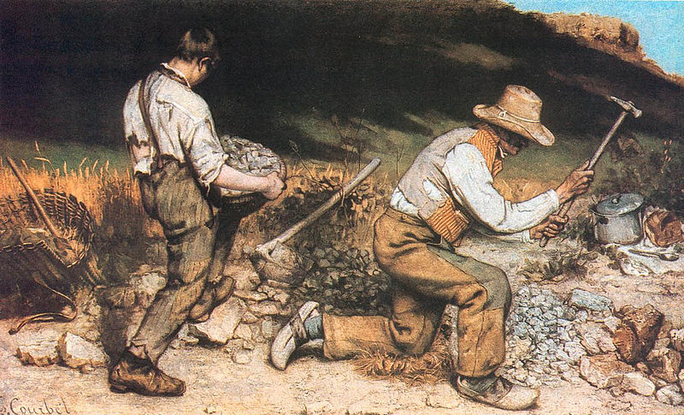  courbet.jpg | Content:  It was a work of social realism, depicting two peasants, a young man and an old man, breaking rocks.  Style:  Realist movement that emerged in mid- 19th-century France. Realist artists represented the subject matter of every day life (especially subjects that had previously been considered inappropriate for depiction) in a relatively naturalistic mode.  Realism is known for its  - muted colors.  - move from whimsical/ romantic themes.  - non-dramatic lighting.  -social commentary.  Contextual Analysis:  Paintings of menial labor and ordinary people exemplify his belief that painters should depict only their own time and place.  The work depicts peasants doing the lowliest and most backbreaking form of work, rendering this labor to the scale of a history painting.  The painting intends to provoke, suggesting that the lowliest of society can be venerated as heroes.  The painting reveals the brutality of modern life. The young boy is depicted with tattered clothes but modern boots while the older man in depicted in traditional peasant clothes. This suggests a beginning and an end.
Nadar Raising Photography to the Height of Art. Honoré Daumier. 1862 C.E. Lithograph.  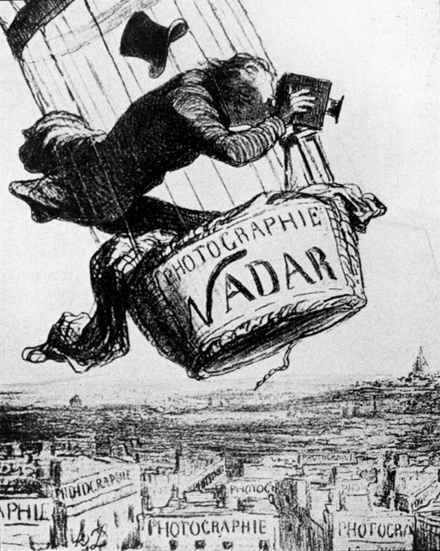  nadar.jpg | Content:  The print depicts Gaspard-Félix Tournachon (known as Nadar) as an absent-minded professor figure who—in his excitement to capture the perfect shot—is unwittingly about to lose his top hat.  Below him, inscribed on every building in Paris, is the word “Photographie.”  Style:  A lithograph is a printmaking process where an image is drawn on a metal plate with oil-based crayon.  Contextual Analysis:  Nadar was a tireless innovator. In 1855 he patented the idea of using aerial photographs in mapmaking and surveying. It was not until 1858, however, that he was able to make a successful aerial photograph—the world’s first—from a balloon. This led Daumier to issue a satirical lithograph of Nadar photographing Paris from a balloon. It was titled Nadar Raising Photography to the Height of Art. Nadar remained a passionate aeronaut until he and his wife and other passengers were injured in an accident in balloon he had built.
Olympia. Édouard Manet. 1863 C.E. Oil on canvas.  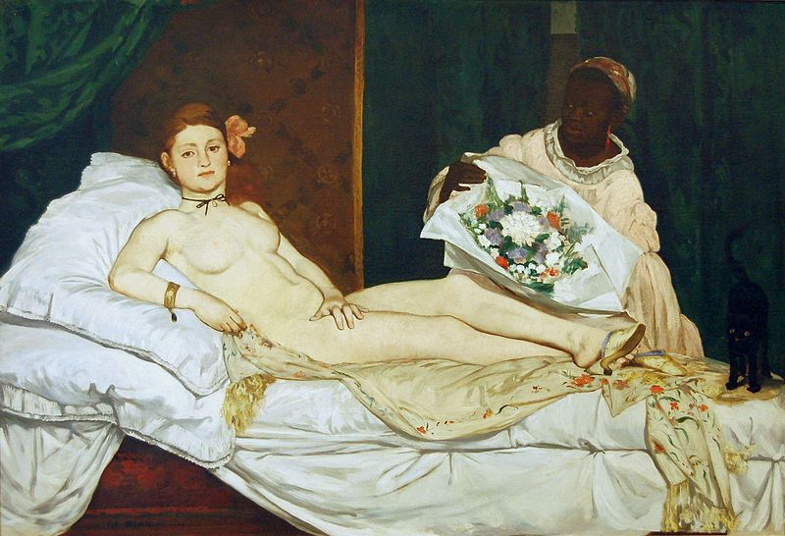  olympia.jpg | Content:  The painting shows a nude woman ("Olympia") lying on a bed being brought flowers by a black servant.  Style:  The work is an oil on canvas.  The painting is characterized by broad, quick brushstrokes, harsh studio lighting that eliminates mid-tones, large color surfaces and shallow depth.  This flatness deviates from the Academic Canon.  Contextual Analysis:  Olympia is naked rather than nude, an impression emphasized by her bony, unclassical proportions. The sheets are slightly rumpled, and a client has clearly sent the flowers that her maid delivers. Olympia's shoes may refer to "street-walking" and the alert black cat is a symbol of sexuality, no doubt because of the popular reputation of the alley cat. The term "cat-house" is a popular term for a brothel. This is an example of French Realism in the 1860s.  The work is definitely inspired by  Titian’s "Venus."  http://quizlet.com/53929689/arhs-1003-test-2-artworks-flash-cards/
The Saint-Lazare Station. Claude Monet. 1877 C.E. Oil on canvas.  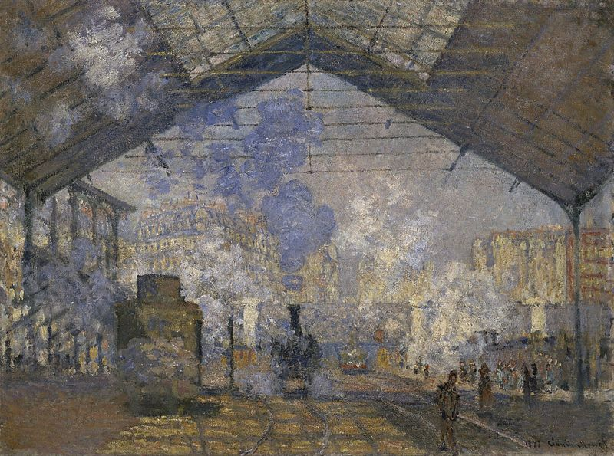  lazarestation.jpg | Content:  The subject of Le Gare Saint-Lazare is a train station in Paris.  The Gare Saint-Lazare was an industrial marvel. Not only were its powerful steam engines mighty signs of modernism, the shed was in itself an architectural wonder.  Style:  Monet worked in a style known as Impressionism.  This work is one of seven works, which constituted Monet’s first series, a deliberate attempt to explore in multiple canvases a single subject at different times of day and under various atmospheric conditions.  Plein air means it was painted outdoors.  Contextual Analysis:  Monet painted inside the train station itself, enabling him to directly study the actual lighting and atmosphere, particularly the appearance of steam and smoke.  Like his fellow painters, Manet and Caillebotte, Monet began to make representations of these urban scenes as Baudelaire had urged painters to do many years before.  Monet was particularly interested in the smoke produced by the engine.  Monet painted the station as a crossroads in perpetual motion, suggesting its noise and its agitation.  The French writer and critic Emile Zola congratulated Monet on his, "terrific view of train stations. You can hear the trains rumbling in, see the smoke billow up under the huge roofs . . . .That is where painting is today....Our artists have to find the poetry in train stations, the way their fathers found the poetry in forests and rivers."
The Horse in Motion. Eadweard Muybridge. 1878 C.E. Albumen print.  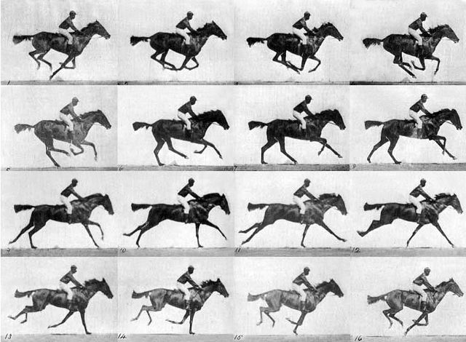  muybridge.jpg | Content:  The work is a motion series of photography of a running horse.  As a result of his motion studies, he is regarded as one of the fathers of the motion picture.  Style:  The series are still photography.  Contextual Analysis:  Born Edward Muggeridge upriver from London, he moved to the United States change his name to the more striking name by which he is known today, he took up photography.  His most famous work began in 1872, when he was hired by Leland Stanford to photograph horses. Stanford reputedly had made a bet that for a moment, all four of a racehorse's hooves are off the ground simultaneously, and he hired Muybridge to take the pictures to prove him right. The initial experiments produced only indistinct images.  Years later, he set up a row of cameras with tripwires, each of which would trigger a picture for a split second as the horse ran by. The results settled the debate once and for all: all four hooves do leave the ground at once.  http://en.wikipedia.org/wiki/Eadweard_Muybridge
The Valley of Mexico from the Hillside of Santa Isabel (El Valle de México desde el Cerro de Santa Isabel). Jose María Velasco. 1882 C.E. Oil on canvas.  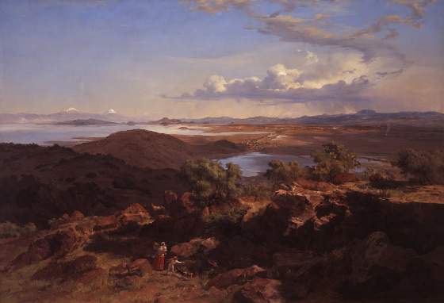  valleyofmexico.jpg | Content:  A painting showing the vista of the natural scenery of the Valley of Mexico.  Style:  The work is the style of Romanticism.  The work is an oil on canvas.  Contextual Analysis:  He was the most representative figure of Mexican academic painting in the 19th century.  In his work the main theme was the spectacular natural scenery of his own country, specially the Valley of Mexico.  He painted the same subject repeatedly throughout his life (9 times in total).  He made Mexican geography a symbol of national identity through his paintings.  Similar to his German predecessors, Velasco explored the romantic relationship between human figures and the scenery they inhabit. Two Indians are presented in transit from the city to the country, reflecting a romantic, yet difficult socio-economic relationship between people and their ancestral land. The figures’ indigenous garments intrinsically relate to the national iconography displayed throughout the image.  Velasco has produced an image where national pride, romantic poetry, and daily life blend to transform the Valley of Mexico into a Romantic masterpiece.  https://www.khanacademy.org/humanities/becoming-modern/painting-mexico/a/velasco-the-valley-of-mexico
The Burghers of Calais. Auguste Rodin. 1884–1895 C.E. Bronze.  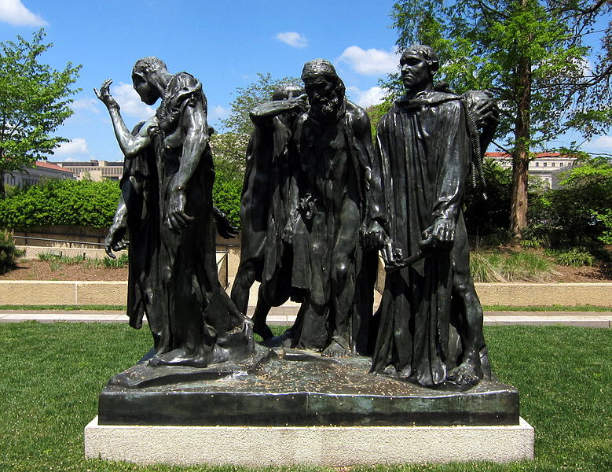  burghers.jpg | Content:  The group sculpture depicts six men with nooses around their necks holding the keys to the town of Calais,  Style:  The Burghers were also cast in bronze and distributed as single figures.  Contextual Analysis:  Rodin closely followed the account of the French chronicler Jean Froissart stating that six of the principal citizens of Calais were ordered to come out of their besieged city with head and feet bare, ropes around their necks.  The keys to the town are in their hands.  They were brought before the English king Edward III, who ordered their beheading.  Rodin has portrayed them at the moment of departure from their city led by Eustache de Saint-Pierre, the bearded man in the middle of the group  Their oversized feet are bare, many have ropes around their necks, and all are in various states of despair, expecting imminent death and unaware that their lives will ultimately be saved by the intercession of the English queen Philippa.  When the piece was completed, it was controversial. The representation of Burghers in their downtrodden, anguished state, rather than as heroic and dignified, did not please the French public.  http://metmuseum.org/toah/works-of-art/1989.407
The Starry Night. Vincent van Gogh. 1889 C.E. Oil on canvas.  .  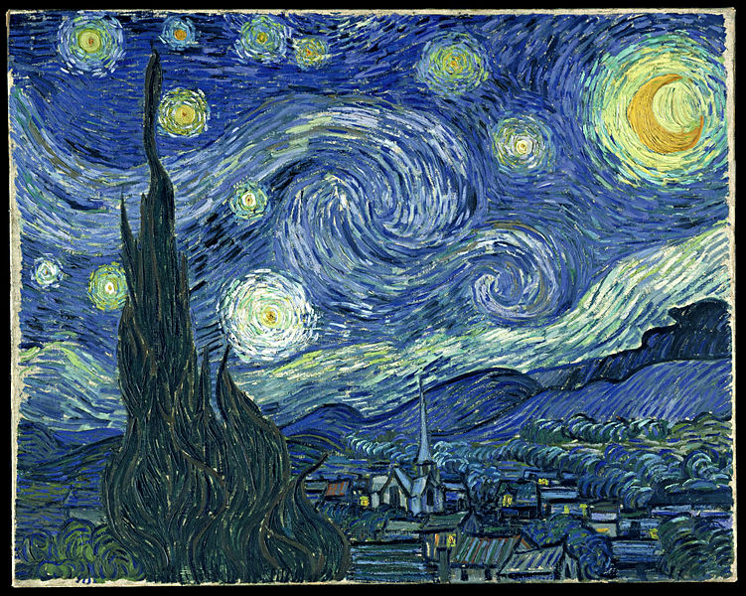  starrynight.jpg | Content:  The work depicts the view from the east-facing window of Van Gogh’s asylum room at Saint-Rémy-de-Provence, just before sunrise  It is Van Gogh's best-known painting and one of the most recognized paintings of Western culture.  Style:  The work is oil on canvas painting in the Post-Impressionist style.  Van Gogh makes use of the thick, impasto technique.  The work is a landscape.  The work is very painterly, with thick globs of paint.  The work has little to no blending yet the linear painting style makes it look blended.  Context:  This was painted in Van Gogh's room in the asylum.  Van Gogh is the master of using  His energetic, almost turbulent brush strokes, and the color create a style that is highly distinctive.  Van Gogh distorts visual reality with big brushstrokes. He disregards linear perspective and concentrates on the swirling brush strokes.  The cyprus tree can mean death, as it is associated in France at that time with funerals.
The Coiffure. Mary Cassatt. 1890–1891 C.E. Drypoint and aquatint.  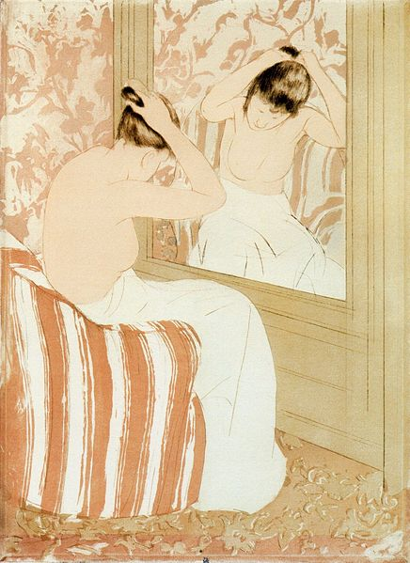  coiffure.jpg | Content:  Mary Cassatt depicts a young woman in a private moment, as she pins up her hair for the day.  Style:  The Coiffure, 1890-1891, dry point and aquatint on laid paper.  The artist of the work is considered an Impressionist, but this print is strongly influenced by Japanese prints.  This love for Japanese culture by French citizens is called Japonisme.  Contextual Analysis:  Cassatt admired the everyday themes and simple beauty.  The Coiffure is one of two nude studies in Cassatt's color series.  Cassatt's simple handling of line and form confirms her skill in drawing the human figure.  The straight lines of the mirror and wall and the chair's vertical stripes contrast with the graceful curves of the woman's body.  Cassatt also emphasizes the nape of the woman's neck, perhaps in reference to a traditional Japanese sign of beauty.  http://www.nga.gov/content/ngaweb/features/slideshows/mary-cassatt-selected-color-prints.html#
The Scream. Edvard Munch. 1893 C.E. Tempera and pastels on cardboard.  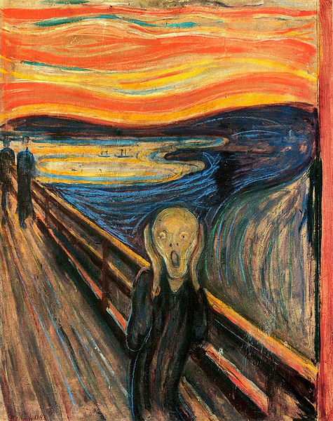  TheScream.jpg | Content:  The painting shows a figure with an agonized expression against a landscape with a tumultuous orange sky.  Style:  The work is tempera and pastel on cardboard.  The style is Expressionism.  Context:  The artist was walking during sunset and swore he heard nature screaming, and the red sky was its blood. Hence  The figure does not look human, only humanoid, but has been stripped of his humanity.  The sky is bloody and contrasts with the ground.  The curvilinear shape of body is echoed through painting except for diagonal of bridge.  Munch emphasizes distance between figure crying out and others in background to make the despair seem silent. The symbolism of this is isolation and the anxiety of modern man.
Where Do We Come From? What Are We? Where Are We Going?  Paul Gauguin. 1897–1898 C.E. Oil on canvas.  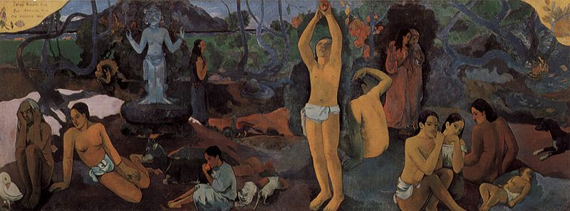  Gauguin.jpg | Content:  Gauguin described the large work in this way:  "To the right, below, a sleeping baby and three seated women. Two figures dressed in purple confide their thoughts to each other. An enormous crouching figure, which intentionally violates the perspective, raises its arm in the air and looks in astonishment at these two people who dare to think of their destiny. A figure in the center is picking fruit. Two cats near a child. A white goat. An idol, both arms mysteriously and rhythmically raised, seems to indicate the Beyond. A crouching girl seems to listen to the idol. Lastly, an old woman approaching death appears reconciled and resigned to her thoughts. She completes the story. At her feet a strange white bird, holding a lizard in its claw, representing a futility of words.”  Style:  The work was painted in oil on canvas.  The artist is considered a Post-Impressionist and/or a Symbolist.  Symbolist painters believed that art should reflect an emotion or idea rather than represent the natural world in the objective, quasi-scientific manner embodied by Realism and Impressionism.  Contextual Analysis:  Gauguin searches for of a place far removed from European materialism. Gauguin moved to Tahiti.  Gauguin used native women and tropical colors to present pessimistic view of the inevitability of the life cycle.  The work can be read as a summary of his artistic methods and views of life.  http://www.cram.com/flashcards/chapter-28-apah-4695917  http://www.gauguin.org/where-do-we-come-from-what-are-we.jsp
Carson, Pirie, Scott and Company Building. Chicago, Illinois, U.S. Louis Sullivan (architect).  1899–1903 C.E. Iron, steel, glass, and terra cotta.  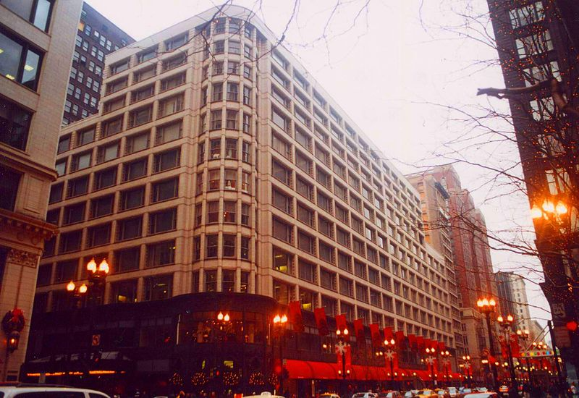  carsonpierie.jpg | Content:  Carson, Pirie, Scott and Company Building was the first all-steel framed high-rise, as was Louis Sullivan's Carson Pirie Scott.  Style:  Sullivan's vertical emphasis through the load-bearing columns became the model.  The frame, covered in glazed white terra cotta, allowed for some of the largest windows ever seen and flexible, wide-open spaces. Both of these features were key to a successful department store and examples of Sullivan’s famous design philosophy, “Form follows Function.”  Contextual Analysis:  "Form ever follow function" was his quote that revolutionized architecture.  Father of the Skyscraper.  Louis Sullivan, who was a key component to the development of skyscrapers, became an architect because of his fascination of bridges.  The building shows the innovation that came after the Chicago Fire of 1871. Skyscrapers were a new innovation and with steel cage construction, this building revolutionized skyscrapers, as we know it.  New materials, concentration of population in new fast growing urban areas, particularly Chicago and New York in the mid-19th century, solid rock foundations, available capital and such inventions as the elevator resulted in the growth upwards of American city buildings.  The Carson, Pirie, Scott Building was originally a dry-goods business.  http://www.blueprintchicago.org/2010/09/29/carson-pirie-scott/
Mont Sainte-Victoire. Paul Cézanne. 1902–1904 C.E. Oil on canvas.  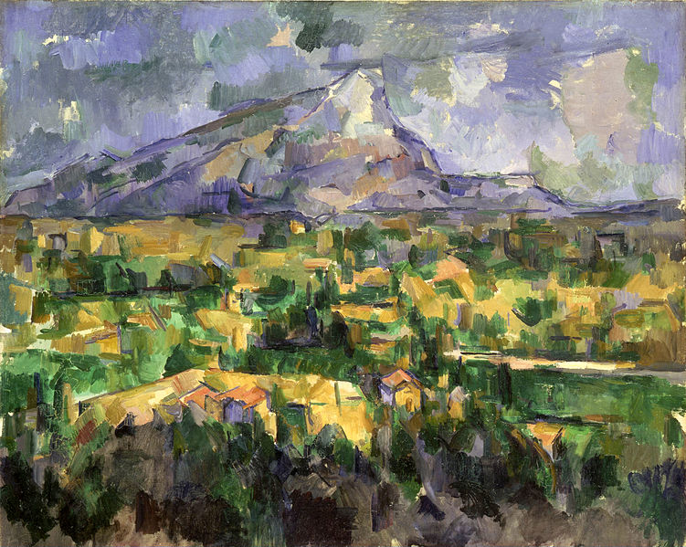  monsantvictoire.jpg | Content:  The painting is a landscape of a mountain.  Style:  The work is an oil on Canvas  The work is a landscape.  The painting pays attention to form but is mostly about color.  The color makes the scene look 3-dimensional.  The strokes are very painterly.  Contextual Analysis:  Cezanne wants to give more form and solidarity. Geometric colors move back in space greater sense of solidarity. Not reliant on traditional methods, depth through atmospheric perspective.  Cezanne painted a series on same subject.  Cezanne immobilized the shifting colors of Impressionism into an array of clearly defined planes composing the objects and spaces in his scene.  http://www.cram.com/flashcards/unit-sheet-22-chapter-28-impressionism-and-post-impressionism-4695947
Les Demoiselles d’Avignon . Pablo Picasso. 1907 C.E. Oil on canvas.  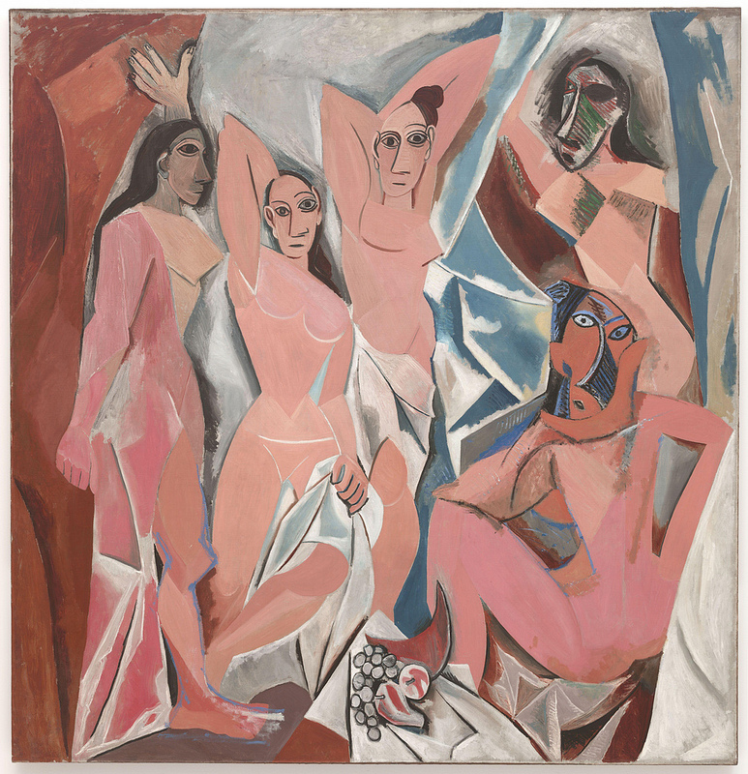  picasso.jpg | Content:  The work portrays five nude female prostitutes from a brothel on Carrer d'Avinyó (Avinyó Street) in Barcelona. Each figure is depicted in a disconcerting confrontational manner and none are conventionally feminine.  Style:  Cubistic?  Space does not recede it moves forward (jagged shards, broken glass).  Humans are sharp, angular, distorted, shards of glass, flat rather than round and voluminous, and asymmetrical.  Contextual Analysis:  No longer set in a classical past, Picasso’s image is clearly of our time. He depicts five prostitutes from an actual brothel, located on a street named Avignon in the red-light district in Barcelona.  The influence derived African masks is obvious.  He creates an effect of menacing and reduces their feminity.  Picasso not only does not attempt to make the women “beautiful” but, by the use of the African masks, positively insists on their ugliness (by the conventional standards of the day).  https://www.khanacademy.org/humanities/art-1010/early-abstraction/cubism/a/picasso-les-demoiselles-davignon
The Steerage. Alfred Stieglitz. 1907 C.E. Photogravure  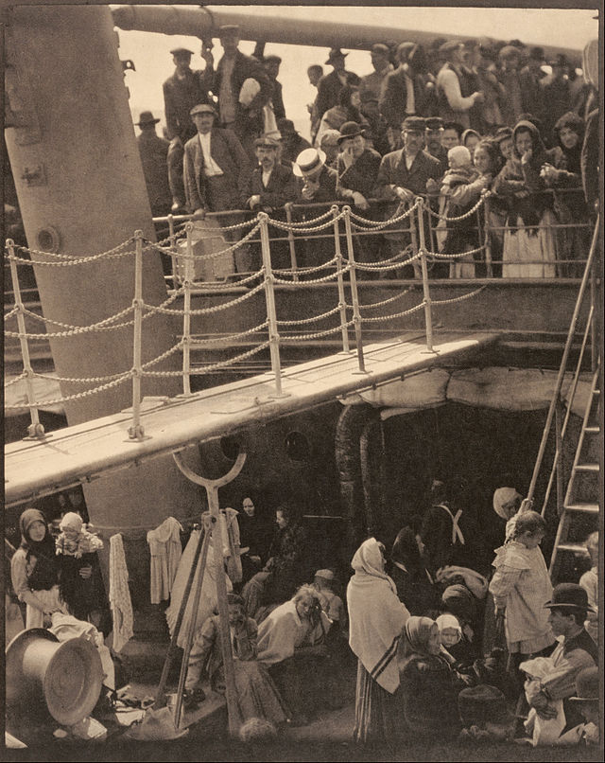  steerage.jpg | Content:  The work is a photograph of rejected immigrants heading back to Europe in the steerage compartment of a passenger ship.  Style:  Photogravure is an intaglio printmaking process which photographic images are printed using forms of mechanized etching plates.  Contextual Analysis:  It has been hailed as one of the greatest photographs of all time because it captures in a single image both a formative document of its time and one of the first works of artistic modernism.  The Steerage reflects the new aesthetic ideas of Stieglitz.  Stieglitz concentrated on a Cubist-like exploration and redistribution of shapes, tonal values, and textures. Stieglitz notes, “You may call this a crowd of immigrants… To me it is a study in mathematical lines, in balance, in a pattern of light and shade. I saw a picture of shapes.”  Steerage refers to the lowest decks of a ship. This area of the ship was once used to accommodate passengers traveling on the cheapest class of ticket, and offered only the most basic amenities, typically with limited toilet use, no privacy, and poor food.  http://www.iub.edu/~iuam/online_modules/picturing_america/_pdf/005_Alfred_Stieglitz_The_Steerage.pdf

