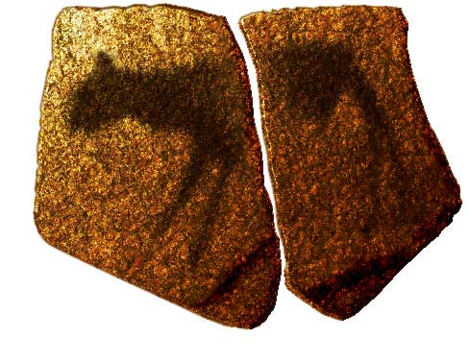  Apollo 11 Stones, Namibia. c 25,500 – 25,300 B.C.E/ Charcoal on Stone | Content:  This piece is a religious or spiritual depiction of a four-legged animal. Once this work was apart of a cave, but now they are pieces of stone that fit together. Animism is the theme of the piece; this is significant because it shows the importance and presence of animal life in a Paleolithic human's life. It shows a depiction of their surroundings and the presence of animals in their stream of consciousness.  Style:  The style is very simplistic, perhaps to their lack of developed technique. It is essentially a contour drawing, or rough outline of a figure with no detail. It is a two- dimensional depiction. There is no focus on trying to portray movement or variety in any aspect of the piece. The shape is a solid color with no texture added. The artist interpreted the animal in the simplest way possible, adding no detail or specific features. The artist utilized the natural plants or minerals in their environment to create the stain and natural rock as their canvas.  Contextual Analysis:  Being Paleolithic art, it was created in a time in which humans and animals coexisted more so than in modern day. Since wildlife was apart of everyday life, it was a constant thought on the Paleolithic human mind, thus why animals were a common subject matter. Being painted in early civilization, the style is not very developed, but it is clearly based of realistic life forms. The purpose is likely thought of being a religious or spiritual expression. The original location being a cave lends itself to being apart of sacred shelter and protection.  (http://www.cram.com/user/jsalka)
Great Hall Of the Bulls, Lascaux, France. Paleolithic Europe. 15,000 – 13,000 B.C.E. Rock Painting 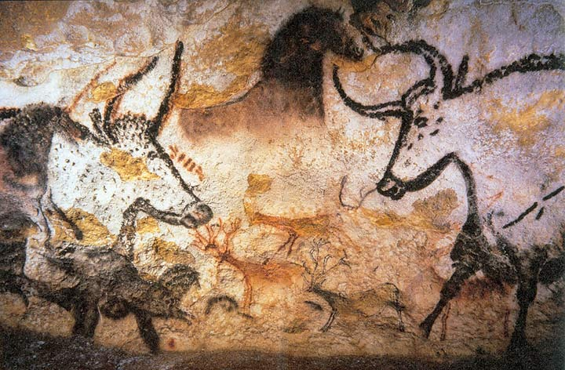 | Content:  This portion of the cave paintings includes a variety of animals. There is a bull and what looks like a horse figure. The animals vary in color and pattern. The subject matter is once again animals, showing their great significance in prehistoric lives. Prehistoric people relied on animals for survival.  Style:  The animals are two-dimensional, however they show much detail, variety, and texture compared to a silhouetted animal figure. The curved, elongating lines of the figures create undulation throughout the painting to demonstrate movement of the animals. The dots and variety on brush strokes create texture and a developed sense of space is created through the use of overlapping.  Contextual Analysis:  Caves were very important to prehistoric man, not only did the provide shelter, but with cave paintings they provided a place for spiritual and religious worship. These paintings depict a variety of animals, which were the ultimate center of man's world during prehistoric times, essential to survival. Caves with paintings such as these became more than just a place of shelter and a place in which the spent more time on their migratory path.  (http://www.cram.com/user/jsalka)
Camelid Sacrum in the shape of a canine. Tequixquiac, central Mexico.14,000 – 7000 B.C.E. Bone  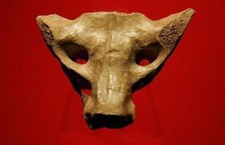 | Content:  This piece is a canine head carved out of a sacrum bone from a likely extinct, camel-like animal. The sacrum bone is located in the pelvic area, perhaps showing the significance of reproduction again.  Style:  The artist utilized the natural shape of the bone and used a subtractive technique for other aspects that were not already characteristics of the bone structure.  Contextual Analysis:  The use of the bone and its roll in the structure of an animal puts meaning into the piece of art. Being in the region of the reproductive system hints at the significance of reproduction to survival. It is thought this piece could have been used as a mask in ritual. It is not very big so the nomadic clans could carry it with them and use it in rituals time and time again. The theme of animism has more to do than just animals being a source of food, it also has to do with the spiritual significance of animals in prehistoric life.
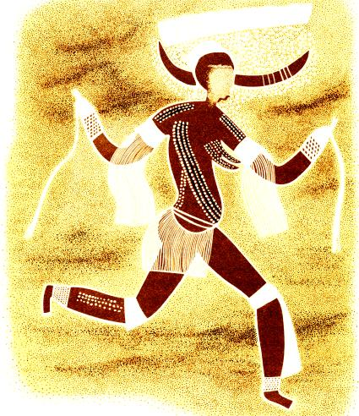  Running horned woman. Tassili n’Ajjer, Algeria. 6000 – 4000 B.C.E. pigment on rock | Content:  This piece is focused on one central female figure with horns surrounded with many smaller humanistic figures. The woman has some clothing on and has body paint decorations. Some of the smaller figures in the background seem to have no heads, suggesting a possible fight or battle. The subject matter takes a shift from animals to humans, telling some sort of story. It could be that this is one of the first recordings of an event.  Style:  The painting was created with a mineral stain on a stone facing. The white pigment is thought to be some sort of chalk-like substance. This piece moves into more detailed depictions of life, including clothing and body decoration. The main woman is drawn over the other smaller figures and there is a developed use of transparent pigment. The placement of the human limbs creates movement, and the light whites in comparison to the dark browns create a strong sense of contrast.  Contextual Analysis:  This piece shifts from depicting animals into depicting humans. It is a part of a group of images and artwork in the area, thus leading historians to believe this was an established site of living. This shows a shift from a nomadic society to one of more stability and permanent residence. The horns on the woman could be some sort of ceremonial representation and the rain above could possibly symbolize a rain dance. The natural environment was still very significant to the culture during this time. People felt the want to record their story and move away from just depicting their surroundings.
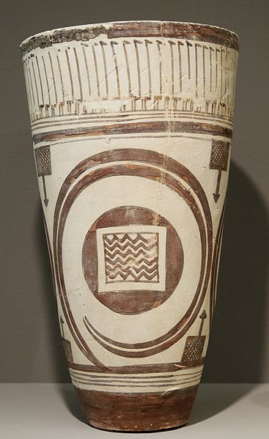  Bushel with ibex motifs. Susa, Iran. 4200 – 3500 B.C.E. Painted Terra cotta. | Content:  This is a ceramic bushel, a large pot, with a motif of an ibex, which is a mountain goat from Iran. Ibex were most likely a food source, essential for human survival. There is what looks like skinny flying birds around the top of the bushel. Animism is clearly still a prominent theme. Historians have found other ceramic pieces with a similar shape and form, but lacking the level of decoration and detail that this one has. This is significant because it shows this particular bushel was one of importance.  Style:  The paintings have a very linear style. All the figures are silhouetted, but the decoration is still very advanced. The animals are stylized and certain qualities, such as the horns, are very exaggerated.  Contextual Analysis:  This bushel could have been used for the storage of items, again showing a shift to a more stable community. It also could have been a present to a significant person in a community or used for ceremonial purposes. The bushel was said to be found in a funerary area, showing people's belief in the significance of death in society. The people were becoming even more aware of their natural surroundings, being able to find clay and heat it to a certain temperature to harden the clay.
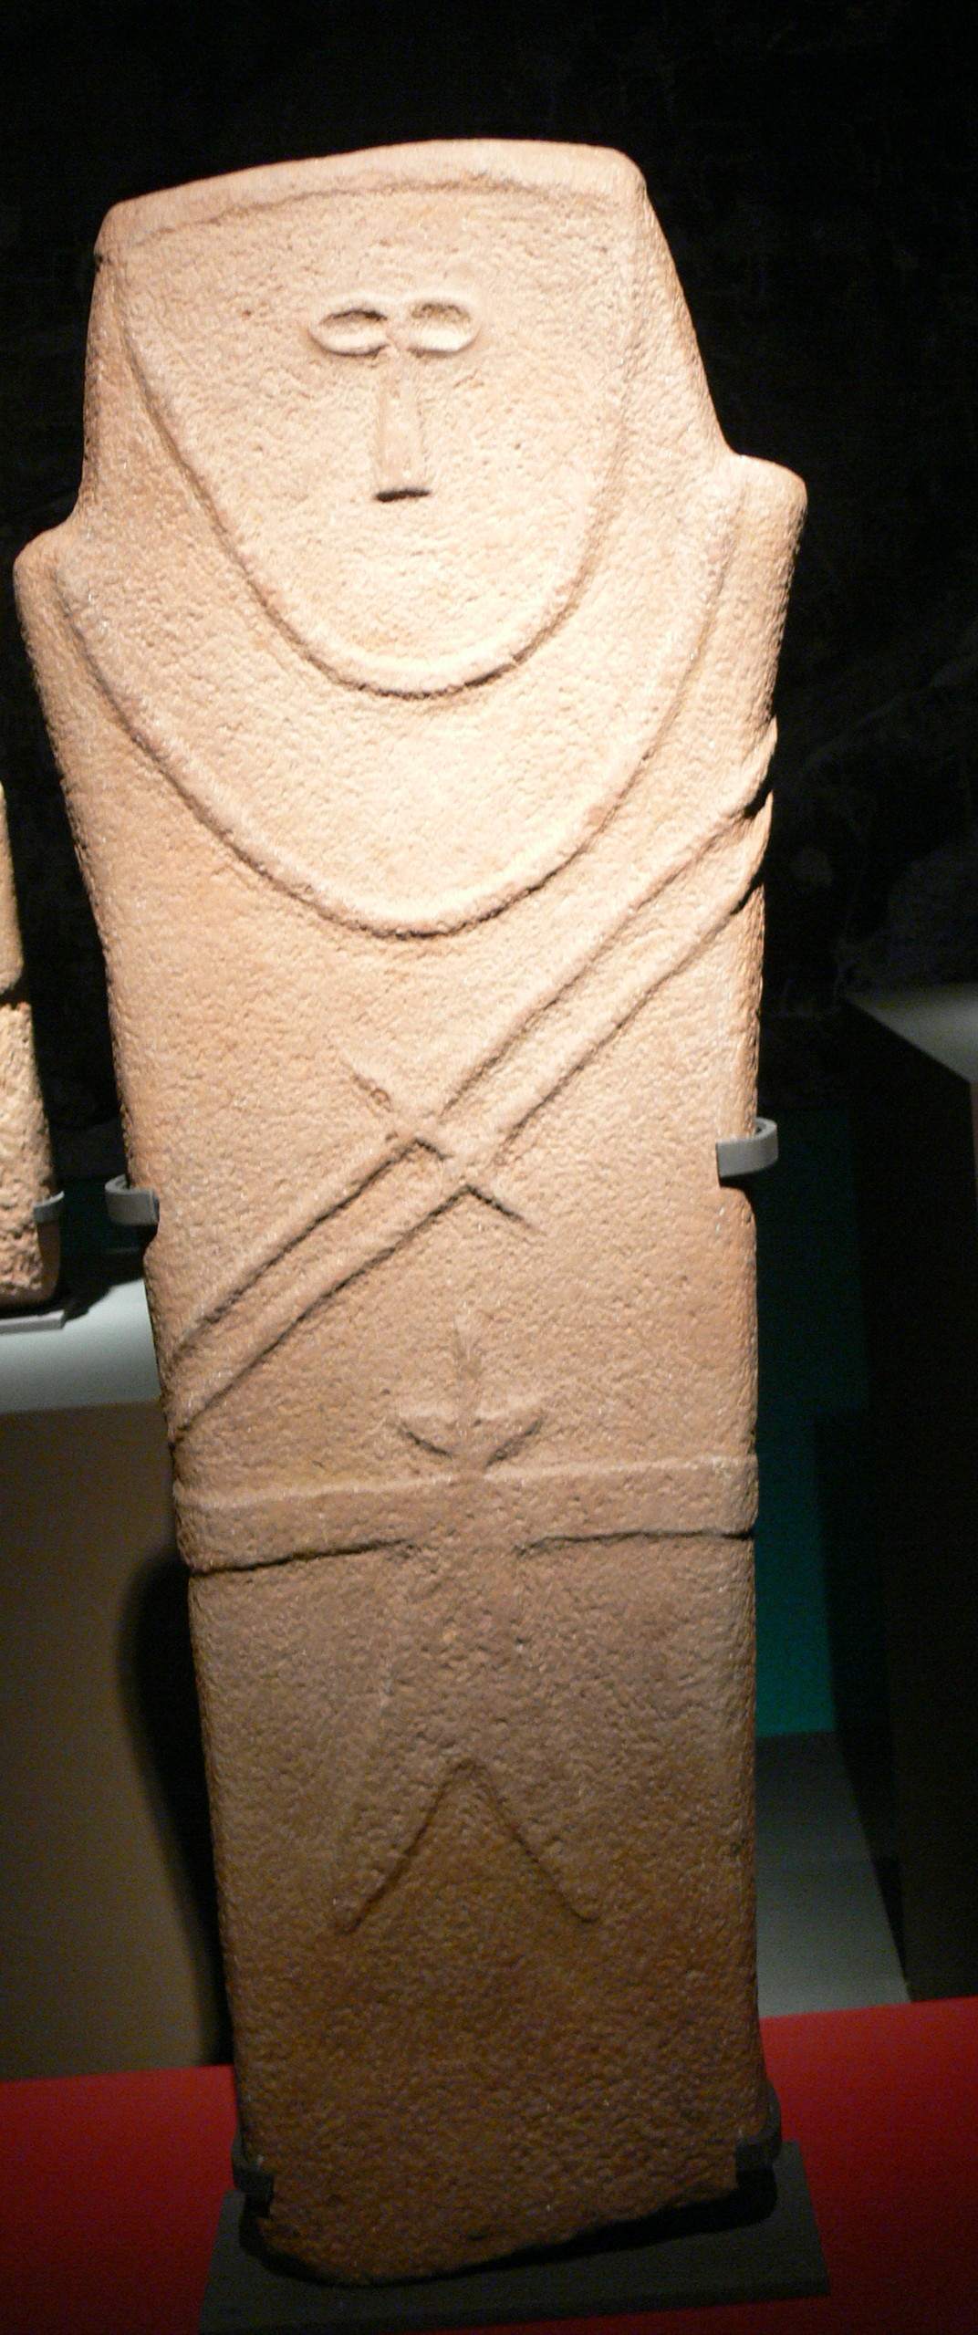  Anthropomorphic stele. Arabian Pennisula. Fourth millennium B.C.E. Sandstone. | Content:  Neolithic Stele's are also known as stone markers. These pieces are meant to stand upright and perhaps mark one's territory or recognition of a person of importance. The knife suggests it is a male figure.  Style:  This piece is a carved, incised stone. The figure is stylized, meaning not realistic, but based off reality. Art begins to communicate individuality.  Contextual Analysis:  This piece communicates individuality and originality. It was made to mark an individual of some importance and signify one individual as opposed to a group of humans.  (http://www.cram.com/user/jsalka)
Jade cong, Liangzhu, China, 3,300-2,200 BCE, carved jade.  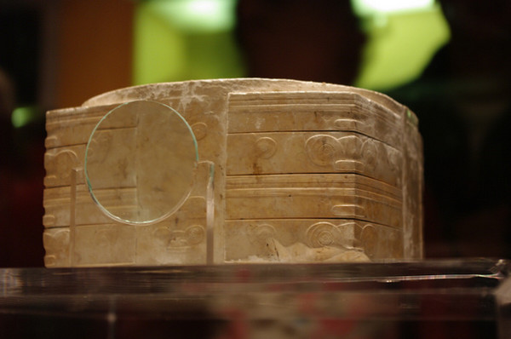 | Content:  This piece is made out of the precious stone jade, which is very plentiful in China. All of the jade congs found have a cylindrical inner part surrounded by a box like outer form with a carved circle at the top. There is a pretty high level of decoration, all incised carvings. The function of these pieces is unknown. The main decorations found on congs are beast-man faces, perhaps referring to spirits.  Style:  All the decorations on the congs are incised, or slightly carved. The lines are very precise, making for a precise shape.  Contextual Analysis:  It is unknown what jade congs specific function were, but it is possible they were used as decoration, trade items, or simply gifts for those of significance in early societies.  (http://www.cram.com/user/jsalka)
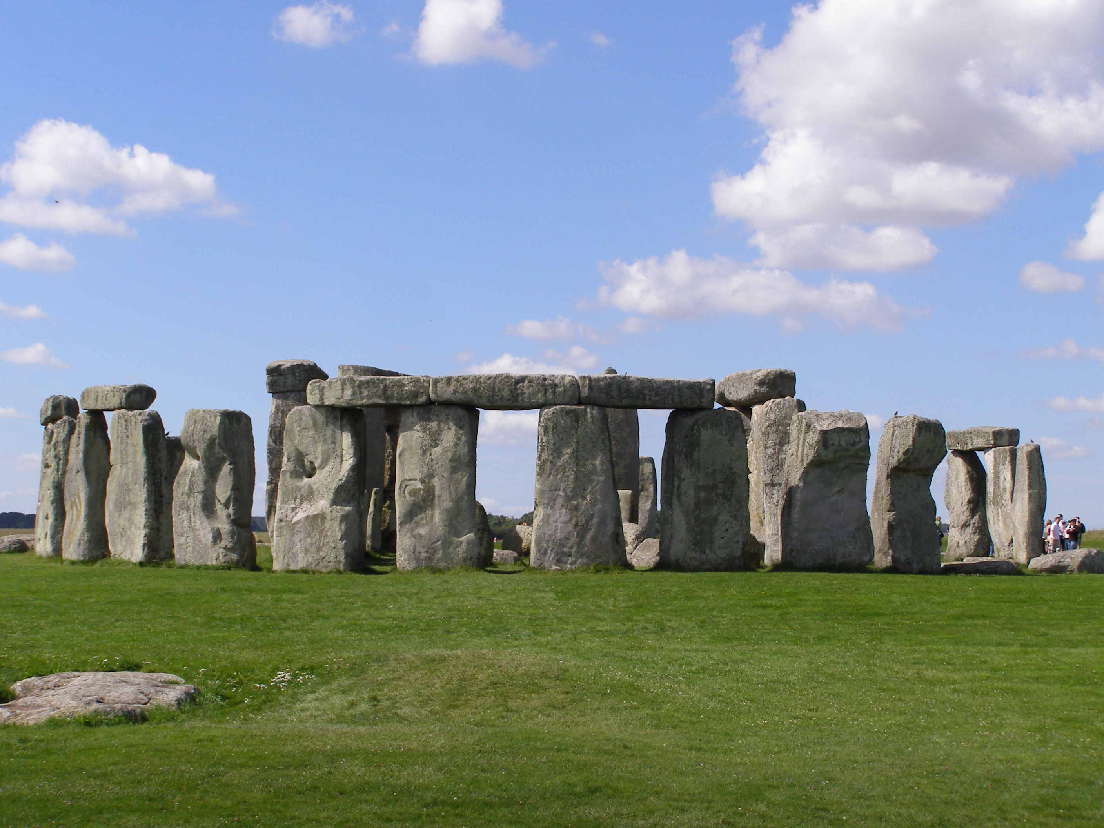  Stonehenge. Wiltshire, UK. Neolithic Europe. c. 2500-1600 B.C.E. sandstone | Content:  Stonehenge is made with slightly carved, stacked stone pillars. The stones are arranged in a structure that lines up with the sun and astronomical cycles. The coherence with the sun marked season and served as an ancient calendar.  Style:  The symmetry of the structure creates a unity of the stones. The precision of the stones to line up with astronomical phenomena is strong. The architectural technique, post and lintel, is used. This is when two posts hold up an arch like roof and is still a major technique used in modern architecture. The lentils create the outer circle.  Contextual Analysis:  The builders of Stonehenge spanned over many years. They were able to control their environment for their own personal wants and needs. They managed to move extremely heavy rocks into the formation known as Stonehenge. The structure serves as a sort of calendar, in which it lines up with the sun during sunrise and sunset and other astronomical happenings. Stonehenge was most likely a religious place, however researchers say it could have also been used as a reference for migration and farming.  (http://www.cram.com/user/jsalka)
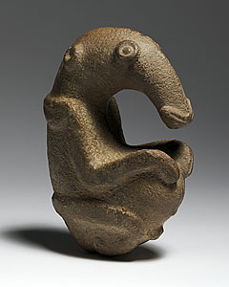  The Ambum Stone. Ambum Valley, Enga Province, Papua New Guinea. c.1500 B.C.E. Greywacke. | Content:  The Ambum Stone appears to be a depiction of some sort of ancient anteater or similar animal. The rounded belly allows for the piece to be freestanding figure.  Style:  The artist subtracted a large amount of stone to create the floating neck of the figure. The style steps away from incision. It is a 3D statue, and the stone is tough meaning it took much time to chip at and create.  Contextual Analysis:  The function of the Ambum stone remains unclear. Very little is known about the Island people who produced it. Today, similar statues are used in spiritual sorcery and other rituals.  (http://www.cram.com/user/jsalka)
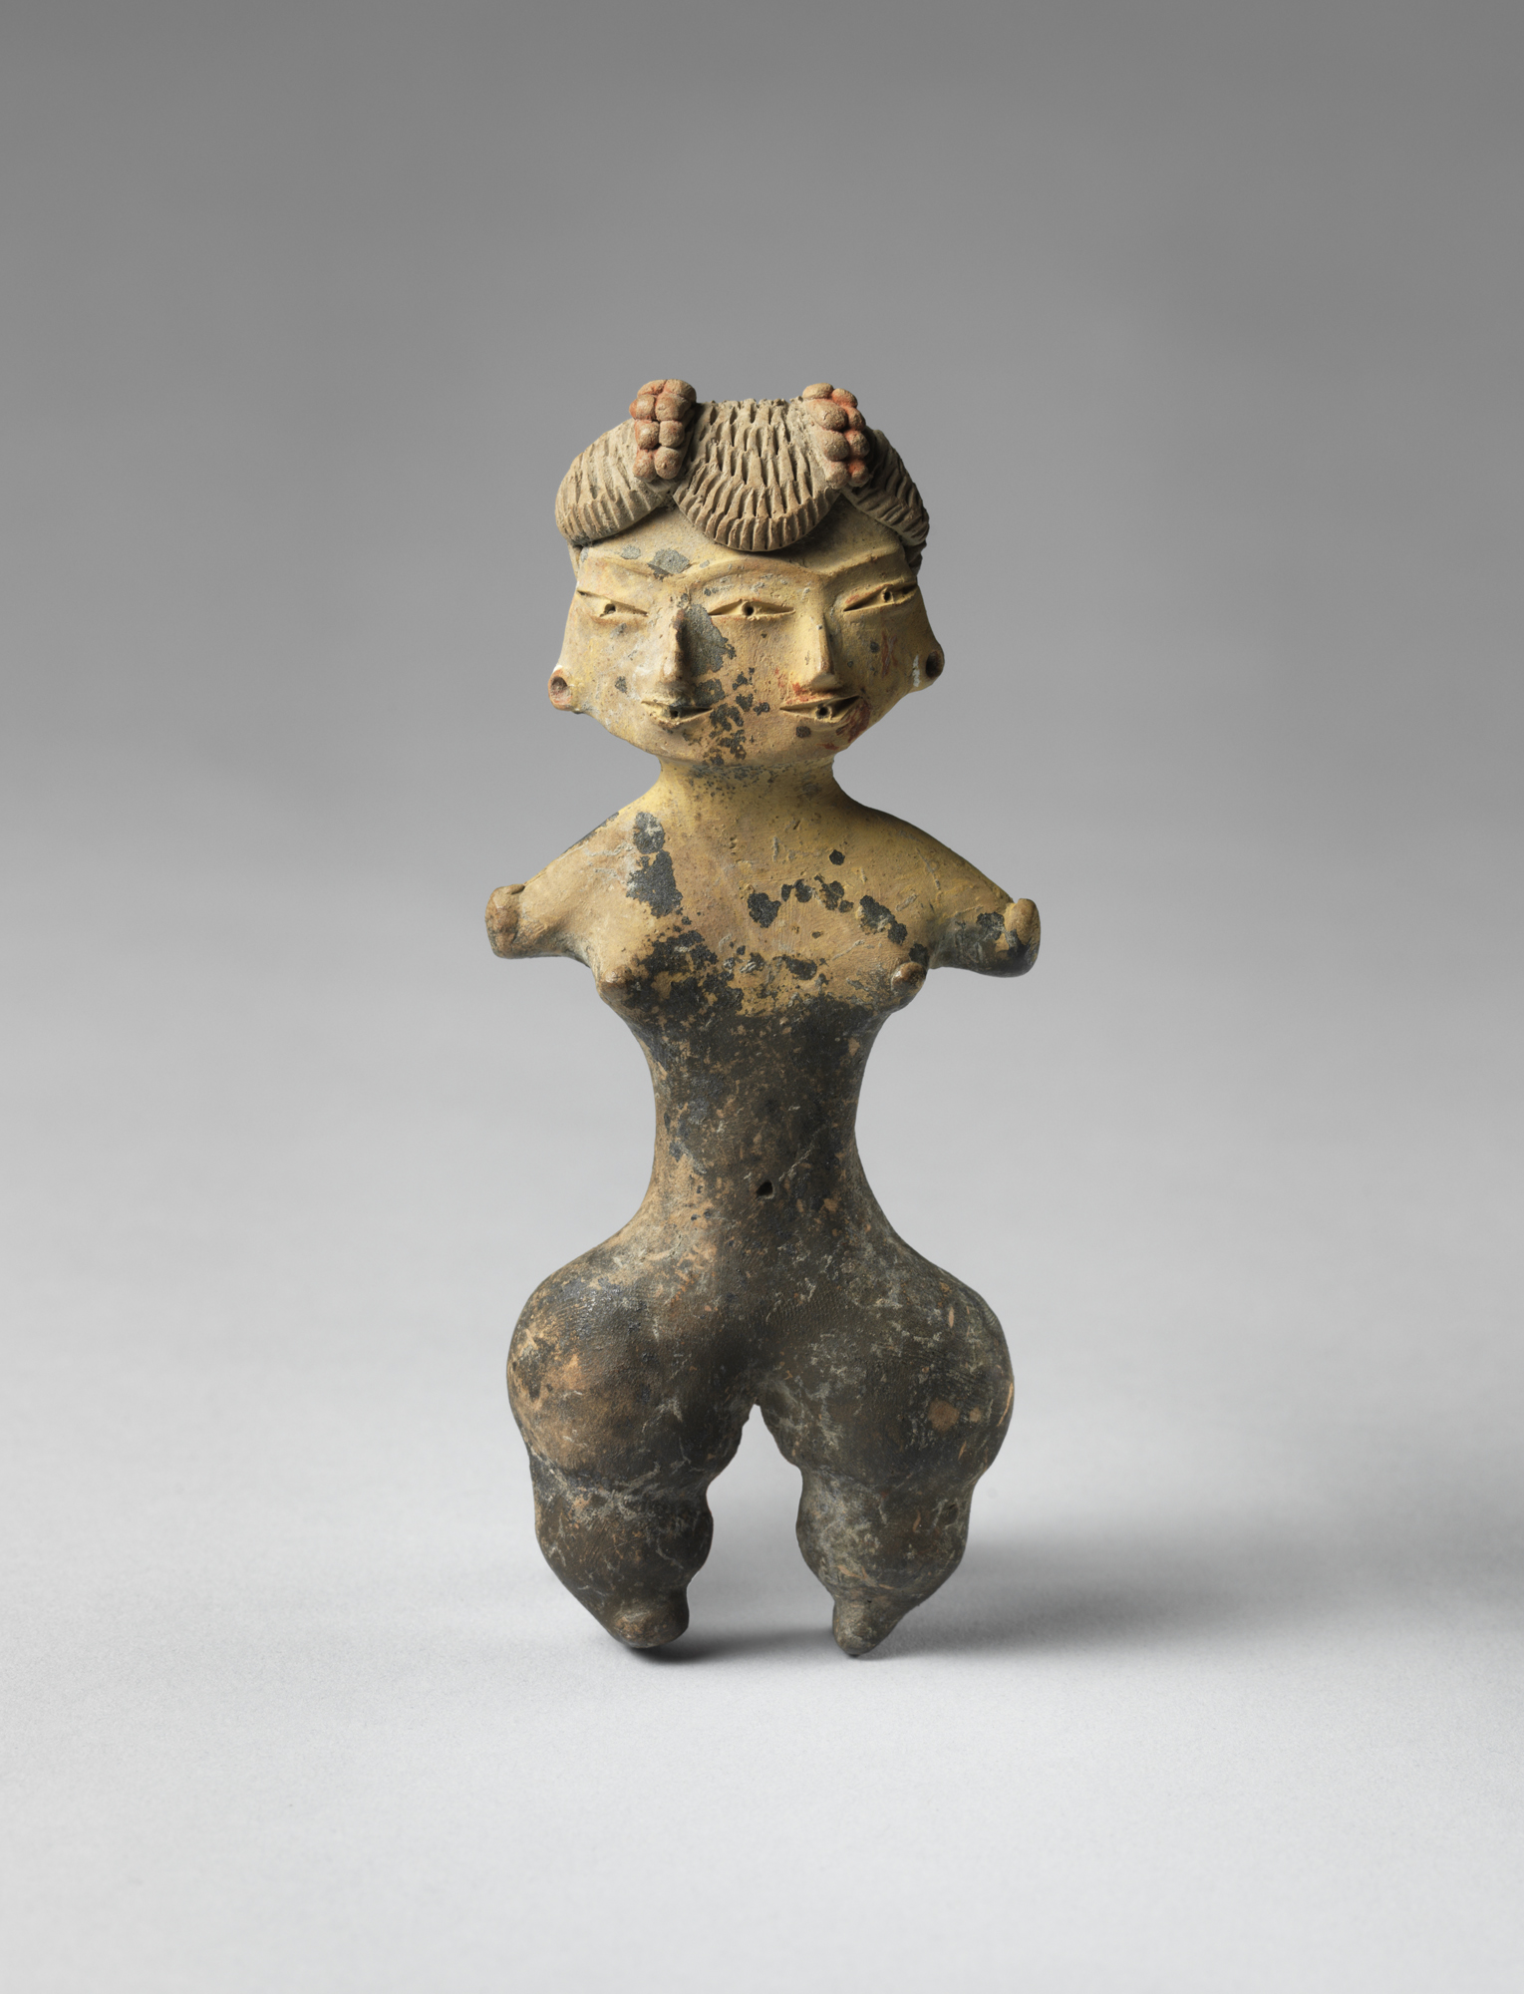  Tlatilco female figure. Central Mexico, site of Tlatilco. 1200 – 900 B.C.E. ceramic. | Content:  This piece is a small figurine made from clay. It is a female, perhaps another sort of fertility figurine. There is much emphasis around the hips, which are significant in bearing a child. There are also two faces, why?  Style:  The use of ceramics shows human understanding of manipulating natural materials. The carvings are very detailed and on top of that there are additional painted details.  Contextual Analysis:  The purpose of this figure is most likely religious or in relation to fertility. The piece is small, hinting that is was meant to be portable. It is not free standing, so it was perhaps meant to be carried, however, being ceramic it is much more fragile than a rock figurine.  (http://www.cram.com/user/jsalka)
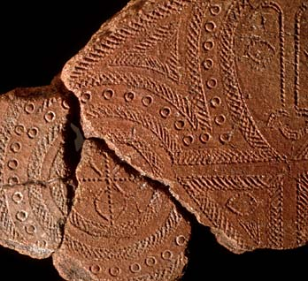  Terra cotta fragment. Lapita. Solomon Islands, Reef Islands. 100 B.C.E. Terra cotta (incised). | Content:  This piece demonstrated the repetition of geometric patterns. There is occasionally a stylized face within the carvings. Many Lapita ceramics are large vessels thought to be used for cooking or storage.  Style:  The patterns on these fragments or other whole vessels were incised into the wet clay before firing. They used a comb like tool to stamp the designs into the clay.  Contextual Analysis:  These pieces come from what once was a large vessel likely used for cooking or storage. The designs often included specific patterns or stylized faces that may have been used to resemble a specific person or the importance of an individual.  (http://www.cram.com/user/jsalka)

