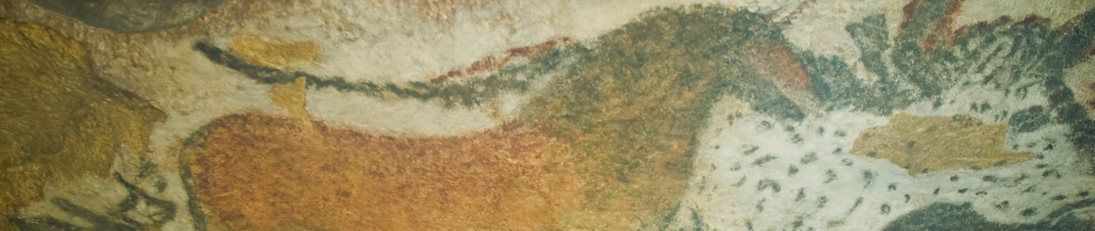

Anthropomorphic Stele, Arabian Peninsula. Fourth millennium B.C.E. Sandstone.

Citation: By Wolfgang Sauber (Own work) [GFDL (http://www.gnu.org/copyleft/fdl.html) or CC-BY-SA-3.0-2.5-2.0-1.0 (http://creativecommons.org/licenses/by-sa/3.0)], via Wikimedia Commons

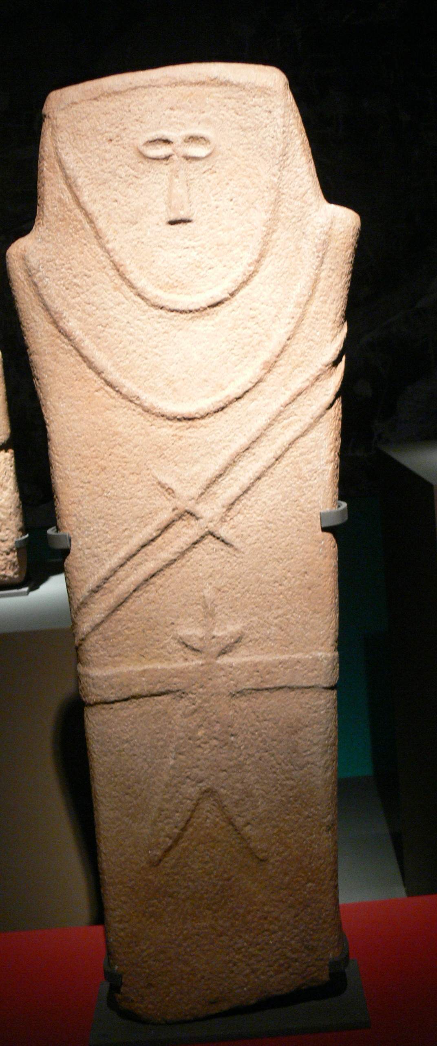

This haunting anthropomorphic stele is among the earliest known works of art from the Arabian Peninsula. Neolithic steles are also known as stone markers. These pieces are meant to stand upright and perhaps mark one's territory or recognition of a person of importance.
This piece is a carved, incised stone. The size of the work is 92 cm in height by 21 cm in width. The figure is stylized, meaning not realistic, but based off reality. The figure's distinctive belted robe and double-bladed sword may have been unique to this region.

Citation:
Anthropomorphic Stele. (n.d.). Retrieved September 28, 2014, from http://www.roadsofarabia.com/exhibition/artifact_1.html

