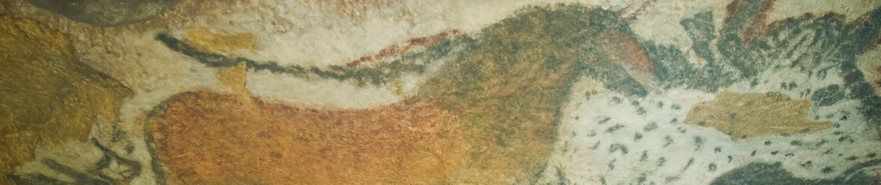
The Ambum Stone. Ambum Valley, Enga Province, Papua New Guinea. c. 1500 B.C.E. Greywacke.

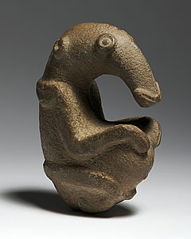

\Photo Citation: Flickr/Steven Zucker/ https://www.flickr.com/photos/profzucker/15795098831/sizes/o/

The earliest known Oceanic sculptures is a variety of ancient stone objects discovered in Papua New Guinea. Found primarily in the mountainous highlands of the interior, they are enigmatic remnants of a culture once existed on the island. The dating of these objects remains uncertain. This figure possibly depicts an echidna, an egg-laying mammal native to New Guinea and Australia. Such "spiny anteater" figures have been unearthed at a number of locations in the New Guinea Highlands. (Met Museum) The significance and function of such stone images remain unknown, although present day people of the region consider them sacred. (nga.gov.au)

Citation:
The Ambum Stone. (2014, January 1). Retrieved September 27, 2014, from http://nga.gov.au/AmbumStone/index.cfm

Heilbrunn Timeline of Art History. (2014, January 1). Retrieved September 27, 2014, from http://www.metmuseum.org/toah/hd/ngss/hd_ngss.htm

