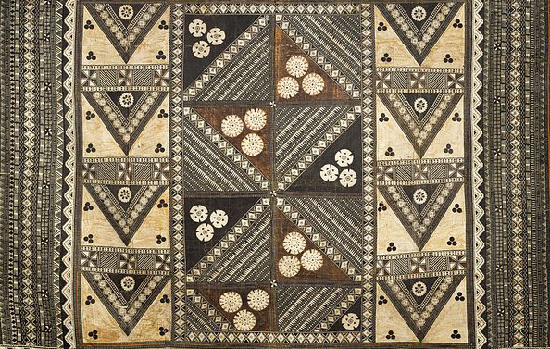

Pacific Arts

Nan Madol. Pohnpei, Micronesia. Saudeleur Dynasty. c. 700–1600 C.E. Basalt boulders
and prismatic columns.

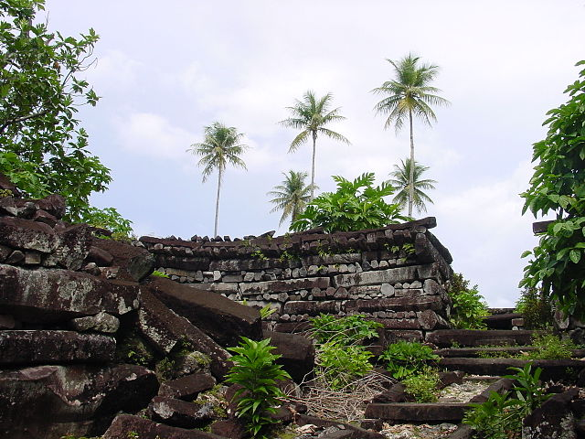

"Nan Madol 5" by CT Snow from Hsinchu, Taiwan - Nan Madol ruins in
Pohnpei. Licensed under CC BY 2.0 via Wikimedia Commons -

Creation Myth
From "Micronesian Legends" by Bo Flood, Beret E. Strong, & William Flood
“A canoe came from beyond the horizon in search of the "Eaves of Heaven." Sapikini, a master canoe builder from the southern land of Eir, slipped away from home with seven men and nine women.
The people on his cane asked the wind to help them on their journey. They sailed until they met the octopus Litakika, who told them to follow the swells until they came to a submerged reef so long it began where the sun touched the sea at dawn and ended where it disappeared at dusk. The people called upon the gods to help them build a stone alter on this holy reef...
The people who sailed from far beyond the horizon finished their work. They stood together and watched as the land beneath the alter spread and rose up to form an island with mountains and swamps. to honor the divinely blessed island, they named it Pohnpei, which means "upon a stone altar."

Just off the east cost of Pohnpei, sits an ancient city built of giant rocks. All the buildings were linked by canals and these grand palaces were the homes of the powerful and wealthy of the Saudeleur dynasty. The construction of Nan Madol was completed in 1200 AD, covering an area of 150 acres. It was only occupied for about 400 years. There was no fresh water source or food sources in the city.One major purpose of constructing a separate city was to insulate the nobility from the common people.
The common folk, living on the island, had to bring all the food to the rulers and the powerful. In 1600 an exiled warrior named Isokelekel raised an army of 333 and took over the city.

Facts about Nam Madol:
- The name Nan Madol means "spaces between" and is a reference to the canals that crisscross the ruins.
- Nan Madol served, in part, as a way for the ruling Saudeleur chiefs to organize and control potential rivals by requiring them to live in the city rather than in their home districts, where their activities were difficult to monitor.
- Nan Madol covers 170 acres and is made up of 92 small man-made islands. These islands are connected by network of canals.
- The islands are oriented northwest to southwest; therefore they receive cooling winds.
- Seawalls protect the Nan Madol from the ocean, as well as breakwaters.
- The islands and structures were built using prismatic basalt in alternating courses.

Citation:
"Pohnpei." Pcep -. Web. 12 Apr. 2015. <https://pcep.wikispaces.com/Pohnpei>.
"Travellers' Guide to Nan_Madol." Travellerspoint. Web. 12 Apr. 2015. <http://www.travellerspoint.com/guide/Nan_Madol/>.

