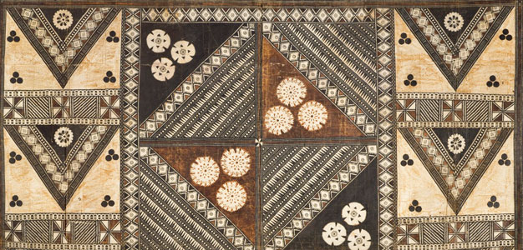
African Art Module

Ndop (portrait figure) of King. Mishe miShyaang maMbul. Kuba peoples (Democratic Republic of the Congo). c. 1760–1780 C.E. Wood.
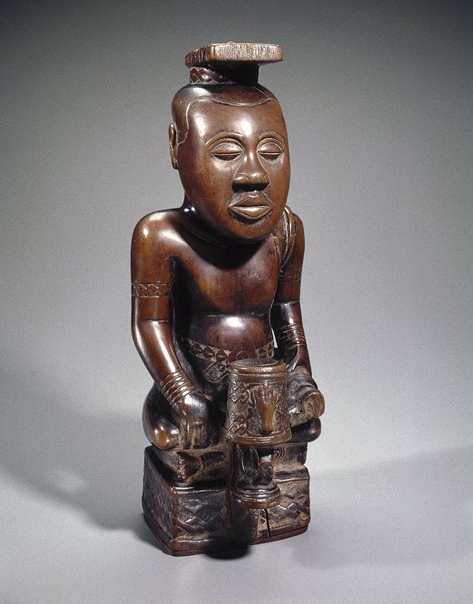

Image Citation: https://www.khanacademy.org/humanities/art-africa-oceania-americas/africa-art/kuba/a/ndop-portrait-of-king-mishe-mishyaang-mambul

“Ndop figures are idealized portraits of individual Kuba rulers. This ndop, considered the oldest in existence, displays the king’s personal symbol, a drum with a severed hand. As in other ndop figures, the ruler sits cross-legged on a raised platform. His face expresses both aloofness and composure. The short sword in his left hand (held with handle out, indicating the nonaggressive pose of the nyim) and the belts, ßarmbands, bracelets, shoulder ornaments, and special projecting headdress are all elements of royal regalia. Ndop figures were believed to represent and honor the spirit of the nyim and serve as a point of contact with his spirit (Brooklyn Museum).”
These figures validate the king's claim to dynastic succession. The sculptures are considered his "spirit double," the material counterpart to his soul. The king is always portrayed in the prime of life and more idealistic since it was believed that the king's health reflected the state of the nation.
This figure has been identified this figure as Mishe miShyaang maMbul, who reigned in the early years of the eighteenth century. Two features determine identity: a distinctive geometric motif around the base and a symbol placed in front of the king. A drum with a severed hand is the ibol for Mishe miShyaang maMbul’s reign, and that helps us identify the sculpture as his likeness (Khan).

Citations:

Collections: Arts of Africa: Ndop Portrait of King Mishe MiShyaang MaMbul." Brooklyn Museum: Arts of Africa: Ndop Portrait of King Mishe MiShyaang MaMbul. Web. 2 Mar. 2015. <http://www.brooklynmuseum.org/opencollection/objects/4791/Ndop_Portrait_of_King_Mishe_miShyaang_maMbul>.

"Khan Academy." Khan Academy. Web. 2 Mar. 2015. <https://www.khanacademy.org/humanities/art-africa-oceania-americas/africa-art/kuba/a/ndop-portrait-of-king-mishe-mishyaang-mambul>.

