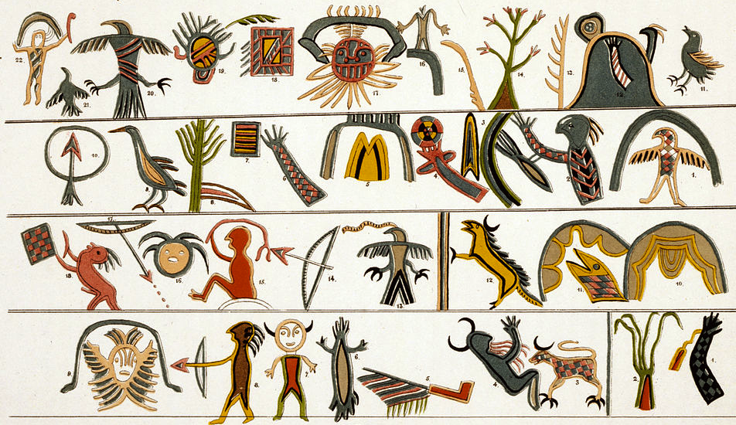
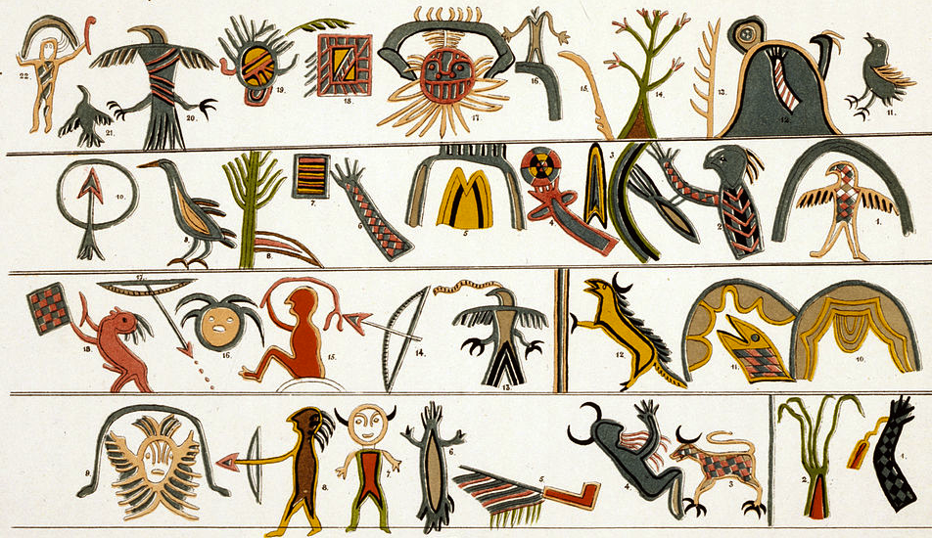
Tenochtitlan (modern Mexico City, Mexico). Mexica (Aztec). 1375–1520 C.E. Jadeite (Olmec-style mask).
Indigenous Americas Module

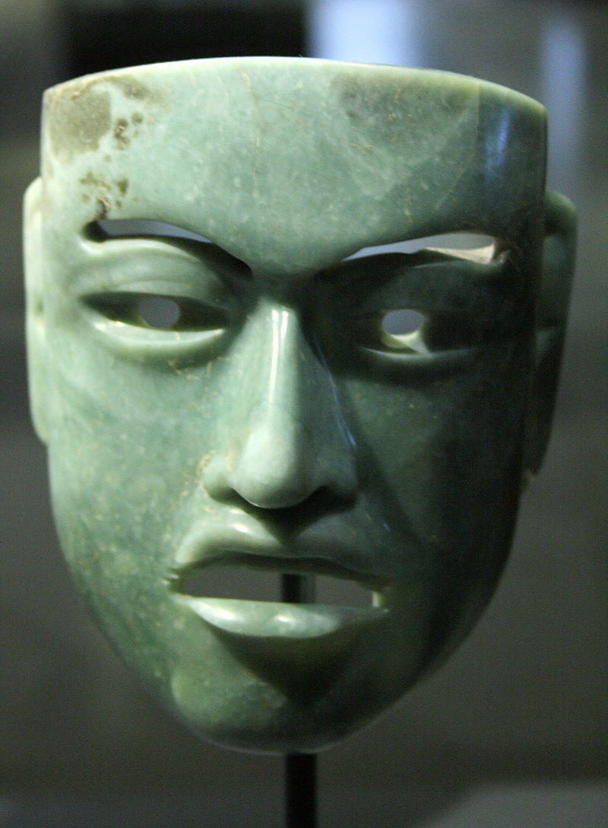

Citation:
"Olmec mask 802" by Michel wal - Own work. Licensed under CC BY-SA 3.0 via Wikimedia Commons –

The image is not the same as the one in your image set.

Over a hundred ritual deposits holding thousands of objects have been found associated with the Templo Mayor. Some of these offerings contained items related to water, like coral, shells and crocodile skeletons, while other deposits related to warfare and sacrifice. Many of these offerings contain objects from faraway places—most likely tribute. Some offerings demonstrate the Mexica’s awareness of the historical and cultural traditions in Mesoamerica. For instance, they buried an Olmec mask made of jadeite, as well as others from Teotihuacan. The Olmec mask was made over a thousand years prior to the Mexica, and its burial in Templo Mayor suggests that the Mexica found it precious and perhaps historically significant (Khan Academy).
Considered the “mother culture” of Mesoamerica and recognized as America’s oldest civilization. The Olmec are best known for the creation of colossal heads carved from giant boulders but also for their work with jadeite. Jadeite was quarried in the Sierra de las Minas in Guatemala, and was imported to the Gulf Coast of Mexico.
Masks of this size in stone have not been excavated in archaeological sites and it is difficult to determine their function. Lacking holes for eyes it may have been used as a costume element or adhered to a mummy of the deceased.
The mask has a thin, straight nose sets off the wide-set eyes. The work has a square jaw, small rounded chin, and puffy eyelids. The flesh, symmetrical lips are open to show gums. One each side of the lower lip is a raised cleft- the Olmec emblem for corn. Corn, or maize, was a plant of significance to ancient Mexico, and it took on religious importance from a very early date. To the Olmecs, masks such as this one carried many meanings, not all of which are understood today. Maize and the color green—both aspects of this mask—were associated with growth, renewal, and rejuvenation after death (Met Museum).

Citations:

"Khan Academy." Khan Academy. Web. 16 Feb. 2015. <https://www.khanacademy.org/humanities/art-africa-oceania-americas/mesoamerica/aztec-mexica/a/mexica-templo-mayor-at-tenochtitlan-the-coyolxauhqui-stone-and-an-olmec-mask>.

"Heilbrunn Timeline of Art History." Mask [Mexico; Olmec] (1977.187.33). Web. 16 Feb. 2015. <http://www.metmuseum.org/toah/works-of-art/1977.187.33>.

