Persepolis Audience Hall (Apadana) of Darius and Xeres
Persepolis, Iran. Persian. c. 520-465 B.C.E
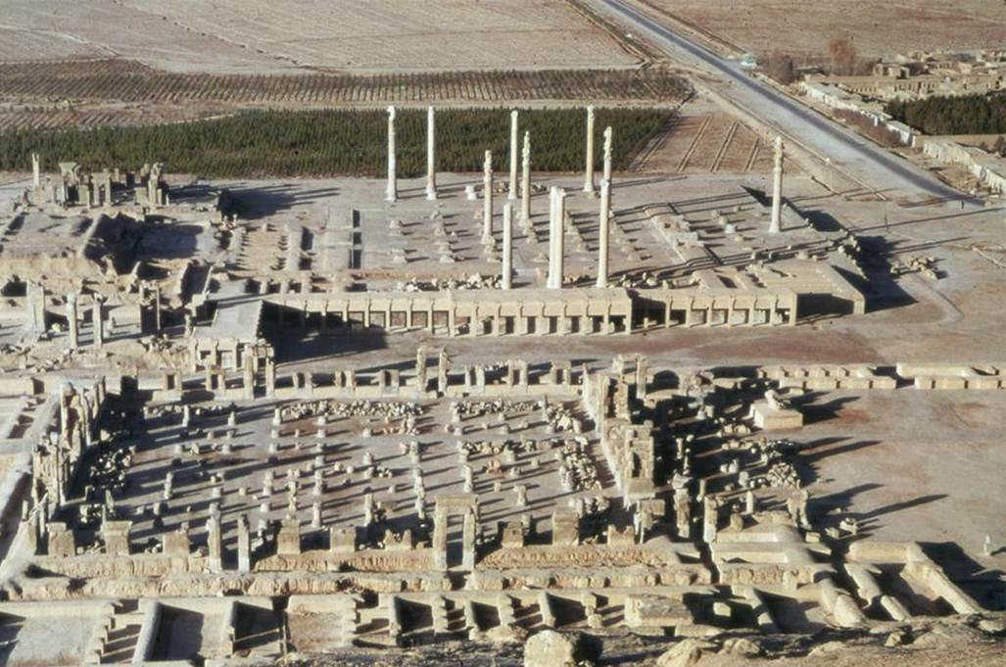
Sources: https://classconnection.s3.amazonaws.com/605/flashcards/22605/jpg/apandana_(audience_hall)_of_darius_i_persepolis1329195454574.jpg
https://www.khanacademy.org/humanities/ap-art-history/ancient-mediterranean-ap/ancient-near-east-a/a/audience-hall-apadana-of-darius-and-xerxes-persepolis
Content: After Alexander killed Darius III, in a lavish way in the royal tombs near Persepolis, he respectfully buried him.
Content:
Darius was the main builder and constructer of Persepolis.
Context:
Cyrus the Great was the one who chose the site of the Persepolis.
Material:
Grey Limestone was the key material used to make the Persepolis.
Content:
It was said that the fire which that burned down Persepolis started in the Hadish Palace of Xeres I.
Form:
The Pillars represented how the architecture of Persian times developed many different types of Doric designs.
Content:
The walls leading up to the reception hall were carved with many sculptures and figures.

Content: Apadana is an audience hall, which is located on the second terrace.
Context: Alexander the Great tore the Original Persepolis down.
Form:
Made of many reliefs and in the round designs.

