Later Europe and America Module I
Portrait of Sor Juana Inés de la Cruz. Miguel Cabrera. c. 1750 C.E. Oil on canvas.

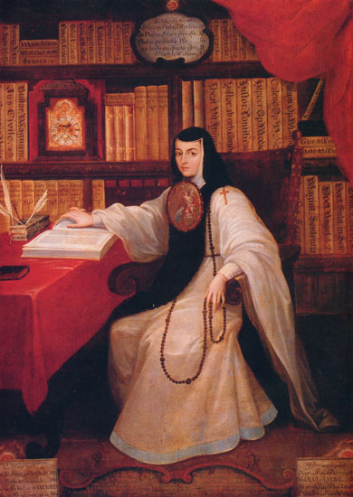

Citation: By Miguel Cabrera (http://es.wikipedia.org/wiki/)
[Public domain], via Wikimedia Commons

Miguel Mateo Maldonado y Cabrera was a New Spanish Baroque painter from the Viceroyalty of New Spain (Mexico.) He was recognized as one of the greatest painter in all of New Spain.
This work is a posthumous portrait of Sor Juana Inés de la Cruz, the famous Mexican nun and writer. Considered the first feminist of the Americas, Sor Juana lived as a nun of the Jeronymite order (St. Jerome) in seventeenth-century Mexico. Rather than marry, she chose to become a nun so she could pursue intellectual interests. She corresponded with scientists, theologians, and other literary intellectuals in Mexico and abroad. She wrote poetry and plays that became internationally famous, and even engaged in theological debates (Khan Academy).
A child prodigy who was allowed to read books from her grandfather’s library, she eventually came to live as a lady in waiting in the house of the viceroy, the representative for the Spanish king in Mexico. Wanting to continue her educational pursuits and not marry, she chose to become a nun. She first entered the Carmelite convent but left to join the Jeronymite order in 1669.The Jeronymite order allowed her to host intellectual gatherings, have her own room and live a comfortable life. She said she chose to become a nun so that she could have freedom, saying she wanted "to have no fixed occupation which might curtail my freedom to study.” (Wikipedia)
Sor Juana wears the habit of her religious order, the Jeronymites. The escudo de monja, or nun’s badge, is depicted under her chin. Escudos de monja were often painted on thin metal plates or occasionally woven. The subject of the works was usually images of the Virgin Mary. Sor Juana’s escudo shows the Annunciation. Her left hand touches her rosary, while the other hand turns the page of a book of St. Jerome. Sor Juana looks at the viewer as she sits at a desk, surrounded by her library and other instruments of learning. Books on philosophy, natural science, theology, mythology, and history can be seen on the shelves. Her written works are alluded to by the writing implements sit on the table (Khan Academy).

Citations:

"Juana Inés De La Cruz." Wikipedia. Wikimedia Foundation. Web. 23 Jan. 2015. <http://en.wikipedia.org/wiki/Juana_Inés_de_la_Cruz>.

"Khan Academy." Khan Academy. Web. 23 Jan. 2015. <https://www.khanacademy.org/humanities/monarchy-enlightenment/Colonial-Americas/a/cabrera-portrait-of-sor-juana-ins-de-la-cruz>.

