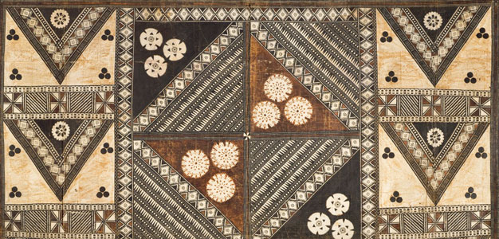
African Art Module

Female (Pwo) mask. Chokwe peoples (Democratic Republic of the Congo). Late
19th to early 20th century C.E. Wood, fiber, pigment, and metal.
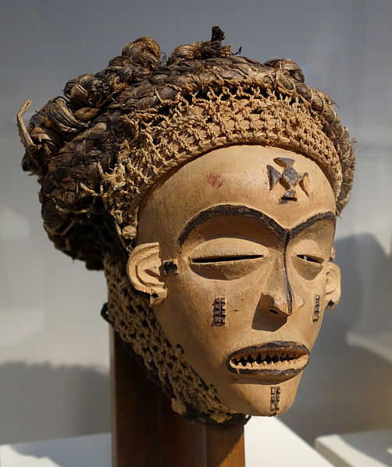

Image Citation: By Daderot (Own work) [CC0], via Wikimedia Commons

The Pwo mask honors founding female ancestors. The masks are especially significant given that the Chokwe trace descent through their mothers. Pwo's joint performance with her male counterpart, Cihongo, brings fertility and prosperity to a community.
Chokwe masks are often performed at the celebrations that mark the completion of initiation into adulthood. That occasion also marks the ending of the bonds of intimacy between mothers and son.
Although Pwo represents a woman and a female role model, she is created by men and performed by males. Women accept this male concept of the ideal female if they feel the performance honors them, but they may drive away as performer whom they feel is not up to standards. Male dancers dance while wearing a costume with the mask, which includes wooden breasts and a female bustle. Characterized by short steps and sensuous hip movements, the dance is the male concept of the ideal female. The women often dance alongside them to test the skills of the impersonator (MetMuseum).

Citations:
"Mask: Female (Pwo) | Chokwe Peoples." Mask: Female (Pwo). Web. 2 Mar. 2015. <http://www.metmuseum.org/collection/the-collection-online/search/319264>.

