Ruler’s feather headdress (probably of Motecuhzoma II). Mexica (Aztec). 1428–1520 C.E. Feathers (quetzal and cotinga) and gold.
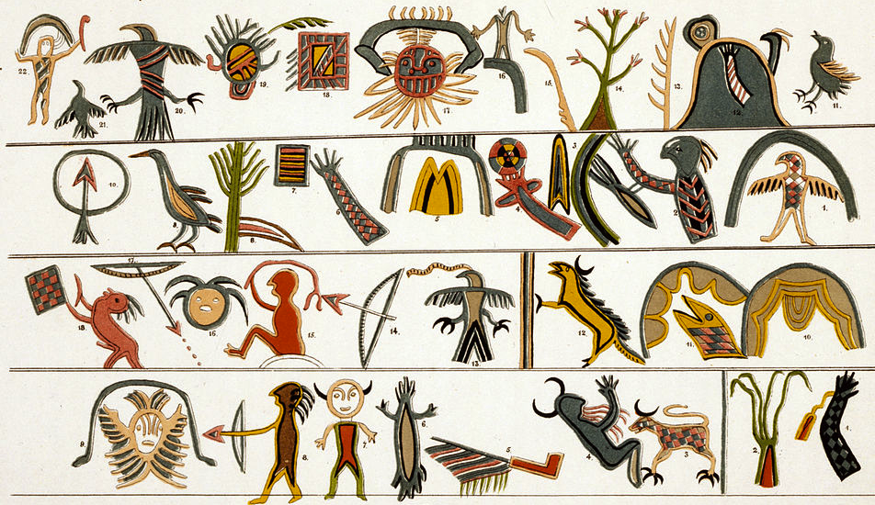
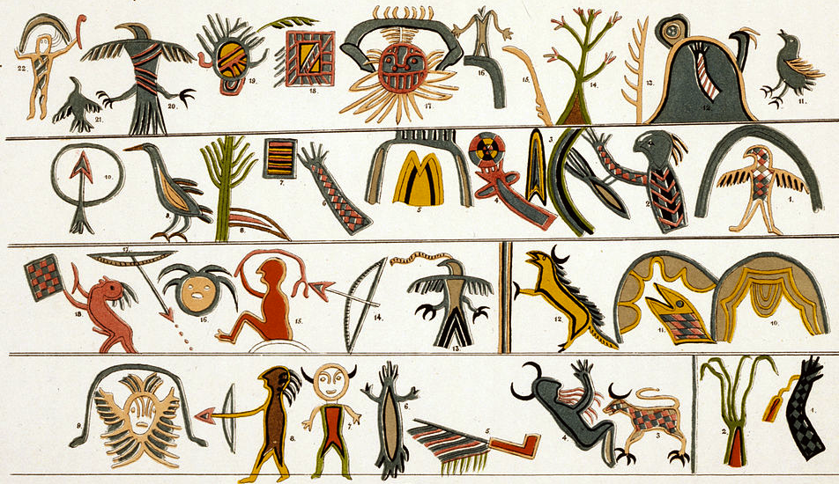
Indigenous Americas Module
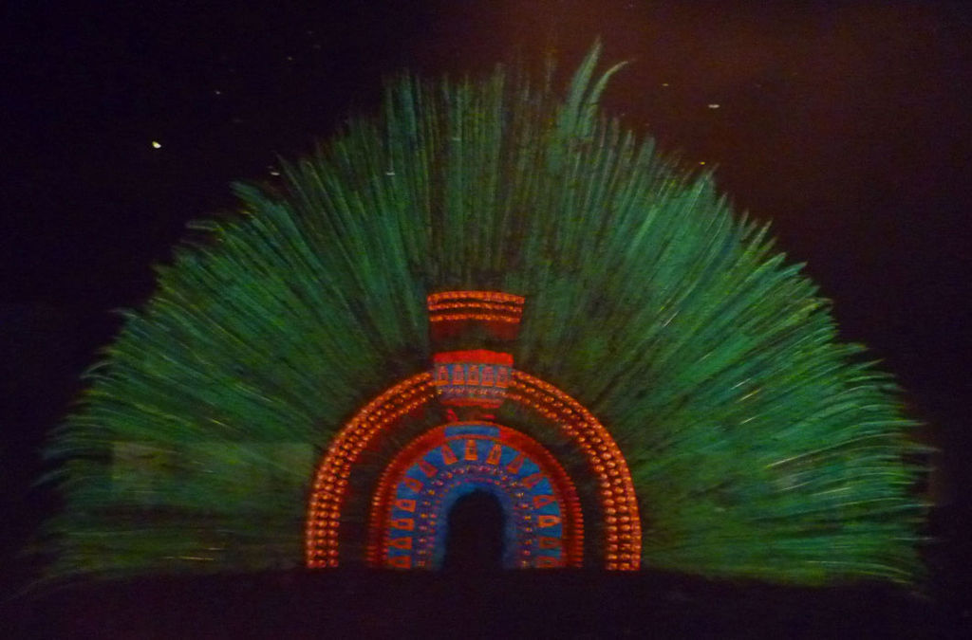

"Aztec headdress" by ·Maunus·ƛ· - Own work. Licensed under Creative Commons
Attribution-Share Alike 3.0-2.5-2.0-1.0 via Wikimedia Commons - http://commons.wikimedia.org/wiki/File:Aztecheaddress.jpg#mediaviewer/File:Aztecheaddress.jpg

Moctezuma's headdress is a feathered crown, which tradition believes belonged to Moctezuma II, the Aztec emperor at the time of the Spanish Conquest. Although the owner is uncertain and even its identity as a headdress has been questioned, it is made of quetzal and other feathers mounted in a base of gold dotted with precious stones. It currently rests in the Museum of Ethnology. This work is a source of dispute between Austria and Mexico as no similar pieces remain in Mexico.
The feathers of the piece have deteriorated over the centuries. It is 46 inches high and 69 inches across. The headdress has made of concentric layers of different colored feathers arranged in a semicircle. The smallest is made from blue feathers of the Lovely Cotinga with small plates of gold in the shapes of half moons, inlaid with precious stones. The next layer is made of pink flamingo feathers, then small quetzal feathers, then a layer of white-tipped red-brown feathers of the squirrel cuckoo, with three bands of small gold plates. The last layer is consists of 400 closely spaced quetzal tail feathers, 22 inches long. The quetzal feathers in the center of the headdress are raised relative to the sides. Leather straps attach the crown to the head of the wearer (Wikipedia). Although attributed to Moctezuma and the Spanish conquest, the origin of the piece is cannot be proven. It became an object of interest to European researchers end of the 19th century. It was restored in 1878, while still thought to be a mantle rather than a headdress. It is attested since 1575 in the collections of Archduke Ferdinand in Ambras near Innsbruck, Austria. At the beginning of the 19th century it was deposited in the Museum of Ethnology in Vienna along with other artifacts of Quetzalcoatl and Ehecatl. Originally, a golden bird’s beak was attached to the headdress. Upon its discovery the headdress was restored, feathers and metal ornaments (now of gilded bronze) were substituted (Mexilcolore).

Citations:
"Montezuma's Headdress." Wikipedia. Wikimedia Foundation. Web. 16 Feb. 2015. <http://en.wikipedia.org/wiki/Montezuma's_headdress>.

"Vienna’s Mesoamerican Featherworks." Vienna’s Mesoamerican Featherworks. Web. 16 Feb. 2015. <http://www.mexicolore.co.uk/aztecs/home/viennas-mesoamerican-featherworks>.

