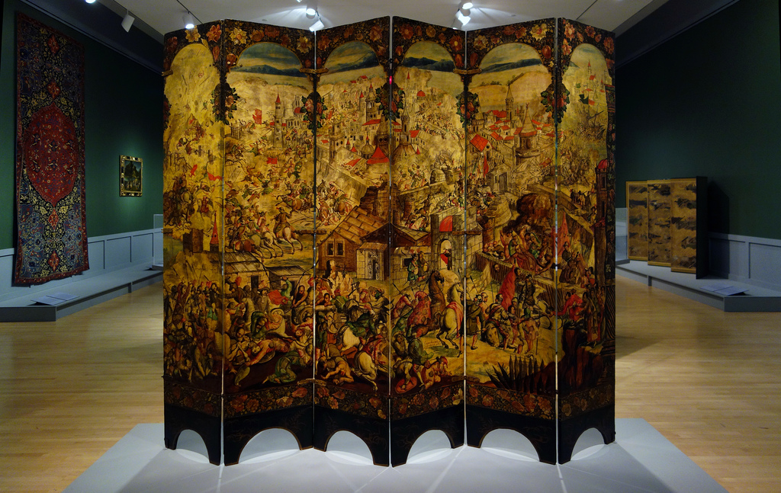
Screen with the Siege of Belgrade and hunting scene. Circle of the González Family. c. 1697–1701 C.E. Tempera and resin on wood, shell inlay.
.

Early Europe and Colonial Americas Module III

These panels constitute half of a twelve-panel screen, created after Asian models by artists working in the circle of the celebrated González family in Mexico City, where it was displayed in the state rooms of the capital’s vice regal palace.

Flickr/ProfZuck/https://www.flickr.com/photos/
profzucker/11917662303/in/album-72157648851606647/

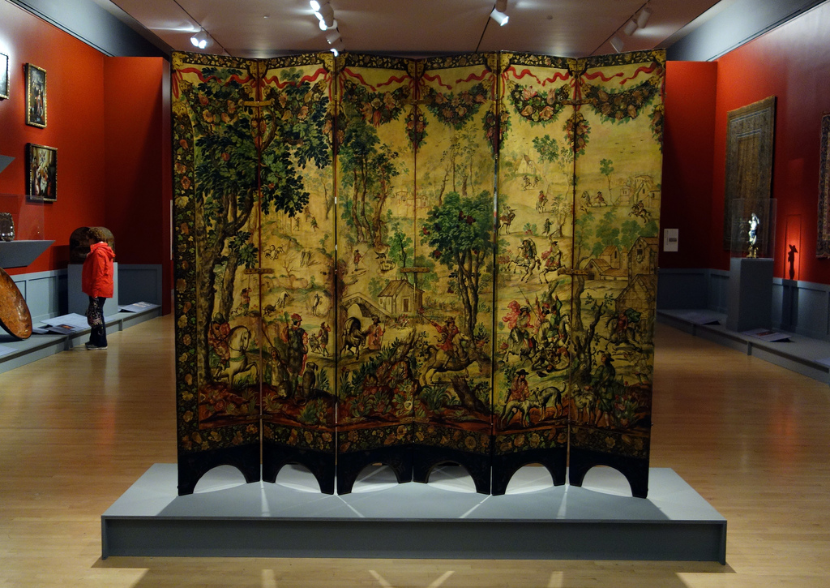

ProfZuck/https://www.flickr.com/photos/profzucker/11917828903/sizes/l
Japanese folding screens, the inspiration of Mexican biombos, were introduced to the Americas in the early seventeenth century. Folding screens were diplomatic gifts from Japanese embassies as well as elite Asian exports. Asian screens became popular with the viceroyalty’s wealthy elite, and local artists began creating the screens in their own style.
Paintings inlaid with mother-of-pearl combined the use of tempera and oil painting with lacquer and mother-of-pearl encrustation techniques.
The scene from the Great Turkish War was modeled after a Dutch print. It served as an ideal propagandistic backdrop of Habsburg power for the welcome of the viceroy’s official visitors. This front depicts a with a major Habsburg victory over the Ottoman Empire, a scene from the Great Turkish War (1683-87). The section depicts the siege of Belgrade on 6 September 1688, when Imperial Habsburg troops under the leadership of Maximilian II Emanuel, took Belgrade, which had been part of the Ottoman Empire.
The Medici court painter Johannes Stradanus for the back of the screen modeled the Hunting scene in part after prints. It would have served as a backdrop for the women’s sitting room in the palace.

Citations:
"The New York History Blog." The New York History Blog. Web. 16 Jan. 2015. <http://newyorkhistoryblog.org/2012/05/14/brooklyn-museum-acquires-rare-folding-screen/>.

