The Standard of Ur has two sides with two separate stories. One side shows war and the other side shows peace.
The Standard of Ur is a box (trapezoidal).
It is 8.5 Inches high by 19.5 Inches long.

Standard of Ur in one of the largest tombs in Ur.
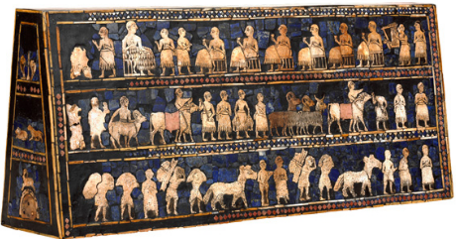
The Standard of Ur is made of lapis lazuli, which is an expensive stone.
Original function is unknown.
The Standard of Ur is currently at a British Museum.
Was found in Sumer, Mesopotamia, which is present day Iran.
Standard of Ur is a mosaic. A mosaic is a picture or pattern produced by arranging together small colored pieces of hard material, such as stone, tile, or glass.

The details of the pictography have helped archaeologists today to appreciate how the ancient Sumerians lived.

http://www.penn.museum/sites/iraq/?page_id=48

