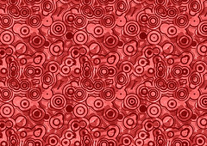
Global Contemporary

Summer Trees. Song Su-nam. 1983 C.E. Ink on paper.

Click this link to see the work:
http://www.britishmuseum.org/research/collection_online/collection_object_details.aspx?objectId=267937&partId=1

Song Su-nam is one of the leaders of the 'Sumukhwa' or Oriental Ink Movement of the 1980s, based at Hongik University, Seoul. This movement shared the general feeling that it was necessary to 'recover' a national identity and began to concentrate on subtle tonal variations of ink wash. This was an attempt to elicit an inner spirituality, which was felt to be lost in a modern technological age.
This image was a part of the larger Oriental Ink Movement attempts to combine traditional ink on paper (an eastern tradition) with abstract style of painting. The intent was to create a balance between East and West as well as a balance between the past and present. Song Su-nam uses a variety of different tones to convey an abstract image of "summer trees."

Citation:
"Collection Object Details." British Museum. Web. 2 May 2015. <http://www.britishmuseum.org/research/collection_online/collection_object_details.aspx?objectId=267937&partId=1>.

