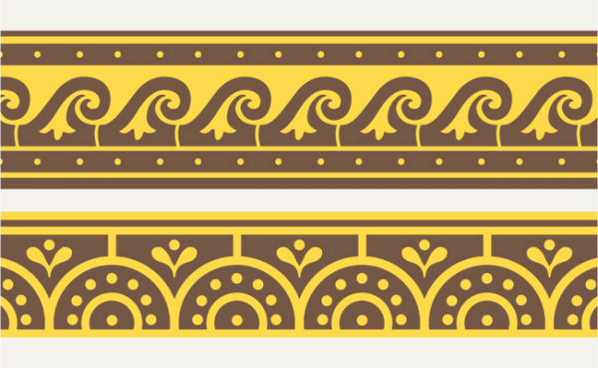

ANCIENT MEDITERRANEAN
MODULE /PART II

Temple of Minerva (Veii, near Rome, Italy) and sculpture of Apollo. Master sculptor Vulca. c. 510–500 B.C.E. Original temple of wood, mud brick, or tufa (volcanic rock); terra cotta sculpture.

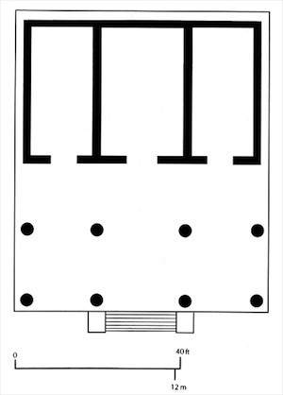
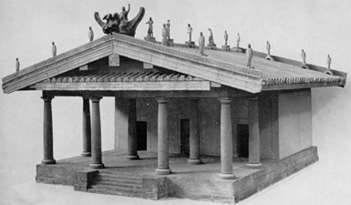

Images: http://smarthistory.khanacademy.org/temple-of-minerva.html

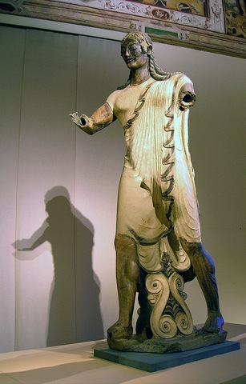

Among the early Etruscans, the worship of the gods did not take place in or around monumental temples in nature. Early Etruscans created ritual spaces in groves and enclosures open to the sky. Around 600 B.C.E., however, the desire to create monumental structures for the gods spread throughout Etruria as a result of Greek influence. While the desire to create temples for the gods may have been inspired by contact with Greek culture. Unlike the Greeks, Etruscan temples were markedly different in material and design. These colorful and ornate structures typically had stone foundations but their wood, mud-brick and terracotta structures unfortunately insured a short-lived nature. Fortunately, an ancient Roman architect by the name of Vitruvius wrote about Etruscan temples in his book De architectura in the late first century B.C.E. Vitruvius described the key elements of Etruscan temples and it was his description that inspired Renaissance architects to return to the roots of Tuscan design and allows art historians today to recreate their appearance.

The Temple of Minerva, dedicated to the goddess Menrva. It is located in the city of Veii about 18 km north of Rome. The temple is divided into two parts—a deep front porch with Tuscan columns and a back portion divided into three separate rooms or cellas. The multiple cella plan seems to reflect the worship of multiple gods. Some of the major differences between the Greek temple and the Etruscan temple other than the materials are the high podium and the solely frontal entrance.

An interesting fact about the Etruscan temples is the many terracotta sculptures still remains from the roofline of the temples. In similar fashion to the Greeks, the sculptures are placed to narrate as specific mythical event. The most famous is the Apollo of Veii. It is a large, terracotta masterpiece sculpture that is powerful striding forward. Apollo, dressed in a tunic and short cloak advances towards his left with his right arm outstretched and bent. Most likely he was holding a bow. The sculpture is definitely related to Archaic Greek models forward on his front foot and his back foot is slightly raised. While the Etruscan artist applied an Archaic smile to Apollo, the figure's head is more egg-shaped than round. (www.boundless.org)

For more information:
http://www.ou.edu/class/ahi4163/files/7terra.html

