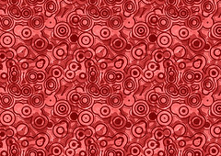
Global Contemporary

The Gates. New York City, U.S. Christo and Jeanne-Claude. 1979–2005 C.E. Mixed-media installation.
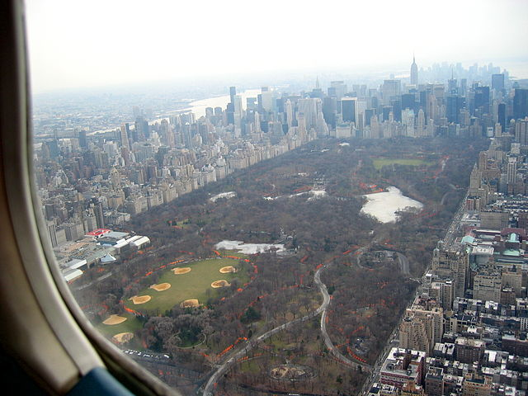
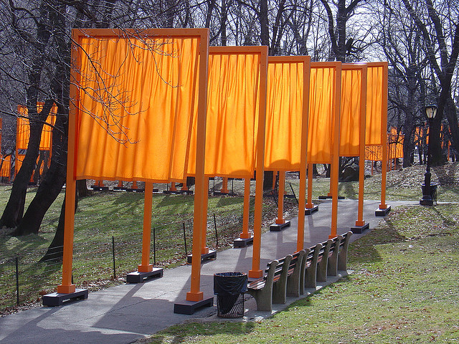
"CentralParkWithGatesFrom2000feet". Licensed
under CC BY-SA 3.0 via Wikimedia Commons
Photo Citation: "ChristoGates" by Delaywaves - Own work.
Licensed under CC BY 3.0 via Wikimedia Commons

The Gates is a land art project by Christo and Jeanne Claude.. They have created their temporary environmental artworks together since 1961, with Christo doing the preliminary drawings for the works. The artists installed 7,500 metal “gates” along 23 miles of pathways in Central Park in New York City. From each gate hung a flag-shaped piece of saffron-colored fabric. The project ran from February 12, 2005 through February 27, 2005.
The artist said this about the Gates:
“Our aspiration to create a major public work of art for New York began when we emigrated from Europe in 1964. During the 1970s, while creating projects elsewhere but continuing to live and work in New York, we remained committed to succeeding in completing a major outdoor work of art in the City. Our attention turned toward the vast flow of people walking through the streets. The resulting proposal was The Gates, a project directly related to the human scale, to be sited in Central Park, whose 843 acres are the ultimate locale for walking at leisure. First proposed in 1979, The Gates were then 12 feet tall, of a totally different design, and the first drawing was titled The Thousand Gates. The project was rejected in 1981 but ultimately approved on January 22, 2003 by Mayor Michael R. Bloomberg, for completion in February 2005 NYC).”
“The environmental works the pair have created span great distances in populated landscapes, both rural and urban. They are mostly made of fabric, created in the form of a large curtain, wrapped forms (buildings, coastline, a bridge), surrounded islands, large umbrellas, and other forms. They have paid all expenses associated with the artworks, including planning, construction, and taking down, partly from the sale of Christo's preliminary drawings, early works from the 1950's and 1960's, and lithographs. They have accepted no contributions, grants or other financial assistance, preferring to make their aesthetic decisions apart from any influence financial backing might involve. A large group of paid workers is necessary to construct and take down these works, which can extend for great distances. Usually, there are years of planning, and meetings and hearings held by governments and communities, to gain approval for their projects (NDoyle).”

Citation:
"Artist Profile: Christo and Jeanne-Claude, Environmental Artists." Artist Profile: Christo and Jeanne-Claude, Environmental Artists. Web. 29 Apr. 2015. <http://www.ndoylefineart.com/christo.html>

"The Gates - Christo and Jeanne-Claude in Their Own Words." The Gates - Christo and Jeanne-Claude in Their Own Words. Web. 29 Apr. 2015. <http://www.nyc.gov/html/thegates/html/qanda.html>

