The Great Hall of Bulls
Context: Shows the close relationship between animals and humans in this hunter-gatherer society.
Lascaux, France. Paleolithic Europe, Rock Painting, 15,000-13,000 B.C.E.
Form: We see the animals in a twisted perspective. This means we see the profile of their bodies, but the horns are facing the front.
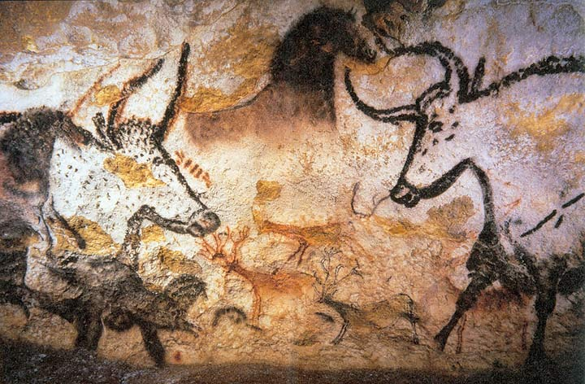
Source: https://commons.wikimedia.org/wiki/File:Lascaux_painting.jpg
Form: Figures are outlined in a way with pigments to give more definition to the body of the animal.
Function: Due to the narrow passageways and difficult to maneuver areas leading up to this piece historians can predict that this was not meant as art-for-art’s sake.
Content: Depicts many animals including horses, bears, rhinos, lions, bison, reindeer, etc. However, there is very little human depiction in this piece.
Function: Believed to have been used for rituals for hunting or other things due to the size of the room or cave this piece was found in.
Content: Uses sympathetic magic to show how they believed picturing the animals would help them in some way like hunting.
Function: Believed that the drawings of animals could have been used to tell stories as well.
Content: Some animals shown are already dead, possibly due to the fact that the hunters wanted to see what could happen in the future while hunting.
Form: There appears to be no landscape that all animals are standing on. You cannot see a clear ground or even a scene where all animals would be together.

