The Tale of Genji
By Murasaki Shikibu, translated by Royall Tyler
Penguin Classics, 2001

1. Kiritsubo
At the court of the Emperor (he lived it matters not when) there was among the many gentlewomen of the Wardrobe and Chamber one who, though she was not of very high rank, was favored far beyond all the rest; so that the great ladies of the Palace, each of whom had secretly hoped that she herself would be chosen, looked with scorn and hatred upon the upstart who had dispelled their dreams. Still less were her former companions, the minor ladies of the Wardrobe, content to see her raised so far above them. Thus her position at Court, preponderant though it was, exposed her to constant jealousy and ill will; and soon, worn out with petty vexations, she fell into a decline, growing very melancholy and retiring frequently to her home. But the Emperor, so far from wearying of her now that she was no longer well or gay, grew every day more tender, and paid not the smallest heed to those who reproved him, till his conduct became the talk of all the land; and even his own barons and courtiers began to look askance at an attachment so ill-advised. They whispered among themselves that in the Land Beyond the Sea such happenings had led to riot and disaster. The people of the country did indeed soon have many grievances to show: and some likened her to Yang Kuei-fei, the mistress of Ming Huang. Yet, for all this discontent, so great was the sheltering power of her master's love that none dared openly molest her.
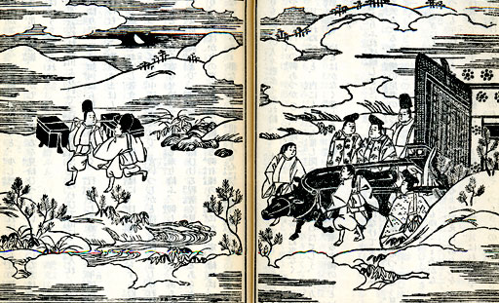
Aristocratic residents of Heian ride in a carriage, perhaps on their way to a day in the countryside.
Her father, who had been a Councillor, was dead. Her mother, who never forgot that the father was in his day a man of some consequence, managed despite all difficulties to give her as good an upbringing as generally falls to the lot of young ladies whose parents are alive and at the height of fortune. It would have helped matters greatly if there had been some influential guardian to busy himself on the child's behalf. Unfortunately, the mother was entirely alone in the world and sometimes, when troubles came, she felt very bitterly the lack of anyone to whom she could turn for comfort and advice. But to return to the daughter. In due time she bore him a little Prince who, perhaps because in some previous life a close bond had joined them, turned out as fine and likely a man-child as well might be in all the land. The Emperor could hardly contain himself during the days of waiting. But when, at the earliest possible moment, the child was presented at Court, he saw that rumor had not exaggerated its beauty. His eldest born prince was the son of Lady Kokiden, the daughter of the Minister of the Right, and this child was treated by all with the respect due to an undoubted Heir Apparent. But he was not so fine a child as the new prince; moreover the Emperor's great affection for the new child's mother made him feel the boy to be in a peculiar sense his own possession. Unfortunately she was not of the same rank as the courtiers who waited upon him in the Upper Palace, so that despite his love for her, and though she wore all the airs of a great lady, it was not without considerable qualms that he now made it his practice to have her by him not only when there was to be some entertainment, but even when any business of importance was afoot. Sometimes indeed he would keep her when he woke in the morning, not letting her go back to her lodging, so that willy-nilly she acted the part of a Lady-in-Perpetual-Attendance.
Seeing all this, Lady Kokiden began to fear that the new prince, for whom the Emperor seemed to have so marked a preference, would if she did not take care soon be promoted to the Eastern Palace. But she had, after all, priority over her rival; the Emperor had loved her devotedly and she had born him princes. It was even now chiefly the fear of her reproaches that made him uneasy about his new way of life. Thus, though his mistress could be sure of his protection, there were many who sought to humiliate her, and she felt so weak in herself that it seemed to her at last as though all the honours heaped upon her had brought with them terror rather than joy.
Her lodging was the wing called Kiritsubo. It was but natural that the many ladies whose doors she had to pass on her repeated journeys to the Emperor's room should have grown exasperated; and sometimes, when those coming and goings became frequent beyond measure, it would happen that on bridges and in corridors, here or there along the way that she must go, strange tricks were played to frighten her or unpleasant things were left lying about which spoiled the dresses of the ladies who accompanied her. Once indeed someone locked the door of a portico, so that the poor thing wandered this way and that for a great while in sore distress. So many were the miseries into which this state of affairs now daily brought her that the Emperor could no longer endure to witness her vexations and move her to the Koroden. In order to make room for her he was obliged to shift the Chief Lady of the Wardrobe to lodgings outside. So far from improving matters he had merely procured her a new and most embittered enemy!
The young prince was now three years old. The Putting on of the Trousers was performed with as much ceremony as in the case of the Heir Apparent. Marvellous gifts flowed from the Imperial Treasury and Tribute House. This too incurred the censure of many, but brought no enmity to the child himself; for his growing beauty and the charm of his disposition were a wonder and delight to all who met him. Indeed many persons of ripe experience confessed themselves astounded that such a creature should actually have been born in these latter and degenerate days.
In the summer of that year the lady became very downcast. She repeatedly asked for her leave to go to her home, but it was not granted. For a year she continued in the same state. The Emperor to all her entreaties answered only 'Try for a little while longer.' But she was getting worse every day, and when for five or six days she had been growing steadily weaker her mother sent to the Palace a tearful plea for her release. Fearing even now that her enemies might contrive to put some unimaginable shame upon her, the sick lady left her son behind and prepared to quit the Palace in secret. The Emperor knew that the time had come when, little as he liked it, he must let her go. But that she should slip away without a word of farewell was more than he could bear, and he hastened to her side. He found her still charming and beautiful, but her face very thin and wan. She looked at him tenderly, saying nothing. Was she alive? So faint was the dwindling spark that she scarcely seemed so. Suddenly forgetting all that had happened and all that was to come, he called her by a hundred pretty names and weeping showered upon her a thousand caresses; but she made no answer. For sounds and sights reached her but faintly, and she seemed dazed, as one that scarcely remembered she lay upon a bed. Seeing her thus he knew not what to do. In great trouble and perplexity he sent for a hand litter. But when they would have laid her in it, he forbad them, saying, 'There was an oath between us that neither should go alone upon the road that all at last must tread. How can I now let her go from me?' The lady heard him and 'At last!' she said; 'Though that desired at last become, because I go alone how gladly I would live!'
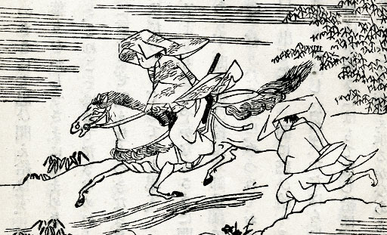
Genji is sent away from the house of his young lover Oborozukiyo in a driving rainstorm after being caught in bed with her by her father.
Thus with faint voice and failing breath she whispered. But though she found strength to speak, each word was uttered with great trial and pain. Come what might, the Emperor would have watched by her till the end, but that the priests who were to read the Intercession had already been dispatched to her home. She must be brought there before nightfall, and at last he forced himself to let the bearers carry her away. He tried to sleep but felt stifled and could not close his eyes. All night long messengers were coming and going between her home and the Palace. From the first they brought no good news, and soon after midnight announced that this time on arriving at the house they had heard a noise of wailing and lamentation, and learned from those within that the lady had just breathed her last. The Emperor lay motionless as though he had not understood.
Though his father was so fond of his company, it was thought better after this event that the Prince should go away from the Palace. He did not understand what had happened, but seeing the servants all wringing their hands and the Emperor himself continually weeping, he felt that it must have been something very terrible. He knew that even quite ordinary separations made people unhappy; but here was such a dismal wailing and lamenting as he had never seen before, and he concluded that this must be some very extraordinary kind of parting.
When the time came for the funeral to begin, the girl's mother cried out that the smoke of her body would be seen rising beside the smoke of her child's bier. She rode in the same coach with the Court ladies who had come to the funeral. The ceremony took place at Atago and was celebrated with great splendor. So overpowering was the mother's affection that so long as she looked on the body she still thought of her child as alive. It was only when they lighted the pyre she suddenly realized that what lay upon it was a corpse. Then, though she tried to speak sensibly, she reeled and almost fell from the coach, and those with her turned to one another and said 'At last she knows.'
A herald came from the palace and read a proclamation which promoted the dead lady to the Third Rank. The reading of this long proclamation by the bier was a sad business. The Emperor repented bitterly that he had not long ago made her a Lady-in-Waiting, and that was why he now raised her rank by one degree. There were many who grudged her even this honour; but some less stubborn began now to recall that she had indeed been a lady of uncommon beauty; and others, that she had very gentle and pleasing manners; while some went so far as to say it was a shame that anybody should have disliked so sweet a lady, and that if she had not been singled out unfairly from the rest, no one would have said a word against her.
The seven weeks of mourning were, by the Emperor's order, minutely observed. Time passed, but he still lived in rigid seclusion from the ladies of the Court. The servants who waited upon him had a sad life, for he wept almost without ceasing both day and night.
Kokiden and the other great ladies were still relentless, and went about saying 'it looked as though the Emperor would be no less foolishly obsessed by her memory than he had been by her person.' He did indeed sometimes see Kokiden's son, the first-born prince. But this only made him long the more to see the dead lady's child, and he was always sending trusted servants, such as his own old nurse, to report to him upon the boy's progress. The time of the autumn equinox had come. Already the touch of the evening air was cold upon the skin. So many memories crowded upon him that he sent a girl, the daughter of his quiver-bearer, with a letter to the dead lady's house. It was beautiful moonlit weather, and after he had dispatched the messenger he lingered for a while gazing out into the night. It was at such time as this that he had been wont to call for music. He remembered how her words, lightly whispered, had blended with those strangely fashioned harmonies, remembered how all was strange, her face, her air, her form. He thought of the poem which says that 'real things in the darkness seem no realer than dreams,' and he longed for even so dim a substance as the dream-life of those nights.
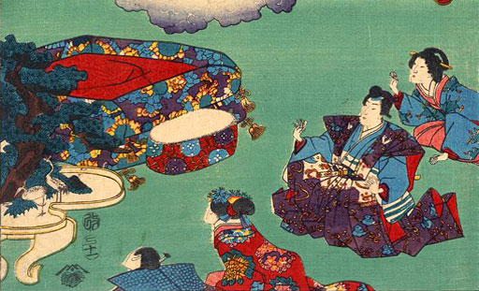
Library of Congress Digital Collections
Visits from spirits are a metaphor for the lovely world readers visit when they read The Tale of Genji.

