Later Europe and America Module II
The Valley of Mexico from the Hillside of Santa Isabel (El Valle de México desde el Cerro de Santa Isabel). Jose María Velasco. 1882 C.E. Oil on canvas.

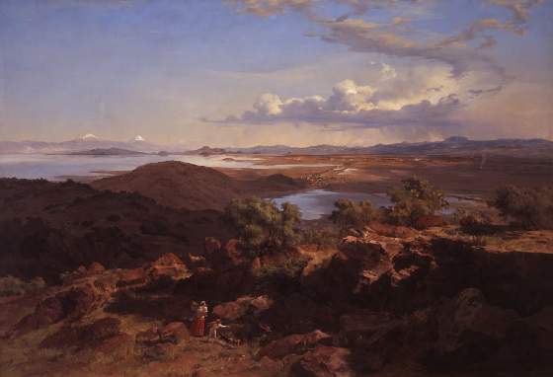

Photo Citation: https://www.khanacademy.org/humanities/becoming-modern/painting-mexico/a/velasco-the-valley-of-mexico

José María Velasco Gómez was the most representative figure of Mexican academic painting in the 19th century. In his work, the main theme was the spectacular natural scenery of his own country, specially the Valley of Mexico. He first painted the view of the "Valley of Mexico" from the hill of Santa Isabel and painted nine different times in his life.
“The Valley of Mexico from the Hillside of Santa Isabel can be viewed as a re-interpretation of the common late eighteenth-century German subject. The “pastoral idylls” is a work where a sense of poetic harmony and daily life were united. In the tradition of artists such as Casper David Friedrich, Velasco explored the romantic relationship between human figures and the scenery they inhabit. Two Indians are presented in transit from the city to the country, reflecting a romantic, yet difficult socio-economic relationship between people and their ancestral land. Velasco has produced an image where national pride, romantic poetry, and daily life blend to transform the Valley of Mexico into a Romantic masterpiece( Khan).”

Citations:
"Khan Academy." Khan Academy. Web. 25 Jan. 2015. <https://www.khanacademy.org/humanities/becoming-modern/painting-mexico/a/velasco-the-valley-of-mexico>.

