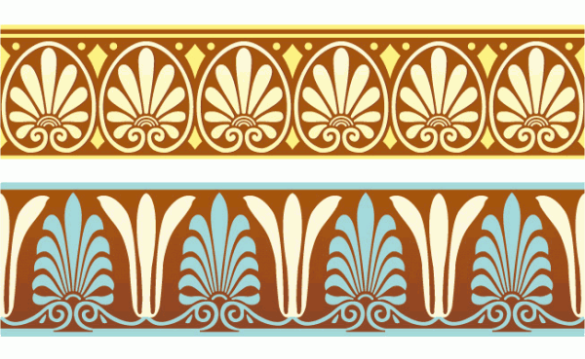
ANCIENT MEDITERRANEAN
MODULE/PART I

White Temple and its ziggurat. Uruk (modern Warka, Iraq). Sumerian. c. 3500–3000 B.C.E. Mud brick.
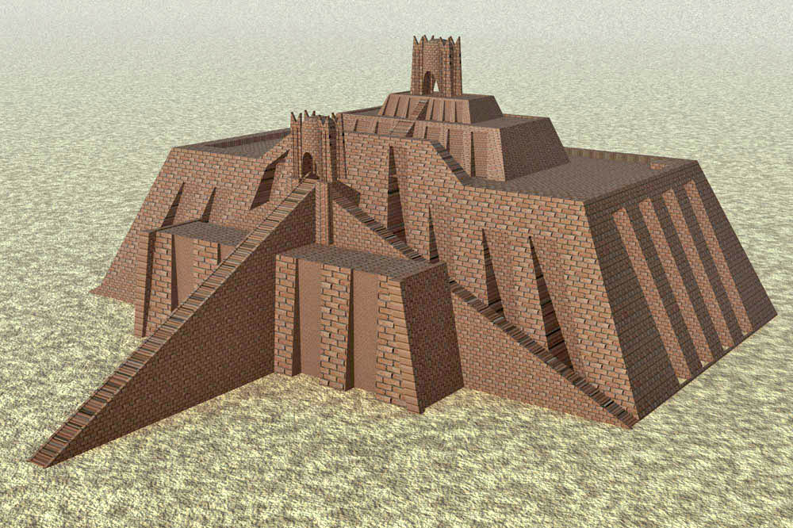

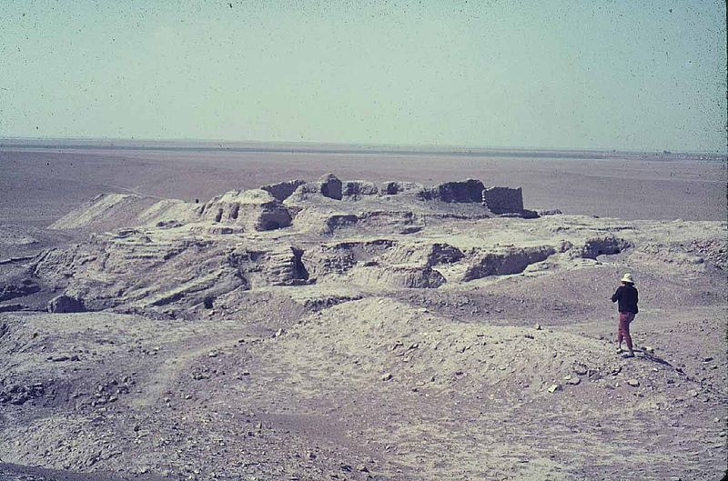
Photo Citation: "Ziggurat of ur" by user:wikiwikiyarou - Own work, based on a 1939 drawing by Leonard Woolley, Ur Excavations, Volume V. The Ziggurat and its Surroundings, Figure 1.4 [1][2]. Licensed under Public Domain via Wikimedia Commons -

By Таис Гило [Public domain], via Wikimedia Commons

There, in the fertile valley that lay between the Tigris and the Euphrates rivers, the earliest cities arose. Uruk was the first of these. Like other early city-states, Uruk was associated with a particular deity. It is thought that the sky god, Anu, was the protector of the urban city where the White Temple and Ziggurat is located. In addition to its religious function the temple also served as a center for political matters.
The White Temple was made out of mud brick, and its whitewashed walls gave the nickname by which it is now known. These bricks, now mostly eroded, fragile did not prevent the ancient Sumerians from erecting massive structures centuries before the Egyptians. The construction of these buildings reinforces modern belief about the role religion played in their lives. The desire to create monumental temples in which to worship deities must have been quite immense in order for such effort to be placed in building these types of structures.
The temple is located on the top of a platform known as a ziggurat. The height of the ziggurat reaches to 40 feet above the ground. The height serves two purposes: one to stand out among the other structures and therefore appear the more important; and two to get the temple closer to the sky where the ancient Sumerians believed the gods lived. The ziggurat is basically a “man-made mountain.” Staircases were built in the sloping sides of the ziggurat as well as a ramp. Worshippers climbed the stairs, possibly as a sort of pilgrimage, and the frontal ramp was used to bring animal sacrifices to the temple. The entrance doors of the temple were not located at the top of the staircases, but instead, the worshipper had to make an n additional angular turn. This alignment, known as bent axis approach, was the standard for Sumerian temples. The corners of the White Temple are oriented with the four cardinal points of the compass.
The White Temple contains a shrine that is thought to have been dedicated to Anu. The central hall, known as the cella, was set-aside for the god and housed an altar. The ancient Sumerians believed that the gods/goddesses would come down from the heavens into the cella and meet with the priests. (Gardners’s Art Through the Ages)

(Citation: Garnder’s Art Through the Ages, 13th edition)

For more information:

http://www.mesopotamia.co.uk/ziggurats/home_set.html

