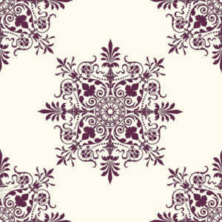
Later Europe and America Module I
Y no hai remedio (And There’s Nothing to Be Done), from Los Desastres de la Guerra (The Disasters of War), plate 15. Francisco de Goya. 1810–1823 C.E. (published 1863).
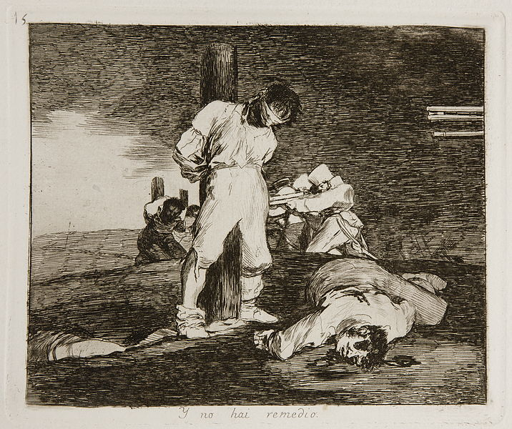

"Prado - Los Desastres de la Guerra - No. 15 - Y no hai remedio" by Francisco Goya - Museo del Prado. Licensed under Public Domain via Wikimedia Commons -

Francisco Goya (1746-1828) was a prominent Spanish painter and printmaker from the Romantic period. Francisco Goya was the official court painter for Spanish King Charles IV until the monarch was removed from the throne during Napoleon’s invasion of Spain in 1808. Goya's later work is renowned for its expressive line, color and brushwork as well as subversive commentary. Goya's paintings and drawings influenced the work of later generations (Boundless).
The leading general of Spain’s asked Goya to record the heroics of the Spanish citizens as they defended against the occupying French army and faced their atrocities. The sketches that Goya began in 1808 and continued even after the Spanish War of Independence would result in the series of prints Goya called Fatal consequences of the bloody war in Spain with Bonaparte, and other emphatic caprices. The series became known as the Disasters of War and was comprised of over eight-eight prints. Rather than depicting local heroics, Goya focused on the suffering experienced in times of wart and the brutality inflicted by all participants during armed conflict.
The Disasters series illustrates scenes of war that range from the bleak to the horrifying and grotesque. Y no hai Remedio (And There’s Nothing to Be Done) depicts exactly what the title suggests. One executed prisoner lies on the ground at the feet of a bound, blindfolded man who awaits his own death. The barrels of their rifles aiming menacingly from the right are the only sign of the executioners. The same scene is repeated in the far background.
The Disasters series was not published in its entirety until 1863, several decades after Goya’s death. The Disasters of War was not published possibly because he feared political repercussions from the regime of Fernando VII's or because he was skeptical about the use of images for political motives. Most historians believe the artist preferred to wait until they could shown without censorship (Wikipedia).

Citations:

Source: Boundless. “Goya.” Boundless Art History. Boundless, 03 Jul. 2014. Retrieved 23 Jan. 2015 from https://www.boundless.com/art-history/textbooks/boundless-art-history-textbook/europe-and-america-in-the-1700s-and-early-1800s-34/spainish-art-210/goya-755-10834/

"The Disasters of War." Wikipedia. Wikimedia Foundation. Web. 24 Jan. 2015. <http://en.wikipedia.org/wiki/The_Disasters_of_War>.

"12 / Conflict and Resistance." Art Through Time: A Global View. Web. 24 Jan. 2015. <http://www.learner.org/courses/globalart/work/42/index.html>.

